Attribution of April 2020 exceptional cold spell over Northeast China

Hongyong Yu¹, Xiaojing Yu^{2,3*}, Ziwei Zhou⁴, Yu Wang⁵, Yingxin Li⁶, Nergui Nanding⁷,
Nicolas Freychet⁸, Buwen Dong⁹, Dongqian Wang¹⁰, Fraser C. Lott¹¹, Simon F. B. Tett⁸,
Sarah Sparrow¹²

¹College of Global Change and Earth System Science, Beijing Normal University, Beijing, China
²LASG, Institute of Atmospheric Physics, Chinese Academy of Sciences, Beijing, China
³University of the Chinese Academy of Sciences, Beijing, China
⁴Department of Atmospheric and Oceanic Sciences, School of Physics, Peking University, Beijing, China
⁵College of Atmospheric Sciences, Lanzhou University, Lanzhou, China
⁶Chinese Research Academy of Environmental Sciences, Beijing, China
⁷Guangdong Province Key Laboratory for Climate Change and Natural Disaster Studies, School of Atmospheric Sciences, Sun Yat-sen University, Zhuhai, China
⁸School of Geosciences, University of Edinburgh, Edinburgh, United Kingdom
⁹National Centre for Atmospheric Science, Department of Meteorology, University of Reading, United Kingdom
¹⁰National Climate Center, China Meteorological Administration, Beijing, China
¹¹Met Office Hadley Centre, Exeter, United Kingdom
¹²Oxford e-Research Centre, Department of Engineering Science, University of Oxford, United Kingdom

* Corresponding author: Xiaojing Yu, yuxj@lasg.iap.ac.cn

Capsule summary:
Human-induced thermodynamic effects have declined the likelihood of April 2020-like cold spells over Northeast China by ~ 80%, but such events tend to be triggered by more intense dynamical factors.

INTRODUCTION
Northeast China (105–135°E, 37–55°N) is an important agricultural production area for wheat, soybean, maize amongst other crops (Lu et al. 2017; http://country.cnr.cn/gundong/20160303/t20160303_521524231_1.shtml), making a substantial contribution to the food security of China. Late boreal spring (mid-April to mid-May) is a transition period when most crops are at their critical growing stage. Under climate change, a widespread shift toward earlier spring greening, triggered by warmer temperature, has been documented (Schwartz et al. 2006; Piao et al. 2015; Tan et al. 2018). Extreme cold events occurred at growth stage are more likely to cause serious damage to crop yields and large economic loss (Wheeler et al. 2000; Li et al. 2015a).

In the recent decades, regional cold extremes, superimposed on a warmer climate, recurred throughout the Northern Hemisphere (Cattiaux et al. 2015; Qian et al. 2017; Christidis and Scott 2020; Zhang et al. 2021). April 2020 was the second hottest April (following April 2016) in the records, being 1.06 ℃ above the 20th-century average (https://www.noaa.gov/news/april-2020-was-earth-s-2nd-hottest-april-on-record). However, Northeast China witnessed an exceptional cold spell from 19th to 25th April 2020, mainly affecting the provinces of Heilongjiang, Jilin, Liaoning, Inner Mongolia, Hebei and Shanxi (Guan et al. 2020). The regional-averaged daily mean temperature anomaly during the coldest 5 days (20–24 April 2020) exceeded -5 ºC with respect to the normal level (Fig. 1a), and some stations were even bellow -7 ºC (Fig. 1b). More than 4 million people and 530,000 hectares of crop area were impacted by this extremely cold event, resulting in a total direct economic loss of 8.2 billion RMB (http://www.mem.gov.cn/xw/yjglbgzdt/202101/t20210102_376288.shtml). This event was one of the top ten natural hazard events in China for 2020 (http://www.cma.gov.cn/2011xwzx/2011xmtjj/202101/t20210104_569543.html) due to its agricultural damage.

Recent attribution studies addressed that anthropogenic forcings have basically reduced the likelihood of extremely cold waves (Qian et al. 2017; Christidis and Stott 2020; Duan et al. 2021; Zhou et al. 2021). It remains insufficient in elaborately documenting the human-induced thermodynamic and dynamical effects on such cold events. Here, we attempt to investigate the changing probability of April 2020-like cold spells over Northeast China due to anthropogenic forcings from both thermodynamic and dynamical perspectives. Our results should provide a comprehensive insight into human influences on cold extremes in a warming climate.

DATA AND METHODS
We used daily mean temperatures from nearly 200 stations over the study region (Fig. 1b), for 1961–2020. This observational dataset is homogenized and provided by the National Meteorological Information Center of China (Li et al. 2015b). The atmospheric circulations were depicted using daily data from the ERA5 reanalysis at a horizontal resolution of 0.25° (Hersbach and Dee 2016). To be consistent, observation and reanalysis data were interpolated into the model resolution (0.56°×0.83°) using the iterative improvement objective analysis and bilinear interpolation [ available in NCAR Command Language (NCL), http://www.ncl.ucar.edu/ ], respectively.

Considering the significant impacts of continuous low temperature on agriculture (Li et al. 2015a) and following the definition of spring cold spells in Zhu et al. (2018), we characterized spring extremely cold events as the minimum value of 5-day running mean of daily mean temperature anomalies (TA5) for 16 April–15 May. To remove the seasonal variations of temperature during the transition period, anomalies were calculated with respect to the daily mean climatology for 1981–2010.

At synoptic scale, the April 2020-like cold spells over Northeast China are closely associated with an anomalous dipole pattern of geopotential height at 500 hPa (Zhu et al. 2018). Thus, we defined a circulation strength index (CSI) as the difference of regional-averaged 500-hPa geopotential height between the Ural ridge (80–115°E, 50–65°N) and the East Asian trough (115–150°E, 35–50°N), identified according to ERA5 reanalysis (Fig. 1d). A positive index means a meridional circulation with anomalous northerlies prevailing between the two regions from the geostrophic wind balance, which favors the transport of cold air into Northeast China (Guan et al. 2020). Significant (p < 0.01) correlations between the regionally averaged TA5 and the corresponding CSI further demonstrate their reasonability (Figures not shown). For slight displacements in the anomalous centers compared with the ERA5 observations (Fig. ES2), the simulated CSI was calculated according to the adjusted region [(75−110°E, 55−70°N) and (110−145°E, 40−55°N)]. In the attribution analysis of the April 2020-like cold extremes, TA5 and CSI represented the thermodynamical and dynamical factors, respectively.

The HadGEM3-GA6-based attribution system (Christidis et al. 2013; Ciavarella et al. 2018) at a resolution of 0.56°×0.83° was used to investigate the anthropogenic influences on the changing probability of the April 2020-like cold extreme over Northeast China. Here, ensembles of simulations from the HadGEM3-A-N216 atmosphere model were used to estimate the frequencies of extremes with and without human influences. First, a 15-member ensemble of historical simulations (Historical) for 1961–2013, driven by both natural (solar variability and volcanic eruptions) and anthropogenic forcings (greenhouse gases, aerosols, ozone and land-use), were compared with observations to evaluate the model’s performances. A Kolmogorov–Smirnoff (K-S) test was applied to test if the distributions of the observations and Historical simulations are from the same population. Then, two 525-member ensembles of simulations for 2020 only, with different specifications of climatic forcings, sea surface temperatures (SSTs) and sea ice, were applied to estimate the probability of the April 2020-like cold events. One ensemble was forced as the Historical simulations (HistoricalExt), and the other was forced by climatic forcings without human influences, comprising the pre-industrial atmospheric forcing and SSTs and sea-ice with anthropogenic contributions removed (HistoricalNatExt).

For a better performance (Figures not shown), a Gamma distribution was fit to the indices for each ensemble of simulations and observations. The probabilities of exceeding the threshold of cold events with (HistoricalExt) and without (HistoricalNatExt) anthropogenic forcings were denoted as P_{All} and P_{Nat}, respectively. Then, the risk ratio (RR) was calculated as P_{All}/P_{Nat} (National Academies of Sciences, Engineering, and Medicine 2016). The 90% confidence interval uncertainty (90% CI) for RR was estimated by bootstraping (sampling with replacements; Efron and Tibshirani 1993).

RESULTS
The overlapping TA5 during 16 April−15 May 2020 shows that the coldest 5 days occurred on 20−24 April (Fig. 1a). During these five days, nearly half of the stations in Northeast China experienced a record-breaking cold event (Fig. 1b). The recorded lowest TA5 was below -7 ºC. The regionally averaged TA5 exceeded -5 ºC, with a return period of about 1-in-20 years (Fig. 1c). This cold extreme was accompanied by positive and negative geopotential height anomalies at 500 hPa over the Western Siberia and East Asia, respectively, with prevailing anomalous northeasterlies between the two regions (Fig. 1d).

Model performance was evaluated by comparing the annual timeseries of minimum TA5 for 16 April–15 May from observations and the 15-member ensemble of Historical simulations (Fig. 2a). HadGEM3-A-N216 basically reproduces the temporal evolution for the April 2020-like cold events, and the observational range is within the model spreads. The probability density functions (PDFs) of the minimum TA5 for 16 April–15 May for observations (1961–2020) and historical simulations (1961–2013) are also highly comparable, confirmed by the K–S test (p=0.55; Fig. 2b). Therefore, the HadGEM3-A-N216 simulations are reliable enough to conduct further attribution analysis.

First we examine the thermodynamic effects of anthropogenic forcings on the April 2020-like cold events. The PDF of the minimum TA5 shifts towards a warmer condition for HistoricalExt simulations compared to HistoricalNatExt simulations for 2020 (Fig. 2c), indicating that the probability of cold events tends to decline due to human influences. The minimum TA5 based on the observation (-5.2 °C) was used as a threshold to define the April 2020-like cold event. The probability of 2020-like cold extremes is ~ 14.3% (90% CI, 12.1–16.4%) for HistoricalNatExt simulations, while it is 2.4% (90% CI, 1.6–3.4%) for HistoricalExt simulations. Thus, RR is 0.17 (90% CI, 0.11–0.25), indicating that anthropogenic forcings have decreased the likelihood of April 2020-like cold events over Northeast China by ~80%. Correspondingly, the return period of such cold events has increased from ~ 1-in-7 years for HistoricalNatExt simulations to ~ 1-in-40 years for HistoricalExt simulations (Fig. ES1).

We further investigate the human-induced dynamical impacts on the April 2020-like cold events. The differences in 500-hPa geopotential height during such cold extremes (minimum TA5 less than -5.2 °C) between HistoricalExt and HistoricalNatExt simulations present positive anomalies over western Siberian region while negative anomalies over the Northeast China (Fig. ES2), with a slight displacement compared with the ERA5 observations (Fig. 1d). As for CSI corresponding to minimum TA5, the PDF shifts toward higher values for HistoricalExt simulations relative to HistoricalNatExt simulations, with a RR of ~ 10.0 (90% CI, 2.9−18.4) (Fig. 2d), indicating that strong cold events, like the one occurred in April 2020, need stronger circulation under the influence of anthropogenic forcings relative to HistoricalNatExt simulations.

The human influences on monthly (16 April－15 May) mean temperature over Northeast China and the 500-hPa circulation strength have also been examined. Clearly, the average value of monthly mean temperature for HistoricalExt simulations is warmer than the counterparts for HistoricalNatExt simulations (Fig. 2e). Meanwhile, the monthly mean CSI shows insignificant changes under anthropogenic forcings (Fig. 2f). This further demonstrates that the anthropogenic forcings have substantially increased the mean state of temperature in late spring, which is attributed to the decline in the likelihood of the April 2020-like cold extremes.

CONCLUSIONS
An exceptional spring cold event in 2020 swept across Northeast China and caused tremendous damage to agricultural production. Using the HadGEM3-GA6-based attribution system, we found that anthropogenic forcings have reduced the probability of April 2020-like cold spells over Northeast China by ~ 80%, in line with previous studies on spring cold events (Christidis and Stott 2020; Duan et al. 2021). The decline is mainly attributed to the substantial increase of mean temperature induced by human influences, reconfirming the conclusions of Lu et al. (2020) and Sun et al. (2020). It is worth noting that such cold events tend to be triggered by more drastic dynamical factors to offset the anthropogenic warming, though the monthly mean circulation changes little.

ACKNOWLEDGMENTS
The authors acknowledge the funding support from National Key R&D Program of China (2018YFC1507701), the UK-China Research & Innovation Partnership Fund through the Met Office Climate Science for Service Partnership (CSSP) China as part of the Newton Fund, the National Natural Science Foundation of China (42025503) and the National Key R&D Program of China (2018YFA0605604) during the virtual event-attribution workshop, at which most of the research was done for this paper. XY and YL were funded by National Key Research and Development Program of China (2018YFC1507701). HY was jointly funded by National Key Research and Development Program of China (2018YFC1507701), National Basic Research Program of China (2017YFA0603601) and the National Natural Science Foundation of China (41525018 and 41930970). YW was jointly funded by National Key Research and Development Program of China (2017YFC1502303) and the National Natural Science Foundation of China (41875096). NN was funded by the National Natural Science Foundation of China (41905101, 41975113, and 41861144014). NF, BD, FCL, SFBT and SS were supported by the U.K.–China Research and Innovation Partnership Fund through the Met Office Climate Science for Service Partnership (CSSP) China as part of the Newton Fund.

REFERENCES
Cattiaux, J. R., R. Vautard, C. Cassou, P. Yiou, and F. Codron, 2015: Winter 2010 in Europe: a cold extreme in a warming climate. Geophy. Res. Lett., 37(20), 114–122, https://doi.org/10.1029/2010GL044613.
Christidis, N., P. A. Stott, A. A. Scaife, A. Arribas, G. S. Jones, D. Copsey, J. R. Knight, and W. J. Tennant, 2013: A new HadGEM3-A-based system for attribution of weather- and climate-related extreme events. J. Climate, 26, 2756–2783, https://doi.org/10.1175/JCLI-D-12-00169.1.
Ciavarella, A., N. Christidis, M. Andrews, M. Groenendijk, J. Rostron, M. Elkington, C. Burke, F. C. Lott, and P. A. Scott, 2018: Upgrade of the HadGEM3-A based attribution system to high resolution and a new validation frame-work for probabilistic event attribution. Wea. Climate Extremes, 20, 9–32, https://doi.org/10.1016/j.wace.2018.03.003.
Chen, Y., W. Chen, Q. Su, F. Luo, S. Sparrow, D. Wallom, F. X. Tian, B.W. Dong, S. F. B. Tett, F.C. Lott, 2019: Anthropogenic warming has substantially increased the likelihood of July 2017–like heat waves over central eastern China. Bull. Amer. Meteor. Soc., 100(1), S91-S95, https://doi.org/10.1175/BAMS-D-18-0087.1.
Christidis, N, and P. A. Stott, 2020: The extremely cold start of the spring of 2018 in the United Kingdom. Bull. Amer. Meteor. Soc., 102(1), S23–S28, https://doi.org/10.1175/BAMS-D-19-0084.1.
Duan, J. P., L. Chen, L. Li, P. Wu, N. Christidis, Z. G. Ma, F. C. Lott, A. Ciavarella, and P. A. Stott, 2021: Anthropogenic influences on the extreme cold surge of early spring 2019 over the Southeastern Tibetan Plateau. Bull. Amer. Meteor. Soc., 102(1), S111-S116, https://doi.org/10.1175/BAMS-D-20-0215.1.
Efron, B., and R. Tibshirani, 1993: An introduction to the bootstrap. New York: Chapman and Hall.
Guan, L., T. Zhang, and Z. Liu, 2020: Analysis of the April 2020 atmospheric circulation and weather (in Chinese with English abstract). Meteor. Mon., 46, 994-1000, https://doi.org/10.7519/j.issn.1000-0526.2020.07.011.
Hersbach, H., and D. Dee, 2016: ERA5 reanalysis is in production. ECMWF Newsletter, 147, https://www.ecmwf.int/en/newsletter/147/news/era5-reanalysis-production.
Li, X., J. Cai, F. Liu, T. Dai, W. Cao, and D. Jiang, 2015a: Spring freeze effect on wheat yield is modulated by winter temperature fluctuations: Evidence from meta-analysis and simulating experiment. Journal of Agronomy and Crop Science, 201 (4), 288–300, https://doi.org/10.1111/jac.12115.
Li, Z., Z. W. Yan, and H. Y. Wu, 2015b: Updated homogenized Chinese temperature series with physical consistency. Atmos. Ocean. Sci. Lett., 8, 17–22, https://doi.org/10.3878/AOSL20140062.
Lu, M., W. B. Wu, L. Z. You, D. Chen, L. Zhang, P. Yang, and H. J. Tang, 2017: A synergy cropland of China by fusing multiple existing maps and statistics. Sensors, 17(7), 1613, https://doi.org/10.3390/s17071613.
Lu, C. H., Y. Sun, N. Christidis, and P. A. Stott, 2020: Contribution of global warming and atmospheric circulation to the hottest spring in eastern China in 2018. Adv. Atmos. Sci., 37(11), 1285−1294, https://doi.org/10.1007/s00376-020-0088-5.
National Academies of Sciences, Engineering, and Med-icine, 2016: Attribution of Extreme Weather Events in the Context of Climate Change. National Academies Press, 186 pp., https://doi.org/10.17226/21852.
Piao, S., J. Tan, A. Chen, Y. H. Fu, P. Ciais, Q. Liu, I. A. Janssens, S. Vicca, Z. Zeng, S.-J. Jeong,Y. Li, R. B. Myneni, S. Peng, M. Shen, J. Peelas, 2015: Leaf onset in the northern hemisphere triggered by daytime temperature. Nat. Commun. 6, 6911, doi: 10.1038/ncomms7911.
Qian, C., J. Wang, S. Dong, H Yin, C. Burke, A. Ciavarella, B. Dong, N. Freychet, F. C. Lott, and S. F. B. Tett, 2017: Human influence on the record-breaking cold event in January of 2016 in eastern China. Bull. Amer. Meteor. Soc., 99(1), S118-S122, https://doi.org/10.1175 /BAMS-D-17-0095.2.
Ren, L., D. Wang, N. An, S. Ding, K. Yang, N. Freychet, S. F. B. Tett, B. Dong, and F. C. Lott, 2020: Anthropogenic influences on the persistent night-time heat wave in summer 2018 over Northeast China. Bull. Amer. Meteor. Soc., 102(1), S83-S88, https://doi.org/10.1175/BAMS-D-19-0152.1.
Schwartz, M. D., R. Ahas, A. Aasa, 2006: Onset of spring starting earlier across the Northern Hemisphere. Glob. Chang. Biol. 12, 343–351, doi: 10.1111/j.1365-2486.2005.01097.x
Sun, Y., S. Dong, T. Hu, X. Zhang, P. Scott, 2020: Attribution of the warmest spring of 2018 in Northeastern Asia using simulations of a coupled and an atmospheric model. Bull. Amer. Meteor. Soc., 101(1), S129-S134, https://doi.org/10.1175/BAMS-D-19-0264.1
Tan, K., G. Zhou, X. Lv, J. Guo, and S. Ren, 2018: Combined effects of elevated temperature and CO₂ enhance threat from low temperature hazard to winter wheat growth in North China. Scientific Reports, 8, 4336, https://doi.org/10.1038/s41598-018-22559-4.
Wheeler, T. R., P. Q. Craufurd, R. H. Ellis, J. R. Porter, and P. V. Prasad, 2000: Temperature variability and the yield of annual crops. Agriculture, Ecosystems and Environment, 82, 159-167, https://doi.org/10.1016/S0167-8809(00)00224-3.
Zhang, X. D., Y. F. Fu, Z. Han, J. E. Overland, A. Rinke, H. Tang, T. Vihma, and M. Y. Wang, 2021: Extreme cold events from East Asia to North America in winter 2020/21: Comparisons, causes, and future implications. Adv. Atmos. Sci., https://doi.org/10.1007/s00376-021-1229-1.
Zhou, C., A. Dai, J. Wang, and D. Chen, 2021: Quantifying Human-induced dynamic and thermodynamic contributions to severe cold outbreaks like November 2019 in the Eastern United States, Bull. Amer. Meteor. Soc., 102(1), S17-S23. https://doi.org/10.1175/BAMS-D-20-0171.1
Zhu, Y. L., H. J. Wang, T. Wang, and D. Guo, 2018: Extreme spring cold spells in North China during 1961–2014 and the evolving processes. Atmos. Ocean. Sci. Lett., 11(5), 432-437, https://doi.org/10.1080/16742834.2018.1514937.

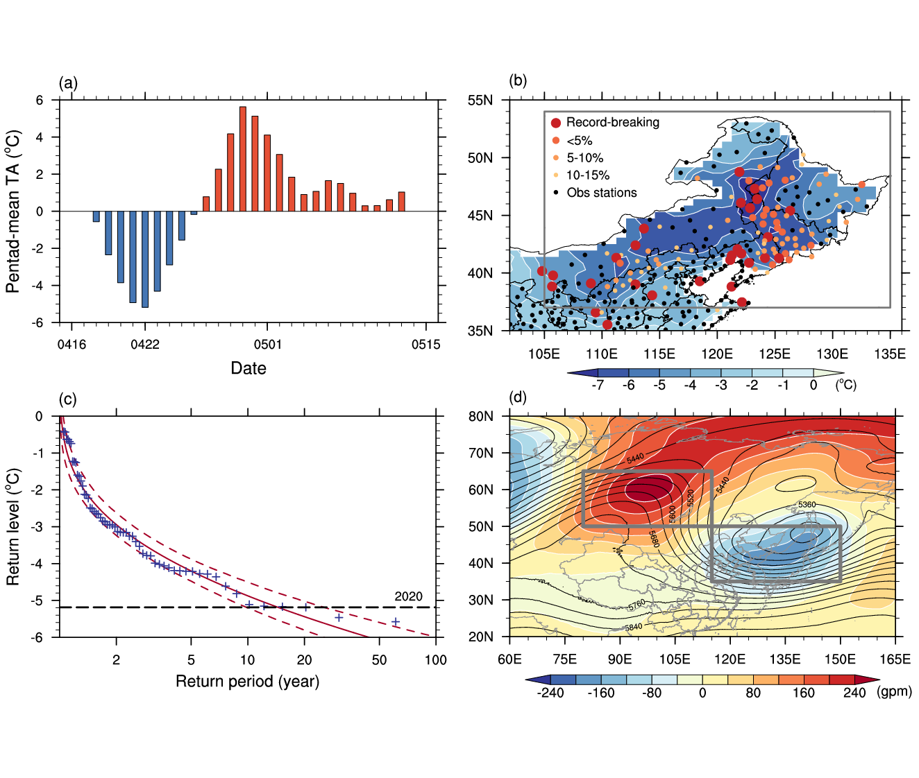
FIG. 1. (a) Observed running pentad-mean temperature anomaly (TA5; °C) averaged over Northeast China during 16 April−15 May 2020, relative to the daily mean climatology for 1981–2010. Each value is indexed by the middle day of the pentad. (b) Observed TA5 (ºC) for 20−24 April 2020. Shading is TA5 based on the gridded observations. Dots are the percentile ranks of minimum TA5 for 16 April−15 May 2020 during 1961−2020 at each station. (c) Return periods of minimum regional TA5 for 16 April−15 May during 1961−2020. (d) 500-hPa geopotential height (contours; gpm) and anomalies (shadings; gpm), for 20−24 April 2020, relative to the monthly mean climatology for 1981−2010. Grey boxes indicate the regions of the Ural ridge (80−115°E, 50−65°N) and East Asian trough (115−150°E, 35−50°N).

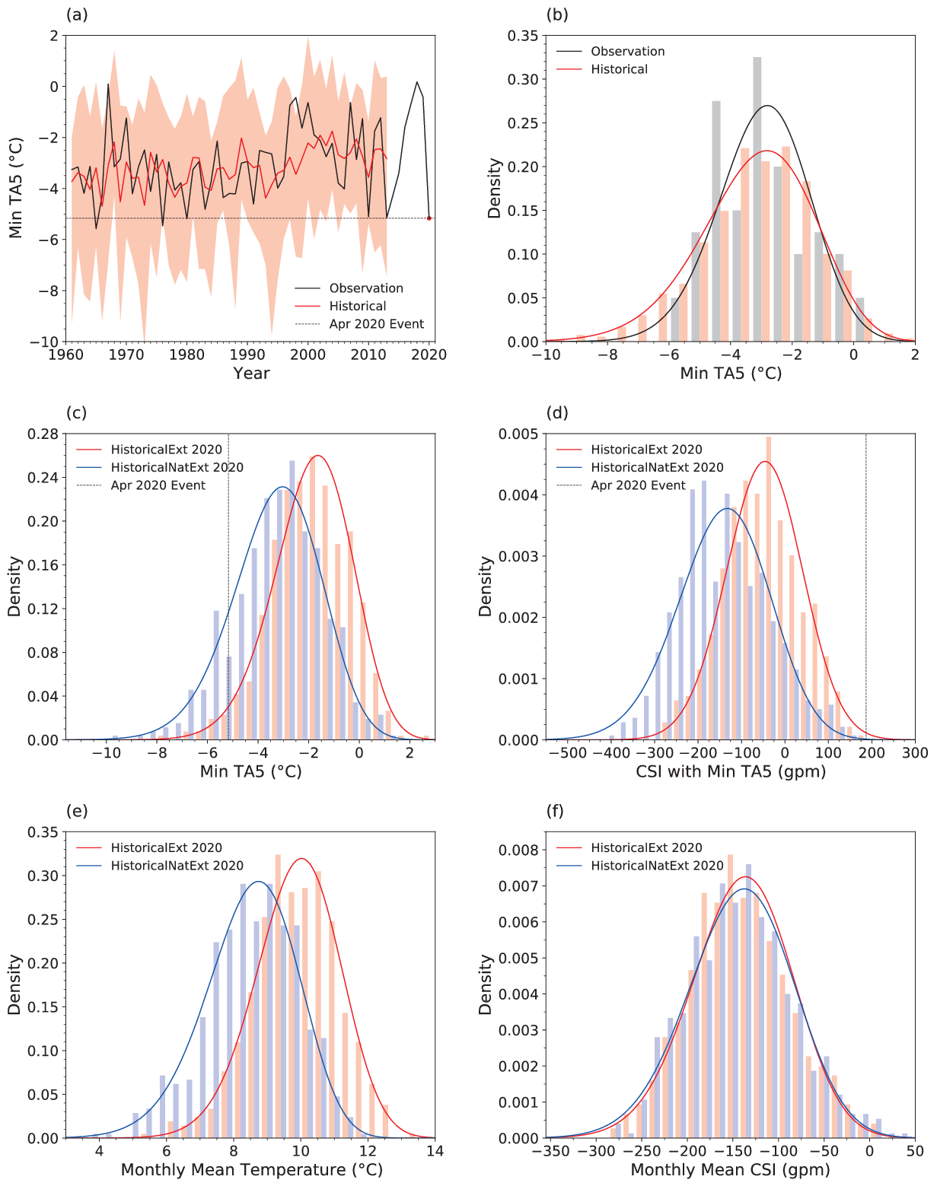
FIG. 2. (a) Timeseries of minimum TA5 (°C) for 16 April−15 May for observations (black, 1961−2020) and Historical simulations (1961−2013). The ensemble mean and spread are illustrated by the red line and pink shadings. (b) Gamma-fitted probability density function (PDF) and histograms of minimum TA5 for 16 April−15 May for observations and Historical simulations. (c−d) Gamma-fitted PDF and histograms of minimum TA5 (c) and corresponding circulation strength index (CSI, d) for 16 April−15 May based on HistoricalExt (red) and HistoricalNatExt (blue) simulations for 2020. The vertical lines in (c) and (d) indicate the minimum TA5 and CSI of April 2020 event. (e−f) Gamma-fitted PDF and histograms of monthly (16 April−15 May) mean temperature (e) and CSI (f) in HistoricalExt and HistoricalNatExt simulations.

