Anthropogenic influences on 2020 extreme dry-wet contrast over South China
Jizeng Du¹, Kaiqi Fu², Kaicun Wang^{2*}, Baoshan Cui¹
¹School of Environment, Beijing Normal University, State Key Joint Laboratory of Environmental Simulation and Pollution Control, Beijing 100875, China
²College of Global Change and Earth System Science, Beijing Normal University, Beijing, 100875, China
Corresponding author: Kaicun Wang, College of Global Change and Earth System Science, Beijing Normal University. Email: kcwang@bnu.edu.cn; Tel.: +086 10-58803143; Fax: +086 10-58800059.

Submitted to Bulletin of the American Meteorological Society
October 8, 2021

Summary
The extreme precipitation and heatwave led to a 1-in-183-year extreme dry-wet contrast over South China in the 2020 summer. Anthropogenic influences increased the risk of such extremes by at least three times.

Introduction
In the 2020 summer, the Yangtze River Basin (YZ) suffered catastrophic floods due to record-breaking precipitation. The floods affected more than 23.86 million people and 2,478 million hectares of crops, resulting in a direct economic loss of 10 billion dollars. However, near YZ, China's southern coastal regions (SC) experienced a long-time heatwave, and the number of high temperature days was the second highest since 1961. In addition, the number of typhoons landing in South China was very low compared to recent years. There was a "no-typhoon July" for the first time since 1949 in SC. The low precipitation caused by the reduced typhoon number, with the continuous high temperature, resulted in the severe and persistent meteorological drought in SC (Liu 2021). Two opposite meteorological disasters occurred in two adjacent areas of South China.
With the occurrence of the El Niño event since autumn 2019, the SST over the northern Indian Ocean had been abnormally warm since April 2020, resulting in an intensified, westward, and larger area of the Western Pacific Subtropical High (WPSH) (Takaya et al. 2020; Zhou et al. 2021). Consequently, most SC was controlled by the strong WPSH and thus had less cloud and precipitation, promoting high-temperature days (Choi and Kim 2019; Wang et al. 2013). The intensified subtropical high had dramatically inhibited the convective activities in the western tropical Pacific, making the region lack the necessary conditions for generating typhoons, resulting in fewer typhoons generated and landed SC (Qi 2021). Additionally, the southwesterly wind west of the intensified WPSH transported more water vapour to the YZ (Zhou and Yu 2005). Then, it met with the abnormally active cold-and-dry air transferred by the northerly wind west of the Mongolian Cyclone and formed a persistent and intense rainband in the YZ (Hsu and Lin 2007; Li et al. 2019). The rainband was mainly located in the middle and lower reaches of the YZ in July and gradually moved to the upper reaches in August, leading to frequent extreme precipitation in Guizhou, Chongqing, and Sichuan (Wei et al. 2020; Xia and Chen 2021).
The above anomalous circulations are closely related to both atmosphere internal variabilities and anthropogenic climate warming (Chen et al. 2021; Ding et al. 2020; Li et al. 2018; Liu et al. 2020; Zhou et al. 2021). Chen and Zhai (2017) suggested that the boreal summer intraseasonal oscillation (BSISO) can simultaneously facilitate precipitation extremes in central-eastern China and extreme high temperatures in South China-Southeast China. Additionally, Ye and Qian (2021) suggested that anthropogenic climate warming explains 80% and 99% of increasing risk for the record-breaking precipitation in YZ and the concurrent extreme heatwave in SC, respectively. Therefore, anthropogenic forcings may be an essential driving factor for the 2020 extreme dry-wet difference in South China.
Here, we used the Standardized Precipitation Evapotranspiration Index (SPEI) to measure the moisture conditions and answer the following two questions: (1) how extreme is the dry-wet contrast between YZ and SC and which is the key driving factor based on observations; (2) whether and to what extent anthropogenic influences have amplified the risk of this extreme event based on model simulations. The exploration of extreme dry-wet contrast in South China is helpful to understand the risk from spatio-temporal compounding of multiple events.

Data and methods
The daily observations from meteorological stations were provided by China's Daily Dataset of Surface Climatic Data (V3.0). 133 and 114 meteorological stations were selected for YZ and SC from 1960 to 2020, respectively (see Figs. S1). All observations have passed strict quality control and homogenization (Cao et al. 2016). Additionally, we used the model simulations for phase 6 of the Coupled Model Intercomparison Project (CMIP6) and HadGEM3-A attribution system (HadGEM3A) to assess the anthropogenic influences on the risk of extreme dry-wet contrast in South China.
As mentioned above, the extreme dry-wet contrast in South China was caused by simultaneous extreme precipitation and heatwave. Therefore, we should select an index considering both precipitation and temperature to measure dry/wet condition variability. The SPEI index combines precipitation and air temperature and is commonly used to measure dry/wet conditions in previous studies (Beguería et al. 2014; Chiang et al. 2021; Vicente-Serrano et al. 2010). We produced the SPEI by the monthly precipitation from station observations and PET calculated by the Thornthwaite equation (Stagge et al. 2014; Thornthwaite 1948; Zarei and Mahmoudi 2020). Positive and negative SPEI values correspond to relatively wet and dry conditions, respectively. Owing to the uneven distribution of weather stations across study regions, we divided all weather stations into the 1° × 1° grids. We first calculated the SPEI time series of every station and then calculated the area-weighted average of SPEI as regional means.
We used the difference of SPEI between YZ and SC (SPEI_{D}) to indicate the dry-wet contrast in South China. SPEI_{2D} is the two-month moving average of SPEI_{D} and the persistent dry-wet contrast event is defined as the maximum SPEI_{2D} in each year (hereafter SPEI_{2Dx}). After calculating the time series of SPEI_{D}, we applied the Kolmogorov-Smirnov test to determine whether the probability density functions (PDFs) of simulated SPEI_{D} have the statistical significance of difference with the observed SPEI_{D} (Marsaglia et al. 2003). Then, we only kept model simulations whose PDFs of SPEI_{D} were indistinguishable from those from observations. Finally, we selected 24 simulations from 6 models for CMIP6 (Gillett et al. 2016) and 15 simulations for the HadGEM3A attribution system (Christidis et al. 2013) (see Table S1).
We applied the Generalized extreme value (GEV) model to fit the distribution of SPEI_{2Dx} from observations or simulations to estimate the probability and return period for the extreme SPEI_{2Dx} in varying scenarios (Huang et al. 2016; Jenkinson 1955). The variations of SPEI mainly involved both precipitation and air temperature. Here, we quantify the contribution of variables by calculating SPEI using original data and detrended data. If variable i is the input variable to SPEI, we replaced the observed i variable with its detrended time series. The detrended series has no long-term trend but not affecting the original data distribution and interannual variabilities. Therefore, we can calculate the probability ratio (RR) and the fraction of attributable risk (FAR) for the i variable as following (Fischer and Knutti 2015; Stott et al. 2016):
$PR\left(i\right)=P(i)/P(NTD) and FAR\left(i\right)=1-P(NDT)/P(i)$ (1)
where P(NTD) indicates the probabilities of exceeding the 2020 extreme SPEI_{2Dx} event threshold in the scenario that all input variables have been replaced by detrended data. P(i) indicates the probabilities exceeding such extremeness in the scenario where the i variable has been replaced by observation. We used the NAT scenario to estimate P(NTD) and the i variable from ALL scenario to estimate P(i) for model simulations. A Monte Carlo bootstrap procedure estimated the 2.5%–97.5% uncertainties of the above indicators.

Results
- Observed extreme dry-wet contrast.
During July-August 2020, the total precipitation in YZ broken the historical record of half a century and reached 482.22 mm, exceeding the previous record during 1960-2020 by 151.70 mm (see Figs. 1a). Conversely, the concurrent total precipitation in SC was 335.92 mm and 56.49 mm less than the historical average in 1960-2020. The concurrent air temperature in SC was 0.74 ℃ higher than in average years (see Figs. 1b), and the extreme heat days reached 11.5 days, which is 2.6 days more than the historical average. In the same period, the frequent heavy rainfall and the high temperature with less precipitation had resulted in a severe flood in YZ and extreme drought in SC, respectively (see Figs. 1c).
As shown in Figs. 1d, the SPEI was positive in YZ while was negative in SC generally during July-August 2020. The regional mean SPEI in YZ broke the historical highest record while SC was the third-lowest since 1960. Therefore, the SPEI_{2Dx} between YZ and SC reached the highest value in 2020 (see Figs. 1e). The return period of the 2020 extreme SPEI_{2Dx} is a 1-in-183-yr event (95% CI: 41 to 1361 yr, see Figs. 1e).
In the past 60 years, there were significant warming trends in both YZ and SC (see Table 1). The precipitation increased in YZ while remained stable in SC. Hence, compared with the YZ, SC showed a dry-warm trend. Additionally, the difference in extreme precipitation and heatwave between YZ and SC seem to be more sensitive to anthropogenic forcings. As shown in Figs. S2, the increased rate of extreme precipitation (excess 90% quantile) was higher in YZ than SC while that of extreme high temperature (excess 90% quantile) was the complete opposite. Above results may suggest that anthropogenic forcings facilitated more extreme precipitation in YZ and heatwave events in SC, thus further increasing the occurrence risk of extreme dry-wet contrast events between the two regions.
- Model attribution
Here, we quantify the anthropogenic influences on extreme SPEI_{2Dx} event by comparing scenarios under all forcings (ALL) and natural forcings only (NAT) from HadGME3A (Christidis et al. 2013; Ciavarella et al. 2018). ALL and NAT simulations during 1960-2015 are freely available in NetCDF4 format from ESGF/CEDA (https://catalogue.ceda.ac.uk/). Note that the ALL scenarios are not stationary climates, and their mean during 1960-2015 is not representative of the climate state in 2020. Hence, the scaled GEV distributions are determined to fit the probability distribution of SPEI_{2Dx} in ALL scenarios (see supplementary material).
As shown in Figs. 2d-e, we found that the likelihood of the 2020 SPEI_{2Dx} anomaly of ALL was 3.51 times (95% CI: 2.01–12.58) that of NAT. Therefore, the anthropogenic effects can explain 71.5% (95% CI: 50.2–92.1%) attributable risk of the extreme SPEI_{2Dx} experienced in July-August 2020 (see Figs. 2b–d).
Besides, we combined historical simulations (2000-14) and corresponding shared socioeconomic pathway (SSP) 2-4.5 scenarios (2014-40) to construct the scenario with all forcings and the scenario with only natural forcings as reference. According to the CMIP6 experiments, the likelihood of the 2020 extreme SPEI_{2Dx} under ALL was 3.12 times (95% CI: 1.41–11.12) than under NAT (see Figs.2d). Anthropogenic climate change explains 67.9% (95% CI: 29.1–91.0%) attributable risk of 2020 extreme SPEI_{2Dx} (see Figs. 2f).
- Key driving factor
As shown in Figs.2b, precipitation variations are the most crucial driving factor leading to extreme SPEI_{2Dx} events among all the related meteorological variables. Compared with detrended data, the precipitation and temperature can increase the probability of extreme SPEI events by 3.48 times (95% CI: 2.07-13.21) and 2.05 times (95% CI: 1.03-7.14), respectively. The combined effect of the two increased the probability of extreme SPEI_{2Dx} by 4.58 times (95% CI: 2.51-15.27), explaining the 78.2% attributable risk (see Figs. 2c). According to HadGEM3A and CMIP6, human-induced precipitation changes increased the risk of extreme SPEI_{2Dx} by 1.76 times (95% CI: 0.85-9.14) and 2.31 times (95% CI: 1.24-8.37) (see Figs. 2f and i). Hence, anthropogenic forcings significantly affect the precipitation difference but have less effect on the warming difference between YZ and SC. Therefore the extreme SPEI_{2Dx} risk was more sensitive to precipitation changes than regional warming.

Conclusion
In the 2020 summer, an extreme dry-wet contrast occurred over South China due to frequent extreme rainfall in the Yangtze River Basin and persistent heat and drought in China's southern coastal regions, breaking the historical record since 1960. Precipitation changes are the main reason for regional extreme dry-wet contrast over South China, followed by temperature variation, which increased the probability of the extreme event by 3.48 and 2.05 times, respectively.
Based on the simulation results of HadGEM3A (CMIP6), anthropogenic climate change increased the probability of the 2020 extreme SPEI_{2Dx} by 3.51 (3.12) times, which can explain the 71.5% (67.9%) attributable risk. Anthropogenic climate change increased the risk of extreme dry-wet contrast events mainly by altering precipitation. Precipitation and temperature changes have an apparent synergistic effect in increasing the risk of such extreme events. Additionally, based on CMIP6 simulation, Chiang et al. (2021) found that anthropogenic climate forcing, primarily anthropogenic aerosol emissions, significantly increase drought risk in South China. The increased intensity in China's southern coastal regions is considerably higher than that in the Yangtze River Basin. Although we detected the effect of anthropogenic forcings on this extreme dry-wet contrast event, it is necessary to explore related physical processes in the future.
Note that Berg and Sheffield (2018) have criticized the use of SPEI for climate trend analysis and projections and particularly to infer soil-moisture related drought changes. They find an unrealistically strong temperature-driven response of SPEI to warming compared to soil moisture responses in model projections. However, we contrast the SPEI between two regions with similar warming trends, and the differences in precipitation trends mainly drive the trend in SPEI difference between the regions. The issues with interpreting SPEI trends identified by Berg and Sheffield are less likely to have a large influence on our results compared to an analysis of SPEI trends for individual warming regions.
Acknowledgements: This study was funded by the National Basic Research Program of China (2018YFC1507701 and 2017YFA0603601), the Fundamental Research Funds for the Central Universities (2019NTST10), and the National Natural Science Foundation of China (42005019). The Met Office for the HadGEM3-A-based attribution system (http://catalog.ceda.ac.uk/) and the World Climate Research Programme's Working Group on Coupled Modeling (http://cmip.pcmi.llnl.gov/cmip6/) for the model simulations.

Reference
Beguería, S., S. M. Vicente‐Serrano, F. Reig, and B. Latorre, 2014: Standardized precipitation evapotranspiration index (SPEI) revisited: parameter fitting, evapotranspiration models, tools, datasets and drought monitoring. International journal of climatology, 34, 3001-3023.
Berg, A., and J. Sheffield, 2018: Climate Change and Drought: the Soil Moisture Perspective. Current Climate Change Reports, 4, 180-191.
Cao, L., Y. Zhu, G. Tang, F. Yuan, and Z. Yan, 2016: Climatic warming in China according to a homogenized data set from 2419 stations. International Journal of Climatology, 36, 4384-4392.
Chen, Y., and P. Zhai, 2017: Simultaneous modulations of precipitation and temperature extremes in Southern parts of China by the boreal summer intraseasonal oscillation. Climate Dynamics, 49, 3363-3381.
Chen, Y., Z. Liao, Y. Shi, Y. Tian, and P. Zhai, 2021: Detectable Increases in Sequential Flood-Heatwave Events Across China During 1961–2018. Geophysical Research Letters, 48, e2021GL092549.
Chiang, F., O. Mazdiyasni, and A. AghaKouchak, 2021: Evidence of anthropogenic impacts on global drought frequency, duration, and intensity. Nature Communications, 12, 2754.
Choi, W., and K.-Y. Kim, 2019: Summertime variability of the western North Pacific subtropical high and its synoptic influences on the East Asian weather. Scientific Reports, 9, 7865.
Christidis, N., and Coauthors, 2013: A New HadGEM3-A-Based System for Attribution of Weather- and Climate-Related Extreme Events. Journal of Climate, 26, 2756-2783.
Ciavarella, A., and Coauthors, 2018: Upgrade of the HadGEM3-A based attribution system to high resolution and a new validation framework for probabilistic event attribution. Weather and Climate Extremes, 20, 9-32.
Ding, Y., P. Liang, Y. Liu, and Y. Zhang, 2020: Multiscale variability of Meiyu and its prediction: A new review. Journal of Geophysical Research: Atmospheres, 125, e2019JD031496.
Fischer, E. M., and R. Knutti, 2015: Anthropogenic contribution to global occurrence of heavy-precipitation and high-temperature extremes. Nature Climate Change, 5, 560-564.
Gillett, N., and Coauthors, 2016: Detection and Attribution Model Intercomparison Project (DAMIP), Geosci. Model Dev. Discuss., doi: 10.5194. gmd-2016-74, in review.
Hsu, H.-H., and S.-M. Lin, 2007: Asymmetry of the tripole rainfall pattern during the East Asian summer. Journal of Climate, 20, 4443-4458.
Li, H., S. He, K. Fan, and H. Wang, 2019: Relationship between the onset date of the Meiyu and the South Asian anticyclone in April and the related mechanisms. Climate Dynamics, 52, 209-226.
Li, X., G. Gollan, R. J. Greatbatch, and R. Lu, 2018: Intraseasonal variation of the East Asian summer monsoon associated with the Madden–Julian oscillation. Atmospheric Science Letters, 19, e794.
Liu, B., Y. Yan, C. Zhu, S. Ma, and J. Li, 2020: Record‐Breaking Meiyu Rainfall Around the Yangtze River in 2020 Regulated by the Subseasonal Phase Transition of the North Atlantic Oscillation. Geophysical Research Letters, 47, e2020GL090342.
Liu, S., 2021: Top 10 weather and climate events in 2020 unveiled. http://www.cma.gov.cn/en2014/20150311/20200414/202101/t20210112_570009.html, China Meteorological News Press.
Marsaglia, G., W. W. Tsang, and J. Wang, 2003: Evaluating Kolmogorov’s distribution. Journal of statistical software, 8, 1-4.
Qi, X., 2021: Research on the “No-Typhoon July” in 2020 and Typhoon Frequency Variations in July in Recent 70 Years. Journal of Geoscience and Environment Protection, 9, 75.
Stagge, J. H., L. M. Tallaksen, C. Y. Xu, and H. A. Van Lanen, 2014: Standardized precipitation-evapotranspiration index (SPEI): Sensitivity to potential evapotranspiration model and parameters. Hydrology in a Changing World, 367-373.
Stott, P. A., and Coauthors, 2016: Attribution of extreme weather and climate‐related events. Wiley Interdisciplinary Reviews: Climate Change, 7, 23-41.
Takaya, Y., I. Ishikawa, C. Kobayashi, H. Endo, and T. Ose, 2020: Enhanced Meiyu-Baiu Rainfall in Early Summer 2020: Aftermath of the 2019 Super IOD Event. Geophysical Research Letters, 47, e2020GL090671.
Thornthwaite, C. W., 1948: An approach toward a rational classification of climate. Geographical review, 38, 55-94.
Vicente-Serrano, S. M., S. Beguería, and J. I. López-Moreno, 2010: A Multiscalar Drought Index Sensitive to Global Warming: The Standardized Precipitation Evapotranspiration Index. Journal of Climate, 23, 1696-1718.
Wang, B., B. Xiang, and J.-Y. Lee, 2013: Subtropical High predictability establishes a promising way for monsoon and tropical storm predictions. Proceedings of the National Academy of Sciences, 110, 2718-2722.
Wei, K., and Coauthors, 2020: Reflections on the catastrophic 2020 Yangtze River Basin flooding in southern China. The Innovation, 1, 100038.
Xia, J., and J. Chen, 2021: A new era of flood control strategies from the perspective of managing the 2020 Yangtze River flood. Science China Earth Sciences, 64, 1-9.
Ye, Y., and C. Qian, 2021: Conditional attribution of climate change and atmospheric circulation contributing to the record-breaking precipitation and temperature event of summer 2020 in southern China. Environmental Research Letters, 16, 044058.
Zarei, A. R., and M. R. Mahmoudi, 2020: Assessment of the effect of PET calculation method on the Standardized Precipitation Evapotranspiration Index (SPEI). Arabian Journal of Geosciences, 13, 1-14.
Zhou, T. J., and R. C. Yu, 2005: Atmospheric water vapor transport associated with typical anomalous summer rainfall patterns in China. Journal of Geophysical Research: Atmospheres, 110.
Zhou, Z.-Q., S.-P. Xie, and R. Zhang, 2021: Historic Yangtze flooding of 2020 tied to extreme Indian Ocean conditions. Proceedings of the National Academy of Sciences, 118.

Table
Table 1. The trends (±95% confidence level) of regional area-weighted average of precipitation (P), air temperature (T) for Yangtze River Basin (YZ), China's southern coastal regions (SC) and regional difference (YZ-SC) during 1960-2020. Note that the bold font denotes the trend is significant at 95% confidence level.
Variables | YZ | SC | YZ-SC
P (mm/10yr) | 0.108±0.243 | 0.006±0.325 | 0.102±0.191
T (℃/10yr) | 0.020±0.012 | 0.017±0.015 | 0.003±0.004
SPEI (/10yr) | 0.0001±0.0018 | -0.0042±0.0021 | 0.0041±0.0025

Figures
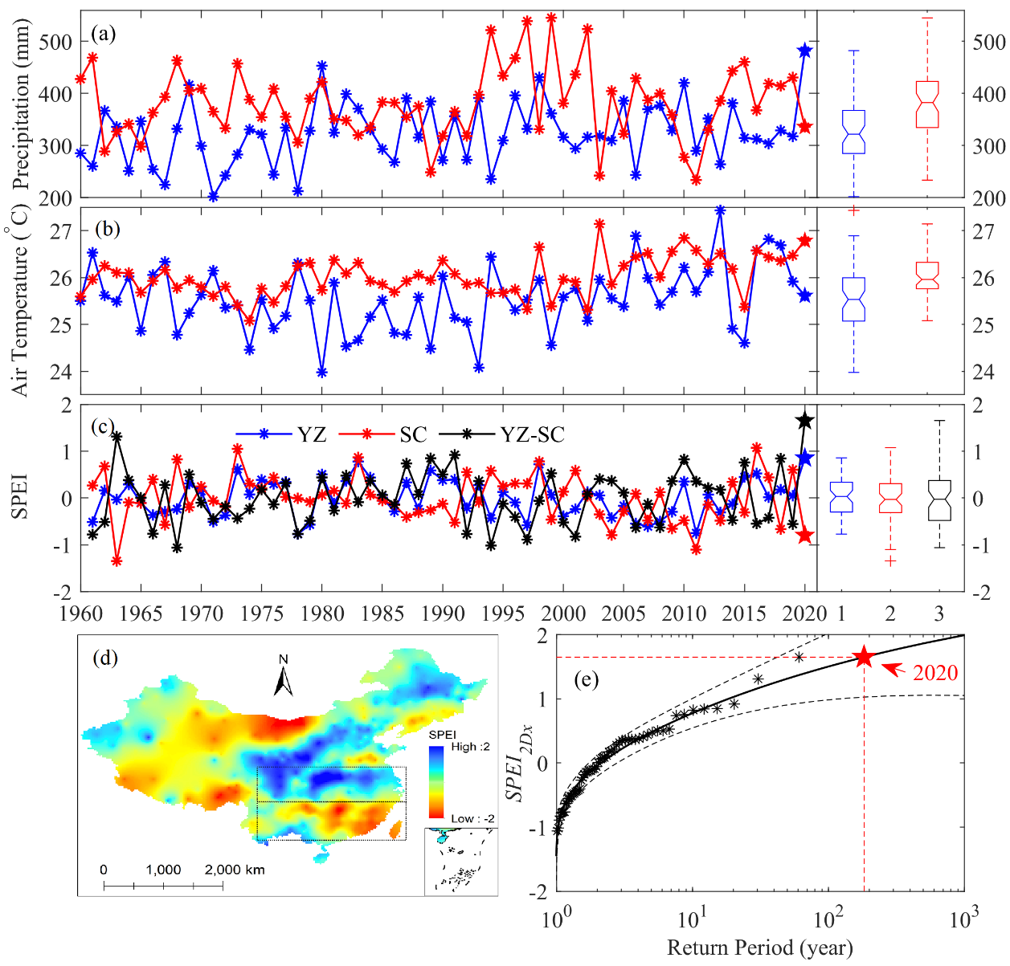Figure 1. (a) Time series of the total precipitation in Yangtze River Basin (YZ) and China's southern coastal regions (SC) during 1970-2020. The subplot is the boxplot of these time series. Each box indicates the 25% and 75%, while the whiskers extend to the last values that are 1.5 times the inter-quartile range above or below the quartiles. (b) Same to (a), but for air temperature. (c) The annual variability of the SPEI of YR (blue line), SC (red line), and the difference between YR and SC (dark line). (d) the spatial pattern of SPEI during July-August 2020 over China. (e) Return periods and 95% confidence intervals for SPEI_{2Dx},, where the red pentacle represent year 2020.

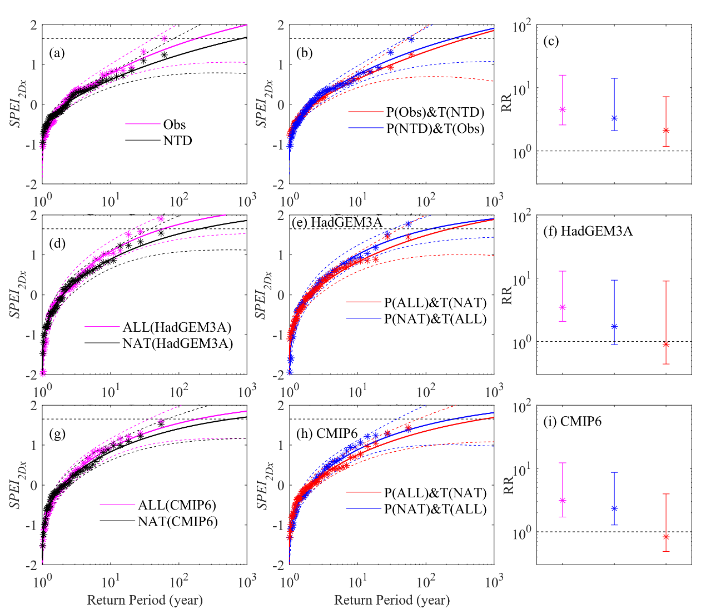
Figure 2. (a-b) Return period distribution of SPEI_{2Dx} calculated by the observed data (Obs, pink line), the data without both precipitation and temperature trends (NTD, dark line), the data without precipitation trend (P(NTD)&T(Obs), red line), and the data without temperature trend (P(Obs)&T(NTD), blue line); (c) showed the probability ratio (RR) of SPEI_{2Dx} due to precipitation, temperature, and their collaborative influence estimated by observation, respectively. (d-e) Return period distributions of SPEI_{2Dx} shifted to the climates of 2020 in HadGEM3A estimated by the data with all forcings (ALL, pink line), the data with natural forcings only (NAT, dark line), the data with ALL but precipitation with NAT (P(NAT)&T(ALL), red line), and the data with ALL but air temperature with NAT (P(ALL)&T(NAT), blue line); (f) showed the probability ratio (RR) of SPEI_{2Dx} due to precipitation, temperature, and their collaborative influence estimated by HadGEM3A. (g-i) as to (d-f), but for CMIP6. The horizontal line in (c) and (d) indicate the 2020 value. Monte Carlo simulations estimate the 2.5%–97.5% uncertainties.

