Towards Near Real-time Attribution of Extreme Weather Events in Aotearoa New Zealand
Jordis S. Tradowsky,^{a,b} Leroy Bird,ª Peter V. Kreft,^{c*} Suzanne M. Rosier,^{d} Iman Soltanzadeh,^{c} Dáithí A. Stone,^{d} Greg E. Bodeker,ª
ª Bodeker Scientific, Alexandra, New Zealand
^{b} Regionales Klimabüro Potsdam, Deutscher Wetterdienst, Germany
^{c} MetService, Meteorological Service of New Zealand Limited, Wellington New Zealand
^{d} NIWA, National Institute of Water and Atmospheric Research, Wellington, New Zealand
* Now retired

Corresponding author: Jordis S. Tradowsky, jordis@bodekerscientific.com

CAPSULE
A consortium, including the National Meteorological Service, is developing an operational capability to evaluate the human contribution to severity and frequency of extreme weather events affecting Aotearoa New Zealand.
- Introduction
The science of extreme weather event (EWE) attribution has developed rapidly since the case study of the European heatwave of 2003 (Stott et al., 2004). Since then, motivated by public and media interest in whether, and to what degree, climate change affects the severity and frequency of these events, significant advances have been made in providing attribution statements in near-real time (e.g., rapid studies by World Weather Attribution (Ciavarella et al., 2020; Vautard et al., 2019) and Otto et al. (2018); Philip et al. (2018)). The Extreme Weather Event Real-time Attribution Machine (EWERAM) project, currently underway in Aotearoa New Zealand (hereafter NZ), aims to provide statements about human-induced changes to the frequency and/or severity of an EWE within days of an event. Recognising the need for a broad range of skills, EWERAM team members have been recruited from research institutions (Bodeker Scientific, NIWA), the National Meteorological Service of New Zealand (MetService) and from academia (Victoria University of Wellington, University of Canterbury). As we work towards making EWERAM operational, MetService's well-established communication channels will be used to publicly disseminate attribution statements. An overarching goal of EWERAM is to enhance the general understanding of NZ’s public as to how climate change is affecting their lives here and now.
In NZ, aside from major earthquakes, intense rainfall events incur the greatest insured losses from natural disasters (ICNZ, 2021). EWERAM thus focuses on extreme precipitation events in addition to temperature related extreme events. Attribution of large-scale EWEs over NZ can be achieved through well-developed approaches that analyse global or regional climate model simulations (Christidis et al., 2014; Philip et al., 2020; Rosier et al., 2015). However, for NZ with its fine-scale topography (mountain ranges rise from sea level to over 3000m within a horizontal distance of about 20km), conducting climate model simulations at the scales required to resolve orographically-forced precipitation extremes is computationally prohibitive. Accordingly, and given available expertise and infrastructure, EWERAM has taken a ‘two-stream’ approach to attribution which (i) assesses changes in the frequency and severity of events using large ensembles of simulations from the weather@home/Australia-NZ project, hereafter weather@home/ANZ (Black et al., 2016), and (ii) diagnoses changes in the severity of EWEs using a more highly-conditioned approach where the large-scale, synoptic circulation underlying the event is prescribed in factual and counterfactual simulations using MetService’s well-tuned Numerical Weather Prediction (NWP) model, which is used for operational predictions of NZ’s weather. The factual simulations represent the extreme event in the climate we currently experience while one counterfactual scenario simulates how the event would have evolved under colder, preindustrial climate conditions. Changes in the severity are typically reported as a percentage change for precipitation and as a total change in degree Celsius for temperature related events, while the change in frequency is reported as a probability ratio pointing out the percentage change this implies.
The generation of a large and diverse set of diagnostics for each target EWE has been automated so that an EWERAM expert group can convene while the event is still of public interest. The group examines these diagnostics, decides which further diagnostics and statistics are required and, once sufficient information for a conclusive analysis has been collected, uses this scientifically defensible foundation as a basis for crafting an attribution statement.
2. Approaches to attribution within EWERAM
An overview of EWERAM's workflow is represented in Figure 1. Once an event is selected, based on expert judgement by MetService meteorologists taking into account public and media interest, the project produces bespoke simulations using the Weather Research and Forecasting (WRF, Skamarock et al., 2019) model and a plethora of diagnostic plots and statistics based on these WRF simulations. In parallel, pre-existing climate model simulations from weather@home/ANZ are analysed for selected regions. Once results from both streams are available, the EWERAM expert group convenes. At least one member from each collaborating institution is required for decision making. The expert group uses analyses of observational data to define the spatial and temporal attributes of the event, to provide historical context to the event and to determine how well the NWP and climate models simulate the target event or class of events. Depending on the outcomes, a decision is made as to whether an attribution statement can be formulated based on pre-calculated statistics, whether further statistics, such as for an updated, carefully chosen event definition, are required prior to making a statement, or whether an attribution assessment is not possible as the methods or models are inadequate. Acknowledging that we will learn with every event analysed, a retrospective assessment following every analysed event enables continual improvements to be made to the processes. The two streams used for attribution within EWERAM are described below.
a. Severity attribution using a numerical weather prediction model
How the severity of an event may have changed can be estimated using simulations from an initialised NWP model configured similar to that described in Reed et al. (2020). At MetService, the WRF model is initialised close to the time of the event using fields from the Global Forecast System (GFS) as boundary conditions. Three WRF-based experiments are defined (see also Fig. 2):
- The factual (here ALL) experiment, which is similar to the operational forecast, but does not assimilate observations.
- The counterfactual, naturalised (here NAT) experiment, in which GFS's sea surface temperature, air temperature, specific humidity and geopotential height are adjusted using the benchmark estimate of the role of total anthropogenic forcing used in the International CLIVAR C20C+ Detection and Attribution Project (Stone et al., 2021).
- The counterfactual ALL+ experiment, in which C20C+ attributable change fields are added to (in contrast to NAT where they are subtracted from) the GFS boundary conditions to test for consistency as suggested in Philip et al. (2020).
For each experiment, in addition to a single deterministic simulation, a 21-member ensemble is initiated. The ALL ensemble is then validated against observations to determine if WRF simulations reproduce the event, which is a prerequisite for any attribution analysis.
b. Severity and frequency attribution using climate model simulations
As EWEs in NZ are affected by changes in large-scale dynamics, we exploit the large attribution ensembles of regional climate model simulations from the weather@home/ANZ project to determine how the likelihood and severity of an event has changed between the factual (natural and anthropogenic forcing included; ALL) and counterfactual (natural forcing only; NAT) realisations using an approach similar to Rosier et al. (2015) and following well-established probabilistic approaches to event attribution. To accommodate any biases in the weather@home/ANZ simulations, we use the return period of the observed event to find the threshold in factual weather@home/ANZ simulations with the same return period (Philip et al., 2020; van Oldenborgh et al., 2021) and then use that threshold in further analyses. We acknowledge, however, the need to extend the analysis to include the use of other climate models (as done e.g. in Philip et al., 2020) to understand the robustness of results.
3. Lessons learned and remaining challenges
While attempting to provide timely attribution statements using expert judgment and modelling infrastructure across several NZ-based organisations has proven challenging, EWERAM has provided insights and advanced our capabilities. For example, we have developed the capability to create factual and counterfactual ensembles using WRF, which may, in addition to their intended use in event attribution prove valuable to drive hydrological models. Recognising that incorporating as many sources of uncertainty as possible is necessary to have confidence in any attribution statement, we have explored how to incorporate physical parameterization uncertainties and numerical scheme uncertainties (see Duda et al., 2016) into the WRF simulations (vertical spread from perturbation schemes in Figure 2). A remaining challenge for incorporating uncertainties into WRF ensembles is to include additional attributable warming estimates to sample across the physically plausible range (horizontal spread resulting from a range of applied deltas within NAT and ALL+ in Figure 2).
Despite the logistic complications entailed, the formulation of attribution statements requires contributions from all areas of expertise within EWERAM achieved by way of expert group meetings. We have learned that availability of a plethora of precalculated diagnostics from model simulations and observations is essential to expert group diagnoses of the characteristic of the target EWE. We have found that the two-stream approach is valuable in gaining a better understanding of climate change's impact on the event. Attribution analyses of several extreme events analysed within EWERAM found no systematic differences in the results obtained from different levels of conditioning (Stone et al., Submitted). While the cross-institutional team is characteristic of EWERAM, we note that the size of the team limits how soon after an event an attribution statement can realistically be agreed upon. We expect the process to become more streamlined as we work through further events.
EWERAM is an ambitious project, and some research questions are yet to be resolved. For example, we need to analyse WRF simulations from further events to decide how we deal with individual ensemble members that do not represent the observed EWE well (see also Figure 2). Another challenge that remains is how best to communicate a coherent public message regarding the attribution of an event when several lines of evidence (see e.g. van Garderen et al., 2021) may result in a nuanced conclusion that cannot easily be digested by non-experts.
4. Conclusion and outlook
EWERAM has developed a system which uses two approaches for event attribution: one based on relatively coarse-resolution climate model simulations which can be analysed using traditional probabilistic approaches to attribution, and one based on much finer-scale simulations using an NWP model constrained to the prevailing synoptic situation which can be used to determine changes in the severity of an event. Analysing simulations for these different levels of conditioning enables analyses of a wider range of events. Looking forward, the goal of EWERAM is to move from the research phase into a pre-operational phase of internal testing, and then to become an operational capability. Achieving this is a challenge in NZ where there is limited financial support for such long-term collaborative activities. Combining the scientific expertise available at research institutions with the operational capabilities of a National Meteorological Service has been a strength of this project. Future delivery of a high-quality timely EWE attribution service that benefits NZ’s public and other stakeholders will require continued support for a team that combines detection and attribution expertise and operational discipline.

Acknowledgments.
The authors would like to thank the NZ Ministry of Business, Innovation and Employment for providing the funding for the EWERAM project under contract BSCIF1801. We would also like to acknowledge the weather@home/ANZ effort which is providing the climate model simulations used in this project.

REFERENCES
Black, M. T. and Coauthors, 2016: The weather@home regional climate modelling project for Australia and New Zealand. Geoscientific Model Development, 9, 3161-3176. doi:10.5194/gmd-9-3161-2016.
Christidis, N., Jones, G. S., and Stott, P. A., 2014: Dramatically increasing chance of extremely hot summers since the 2003 European heatwave. Nature Climate Change, 5(1), 46-50. doi:10.1038/nclimate2468.
Ciavarella, A. and Coauthors, 2020: Prolonged Siberian heat of 2020. World Weather Attribution, Retrieved from https://www.worldweatherattribution.org/wp-content/uploads/WWA-Prolonged-heat-Siberia-2020.pdf
Duda, J. D., Wang, X., Kong, F., Xue, M., and Berner, J., 2016: Impact of a Stochastic Kinetic Energy Backscatter Scheme on Warm Season Convection-Allowing Ensemble Forecasts. American Meteorological Society, 144(5), 1887-1908. doi:10.1175/mwr-d-15-0092.1.
ICNZ. (2021). Insurance Council New Zealand. Retrieved from https://www.icnz.org.nz/natural-disasters/cost-of-natural-disasters
Otto, F. E. L., van der Wiel, K., van Oldenborgh, G. J., Philip, S., Kew, S. F., Uhe, P., and Cullen, H., 2018: Climate change increases the probability of heavy rains in Northern England/Southern Scotland like those of storm Desmond—a real-time event attribution revisited. Environmental Research Letters, 13(2). doi:10.1088/1748-9326/aa9663.
Philip, S. and Coauthors, 2020: A protocol for probabilistic extreme event attribution analyses. Advances in Statistical Climatology, Meteorology and Oceanography, 6(2), 177-203. doi:10.5194/ascmo-6-177-2020.
Philip, S. and Coauthors, 2018: Validation of a Rapid Attribution of the May/June 2016 Flood-Inducing Precipitation in France to Climate Change. Journal of Hydrometeorology, 19(11), 1881-1898. doi:10.1175/JHM-D-18-0074.1.
Reed, K. A., Stansfield, A. M., Wehner, M., and Zarzycki, C. M., 2020: Forecasted attribution ofthe human influence on Hurricane Florence. Science Advances, 6. doi:10.1126/sciadv.aaw9253.
Rosier, S., Dean, S., Stuart, S., Carey-Smith, T., Black, M. T., and Massey, N., 2015: Extreme Rainfall in Early July 2014 in Northland, New Zealand—Was There an Anthropogenic Influence? Bulletin of the American Meteorological Society, 96(12), S136-S140. doi:10.1175/bams-d-15-00105.1.
Skamarock, W. C. and Coauthors, 2019: A Description of the Advanced Research WRF Model Version 4.
Stone, D., and Pall, P., 2021: Benchmark estimate of the effect of anthropogenic emissions on the ocean surface. International Journal of Climatology(41), 3010-3026. doi:10.1002/joc.7002.
Stone, D. A., Rosier, S. M., Bird, L., Harrington, L. J., Rana, S., Stuart, S., and Dean, S. M. (Submitted). The effect of experiment conditioning on estimates of human influence on extreme weather. Submitted to Journal, Weather and Climate Extremes.
Stott, P. A., Stone, D. A., and Allen, M. R., 2004: Human contribution to the European heatwave of 2003. Letters to Nature, 432, 610-614. Retrieved from P:\Admin\Papers\nature\nature03089.pdf
van Garderen, L., Feser, F., and Shepherd, T. G., 2021: A methodology for attributing the role of climate change in extreme events: a global spectrally nudged storyline. Nat. Hazards Earth Syst. Sci., 21. doi:10.5194/nhess-21-171-2021.
van Oldenborgh, G. J. and Coauthors, 2021: Pathways and pitfalls in extreme event attribution. Climatic Change, 166(13). doi:10.1007/s10584-021-03071-7.
Vautard, R. and Coauthors, 2019: Human contribution to the record-breaking July 2019 heat wave in Western Europe. World Weather Attribution, Retrieved from https://www.worldweatherattribution.org/wp-content/uploads/July2019heatwave.pdf

FIGURES
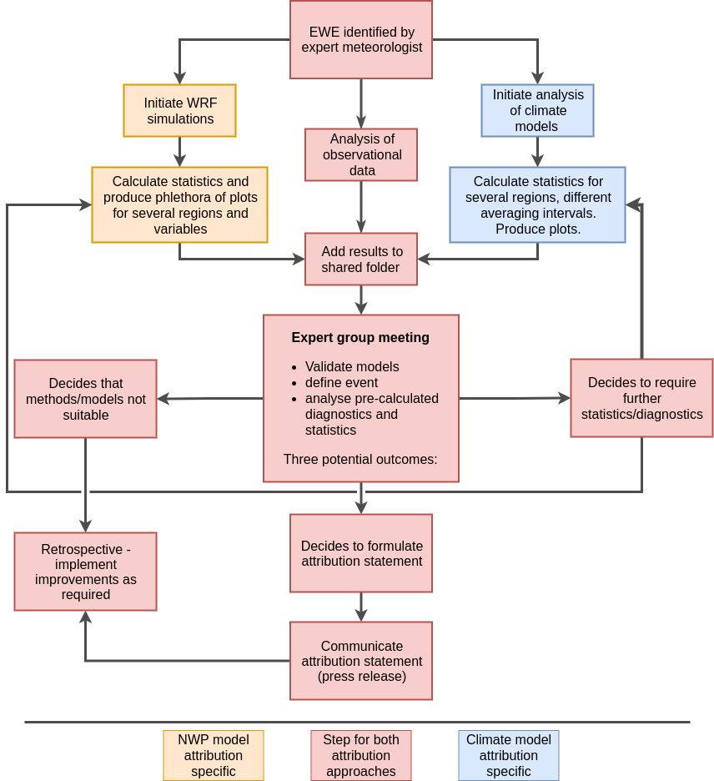
Figure 1: Flowchart of the processes used within EWERAM for EWE attribution.
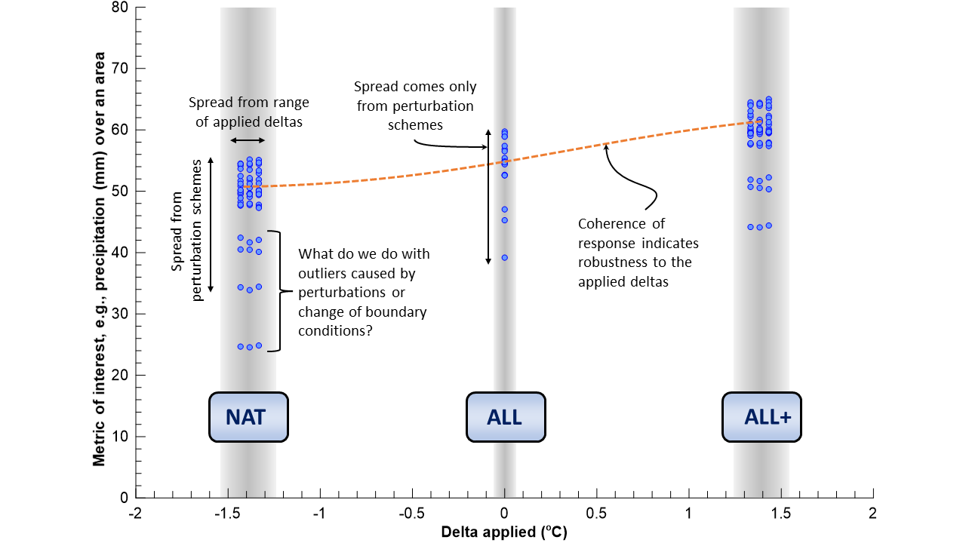
Figure 2: A schematic diagram of the key aspects of severity attribution conducted within EWERAM using three 21-member ensembles of WRF (plus one deterministic run per ensemble). The ALL ensemble represents factual conditions, while the boundary conditions are adjusted by subtracting an attributable warming estimate to mimic naturalised conditions in the counterfactual NAT ensemble. An adjustment in the opposite direction provides the counterfactual ALL+ ensemble that is used as a sanity check. A remaining research question is highlighted. Note that the horizontal spread from a range of applied deltas has not yet been implemented.

