Reduced probability of 2020 June–July persistent heavy Meiyu rainfall event in the mid-lower reaches of the Yangtze River basin under anthropogenic forcing
Haosu Tang^{1, &}, Ziyue Wang^{2, &}, Bin Tang^{1, *}, Yayu Ma³, Lin Pei⁴, Fangxing Tian⁵, Jun Wang⁶, Nergui Nanding⁷, Sarah Sparrow⁸, Simon F. B. Tett⁹, Buwen Dong⁵, Fraser C. Lott¹⁰

¹ State Key Laboratory of Numerical Modeling for Atmospheric Sciences and Geophysical Fluid Dynamics (LASG), Institute of Atmospheric Physics, Chinese Academy of Sciences, Beijing, China / University of Chinese Academy of Sciences, Beijing, China
² Key Laboratory of Meteorological Disaster, Ministry of Education (KLME) / Joint International Research Laboratory of Climate and Environmental Change (ILCEC) / Collaborative Innovation Center on Forecast and Evaluation of Meteorological Disasters (CIC-FEMD), Nanjing University of Information Science and Technology, Nanjing, China
³ Hubei Subsurface Multi-scale Imaging Key Laboratory, Institute of Geophysics and Geomatics, China University of Geosciences, Wuhan, China
⁴ Institute of Urban Meteorology, China Meteorological Administration, Beijing, China
⁵ National Centre for Atmospheric Science, Department of Meteorology, University of Reading, Reading, United Kingdom
⁶ Key Laboratory of Regional Climate‐Environment for Temperate East Asia (RCE‐TEA), Institute of Atmospheric Physics, Chinese Academy of Sciences, Beijing, China
⁷ Guangdong Province Key Laboratory for Climate Change and Natural Disaster Studies, School of Atmospheric Sciences, Sun Yat-sen University, Guangzhou, China
⁸ Oxford e-Research Centre, Department of Engineering Science, University of Oxford, United Kingdom
⁹ School of Geosciences, University of Edinburgh, Edinburgh, United Kingdom
¹⁰ Met Office Hadley Centre, Exeter EX1 3PB, United Kingdom

&These authors contributed equally to this work and should be considered co-first authors.
*Corresponding Author: Bin Tang
Email address: tangbin@mail.iap.ac.cn

Capsule summary
Anthropogenic forcing has approximately halved the probability of 2020 June–July persistent heavy Meiyu rainfall event based on HadGEM3-GA6 simulations without considering the COVID-induced aerosol emission reduction.
Introduction
During June–July (JJ) 2020, the mid-lower reaches of the Yangtze River basin (MLYRB; gray shading in Fig.1a) in China witnessed a persistent heavy rainfall event (termed 2020-Meiyu-event). The total accumulated rainfall over the MLYRB during the period from 11 June to 15 July in 2020 was 87% above the 1981–2010 climatology. With the largest total rainfall amount (759.2 mm) and the longest duration (62 days) of Meiyu season since 1961, this persistent heavy rainfall event threatened ~45.5 million people, with 142 people missing or dead and 29,000 homes destroyed, causing a direct economic loss about 16 billion US dollars (CMA 2021; Wei et al. 2020).
Thus, local inhabitants and policymakers are eager to know whether human-induced climate change played a role in the 2020-Meiyu-event and, if so, to what extent and through what mechanisms. Such knowledge will enable practical adaptation and mitigation planning. Therefore, this study aims to assess the contribution of anthropogenic forcing on the likelihood of 2020-Meiyu-event using the HadGEM3-GA6 attribution system (Ciavarella et al. 2018).
Data and Methods
Gauge-based daily rainfall observations from 2419 meteorological stations in China for 1961–2020 with strict quality control (http://data.cma.cn/) are used in this study. The data is gridded to a horizontal resolution of 1° × 1° by averaging all stations over each grid cell that contains at least one station. Monthly horizontal winds, specific humidity, and sea level pressures (SLP) from the NCEP–NCAR reanalysis (Kalnay et al. 1996) and sea surface temperature (SST) from the Hadley Centre (Rayner et al. 2003) are also used.
The HadGEM3-GA6 model simulations with horizontal grid spacings of 0.56° × 0.83° (Ciavarella et al. 2018) are employed to conduct this attribution analysis. Model simulations are local area averaged into the 1° × 1° grid as in observations. Five sets of simulations (see details in Christidis et al. 2013) are used:
- Historical ensemble, comprising of 15 initial-condition simulation members for 1960–2013, driven by observed SST and sea ice concentration (SIC) with anthropogenic (including anthropogenic aerosols, greenhouse gases, land use and land cover changes) plus natural (volcanic aerosols and solar irradiance) forcings.
- HistoricalExt ensemble which is similar to the Historical ensemble but with 525 members and driven by 2020 SST and SIC boundary conditions.
- HistoricalNatExt ensemble, which differs from HistoricalExt experiment by including only natural forcings and with the 2020 SST and SIC having human influences removed.
- HistoricalExt and HistoricalNatExt ensemble for 2019 which are used to compare the results with those for 2020.
Rx28day is defined as the seasonal maxima of consecutive 28-day total regional-mean rainfall over the MLYRB in June–August and used to measure both the intensity and duration of 2020-Meiyu-event. Anomalous Rx28day is calculated and expressed as a percentage of the 1981–2010 mean (termed Rx28day%; Hoerling et al. 2013), which provides a simple correction of model biases (Figs. ES1a, b; Zhang et al. 2020). The Accumulated Precipitation (AP) averaged over the MLYRB from 20 June to 12 July is also calculated, given that the 2020 Meiyu rainfall was the heaviest during this period (Fig. 1a). The AP index is also transformed into AP%.
The probability density function (PDF) is estimated by the generalized extreme value (GEV) distribution for both the simulations and observations. The two-sample Kolmogorov–Smirnov (K–S) test, probability ratio (PR = P_{ALL}/P_{NAT}), and uncertainty in PR (estimated via bootstrapping; Efron and Tibshirani 1994) are also used. P_{ALL} and P_{NAT} are the occurrence probability of events exceeding the 2020-Meiyu-event threshold in the GEV-fitted HistoricalExt and HistoricalNatExt ensembles, respectively.
Results
Fig. 1a illustrates the spatiotemporal characteristics of the 2020-Meiyu-event. The observed Rx28day is about 60% above the 1981–2010 climatology, surpassing two standard deviations and being about 1-in-60-year event in the 1960–2020 observations (Fig. 1b). The results are similar when the long-term trend is removed (Fig. 1b). The 2020-Meiyu-event is possibly associated with the intensification and westward shift of the Western Pacific subtropical high (WPSH). This transports more water vapor, than normal, from the tropical oceans to feed the persistent heavy Meiyu rainfall (Fig. 1d; Ding et al. 2021).
The model well captures rainband movement in China (Figs. ES1c, d; Burke and Stott 2017) and covers most of the observed range of RX28day% in the MLYRB (Fig. 1b). However, it should be mentioned that the interannual variability of RX28day% is still hard to be well simulated considering the multi-scale feedback processes inherent in the Asian monsoon system. The PDFs of the Rx28day% are similar between model simulations and observations, since they cannot be distinguished at the 0.05 significance level (Fig. 1e). Taken overall, the model can be regarded as reliable for the attribution of 2020-Meiyu-event.
The PDFs of Rx28day% show a clear drying shift from 2020 HistoricalNatExt to HistoricalExt simulations, indicating that rainfall similar to or heavier than 2020-Meiyu-event occurs less frequently due to human-induced climate change (Fig. 2a) and corresponding to increased return periods from the HistoricalNatExt (1-in-31-yr) to HistoricalExt (1-in-55-yr). Anthropogenic forcing has reduced the occurrence probability of the 2020-Meiyu-event from 0.033 (0.023–0.042) for P_{NAT} to 0.018 (0.013–0.024) for P_{ALL}, giving a PR of 0.56 (0.36–0.87). This indicates that anthropogenic forcing has approximately halved the probability of 2020-Meiyu-event, consistent with the results based on 10 models from phase 6 of the Coupled Model Intercomparison Project (CMIP6) in T. Zhou et al. (2021). Similar analysis using AP% gives a PR of 0.63 (0.47–0.93), confirming the robustness of the attribution results (Fig. ES2a, f). These conclusions also hold for a rectangular region (27–34°N, 105–121°E; Fig. ES2a, d; Liu et al. 2020) and when the boundaries are adjusted slightly (Figs. ES2a, b, c, e).
To understand the reduced probability of 2020-Meiyu-event due to anthropogenic forcing, atmospheric circulation differences are analyzed. The East Asian summer monsoon (EASM) index is defined as anomalous SLP difference between 5–15°N, 90–130°E and 22.5–32.5°N, 110–140°E where a positive index means stronger southwesterlies over East Asia. The negative shift of EASM index from 2020 HistoricalNatExt to HistoricalExt simulations shows that anthropogenic forcing leads to a weakening EASM (Fig. 2b). The diﬀerences in JJ mean rainfall and SLP between 2020 HistoricalNatExt and HistoricalExt simulations further show reduced JJ mean rainfall and increased SLP over large areas of East Asia from anthropogenic forcings (Fig. 2c). Further disentangling the weakened EASM suggests that the weakening effect of anthropogenic aerosols on EASM may overwhelm the boosting effect of greenhouse gases, leading to a net effect of reduced probability for 2020-Meiyu-event under anthropogenic forcing (e.g., Lau 2016; Lau and Kim 2017; Dong et al. 2019; T. Zhou et al. 2021). It’s also worth noting that the present-day situations do not indicate the future changes since similar persistent heavy rainfall events are projected to occur more frequently with continuous emissions of greenhouse gas and reductions in aerosols (T. Zhou et al. 2021).
The potential role of year-to-year boundary conditions (SST/SIC) on the risk of 2020-Meiyu-event is next investigated. Since anthropogenic forcing of 2019 and 2020 HistoricalExt simulations are taken from CMIP5 model forcings, the difference between them is negligible. Thus, the primary factor leading to the shift of Rx28day% PDFs (Fig. 2a) are different time evolutions of SST/SIC during two years. The 2020 HistoricalExt PDFs shift toward larger rainfall anomalies compared to those of 2019 (Fig. 2a). Thus, 2020-Meiyu-event is more likely to occur with the time evolutions of SST/SIC in 2020 than those in 2019, with the likelihood increased by about 3 (1.7–8.6) times. PR, relative to HistoricalNatExt, increases from 0.21 (0.08–0.45) in 2019 to 0.56 (0.36–0.87) in 2020, implying a non-linear impact of boundary conditions in this climate versus weather blame game (King et al. 2016; Zhou et al. 2018).
As for possible reasons for changing PR between 2019 and 2020, Takaya et al. (2020) and Z.-Q. Zhou et al. (2021) suggested that the positive Indian Ocean Basin Mode (IOBM) in the 2020 El Niño decaying summer (Fig. 2e) evolving from positive Indian ocean dipole in 2019 (Fig. 2f) as the mechanism, which intensified the WPSH through atmospheric wave responses. The central Pacific El Niño in the 2019 El Niño developing summer (Fig. 2f) is not in favor of the simultaneous rainfall in the MLYRB (Xu et al. 2020). Enhanced WPSH and rainfall at its northern flank from 2019 to 2020 HistoricalExt simulations (Fig. 2d) further suggest that different time evolutions of SST/SIC during two years may modulate atmospheric circulation and therefore the PR of 2020-Meiyu-event between 2019 and 2020. Besides, it’s worth mentioning that natural variability like El Niño may be modulated in frequency and intensity by anthropogenic forcing (e.g., Yeh et al. 2018; Hu et al. 2021). Therefore, the non-linear feedback between "natural variability" and "anthropogenic forced" changes cannot be neglected, too.
Conclusions
Through comparison between 2020 HistoricalNatExt and HistoricalExt ensemble, this study suggests that anthropogenic forcing has approximately halved the probability (13%–64%) of 2020-Meiyu-event in the MLYRB, likely related to a weaker EASM arising from anthropogenic, probably aerosol forcings (Dong et al. 2019). The attribution results are robust against different extreme rainfall indices or small changes to the study region. Through comparison between 2019 and 2020 HistoricalExt ensemble, this study further indicates that the time evolutions of SST/SIC in 2020 has increased the likelihood of 2020-Meiyu-event by about 3 (1.7–8.6) times compared to 2019. One caveat of this study is that model simulations do not consider the COVID-induced aerosol emission reduction in 2020, which is speculated to enhance the Asian summer monsoon (e.g., Fadnavis et al., 2021). To what extent did the COVID-19 influence the 2020-Meiyu-event still needs future detailed numerical experiments.
Acknowledgements
The virtual event attribution workshop, at which most of the research was done for this paper, was funded by the UK–China Research & Innovation Partnership Fund through the Met Office Climate Science for Service Partnership (CSSP) China as part of the Newton Fund, the National Natural Science Foundation of China (42025503) and the National Key R&D Program of China (2018YFA0605604). HT, ZW and JW were funded by the National Key R&D Program of China (2018YFC1507700). HT was also funded by the National Natural Science Foundation of China (41775086). ZW was also funded by Jiangsu postgraduate scientific research innovation program (KYCX21_0941) and the Natural Science Foundation of China (41975105). BT was funded by the National Natural Science Foundation of China (41861144014). YM was funded by the National Natural Science Foundation of China (U2033207). NN was funded by the National Natural Science Foundation of China (41905101, 41975113, and 41861144014). FT, SS, SFBT, BD and FCL were funded by the UK–China Research and Innovation Partnership Fund through the Met Office CSSP China as part of the Newton Fund.
References
Burke, C., and P. Stott, 2017: Impact of anthropogenic climate change on the East Asian summer monsoon. J. Clim., 30, 5205–5220.
Christidis, N., and Coauthors, 2013: A New HadGEM3-A-Based System for Attribution of Weather- and Climate-Related Extreme Events. J. Clim., 26, 2756–2783.
Ciavarella, A., and Coauthors, 2018: Upgrade of the HadGEM3-A based attribution system to high resolution and a new validation framework for probabilistic event attribution. Wea. Climate Extremes, 20, 9–32.
CMA, 2021: China Climate Bulletin 2020. China Meteorological Administration, 54 pp.
Ding, Y., Y. Liu, and Z.-Z. Hu, 2021: The Record-breaking Meiyu in 2020 and Associated Atmospheric Circulation and Tropical SST Anomalies. Adv. Atmos. Sci., 1–14
Dong, B., L. J. Wilcox, E. J. Highwood, and R. T. Sutton, 2019: Impacts of recent decadal changes in Asian aerosols on the East Asian summer monsoon: Roles of aerosol–radiation and aerosol–cloud interactions. Climate Dyn., 53, 3235–3256.
Efron, B., and R. Tibshirani, 1994: An introduction to the bootstrap. CRC press.
Fadnavis, S., T. P. Sabin, A. Rap, R. Müller, A. Kubin, and B. Heinold, 2021: The impact of COVID-19 lockdown measures on the Indian summer monsoon. Environ. Res. Lett., 16, 074054.
Hoerling, M., and Coauthors, 2013: Anatomy of an extreme event. J. Clim., 26, 2811-2832.
Hu, K., G. Huang, P. Huang, Y. Kosaka, and S.-P. Xie, 2021: Intensification of El Niño-induced atmospheric anomalies under greenhouse warming. Nat. Geosci., 14, 377–382.
Kalnay, E., and Coauthors, 1996: The NCEP/NCAR 40-Year Reanalysis Project. Bull. Amer. Meteor. Soc., 77, 437–471.
King, A. D., G. J. van Oldenborgh, and D. J. Karoly, 2016: Climate change and El Niño increase likelihood of Indonesian heat and drought. Bull. Amer. Meteor. Soc., 97, S113 –S117.
Lau, W. K. M., 2016: The Aerosol-Monsoon Climate System of Asia: A New Paradigm. J. Meteor. Res., 30, 1–11.
Lau, W. K. M., and K. M. Kim, 2017: Competing influences of greenhouse warming and aerosols on Asian summer monsoon circulation and rainfall. Asian Pacific. J. Atmos. Sci., 53, 181–194.
Liu, B., Y. Yan, C. Zhu, S. Ma, and J. Li, 2020: Record‐Breaking Meiyu Rainfall Around the Yangtze River in 2020 Regulated by the Subseasonal Phase Transition of the North Atlantic Oscillation. Geophys. Res. Lett., 47, 22.
Rayner, N., and Coauthors, 2003: Global analyses of sea surface temperature, sea ice, and night marine air temperature since the late nineteenth century. J. Geophys. Res. Atmos., 108, 4407.
Takaya, Y., I. Ishikawa, C. Kobayashi, H. Endo, and T. Ose, 2020: Enhanced Meiyu‐Baiu Rainfall in Early Summer 2020: Aftermath of the 2019 Super IOD Event. Geophys. Res. Lett., 47, 22.
Wei, K., and Coauthors, 2020: Reflections on the Catastrophic 2020 Yangtze River Basin Flooding in Southern China. Innov., 2, 100038.
Xu, K., H.-Y. Miao, B. Liu, C.-Y. Tam, and W. Wang, 2020: Aggravation of record-breaking drought over the mid-to-lower reaches of the Yangtze River in the post-monsoon season of 2019 by anomalous Indo-Pacific oceanic conditions. Geophys. Res. Lett., 47, e2020GL090847.
Yeh, S.-W. and Coauthors, 2018: ENSO atmospheric teleconnections and their response to greenhouse gas forcing. Rev. Geophys., 56, 185–206.
Zhang, W., and Coauthors, 2020: Anthropogenic inﬂuence on 2018 summer persistent heavy rainfall in central western China. Bull. Amer. Meteor. Soc., 101, S65–S70.
Zhou, C., K. Wang, and D. Qi, 2018: Attribution of the July 2016 extreme precipitation event over China’s Wuhan. Bull. Amer. Meteor. Soc., 99, S107–S112.
Zhou, T., L. Ren, W. Zhang, 2021: Anthropogenic influence on extreme Meiyu rainfall in 2020 and its future risk. SCIENCE CHINA: Earth Sciences. In press
Zhou, Z.-Q., S.-P. Xie, and R. Zhang, 2021: Historic Yangtze flooding of 2020 tied to extreme Indian Ocean conditions. Proc. Natl. Acad. Sci., 118, 12.
Figure Captions:
Fig. 1. (a) Observed Accumulated Precipitation (AP) anomalies (mm) during JJ 2020, with inset showing the daily rainfall evolution of which dashed green line for the mean value, green curve for 7-day running average, and blue dots for the daily climatology. (b) Time series of regional mean Rx28day% for observations (bar) and Historical simulations (red line and pink shading). (c) Return periods of observed Rx28day% in GEV fit with 90% uncertainty range, with red star for the 2020 event and blue circles for other years. (d) Anomalies of SLP (shading; Pa) and column-integrated water vapor flux (vectors; kg∙m⁻¹∙s⁻¹) during JJ 2020. The MLYRB is highlighted in red. (e) PDFs of Rx28day% for observations (blue) and Historical simulations (red) with p value for K–S test.
Fig. 2. (a) The PDFs of Rx28day% for HistoricalExt (red) and HistoricalNatExt (blue) simulations in 2019 (dashed) and 2020 (solid). The dotted black line denotes the observed 2020 event. (b) The PDFs of EASM index, calculated by JJ mean anomalous SLP difference (Pa) between blue and green box (e and f) for 2020 HistoricalExt (red) and HistoricalNatExt (blue) simulations. (c) Ensemble mean differences of JJ mean precipitation (shadings, mm∙day⁻¹) and SLP (contours, Pa) between 2020 HistoricalExt and HistoricalNatExt simulations. Dots denote the region with 5% significance level, and MLYRB is highlighted in red. (d) same as (c) except for differences between 2020 and 2019 HistoricalExt simulations. (e) 2020 and (f) 2019 JJ mean SST anomalies (°C) relative to the climatology of 1981–2010.
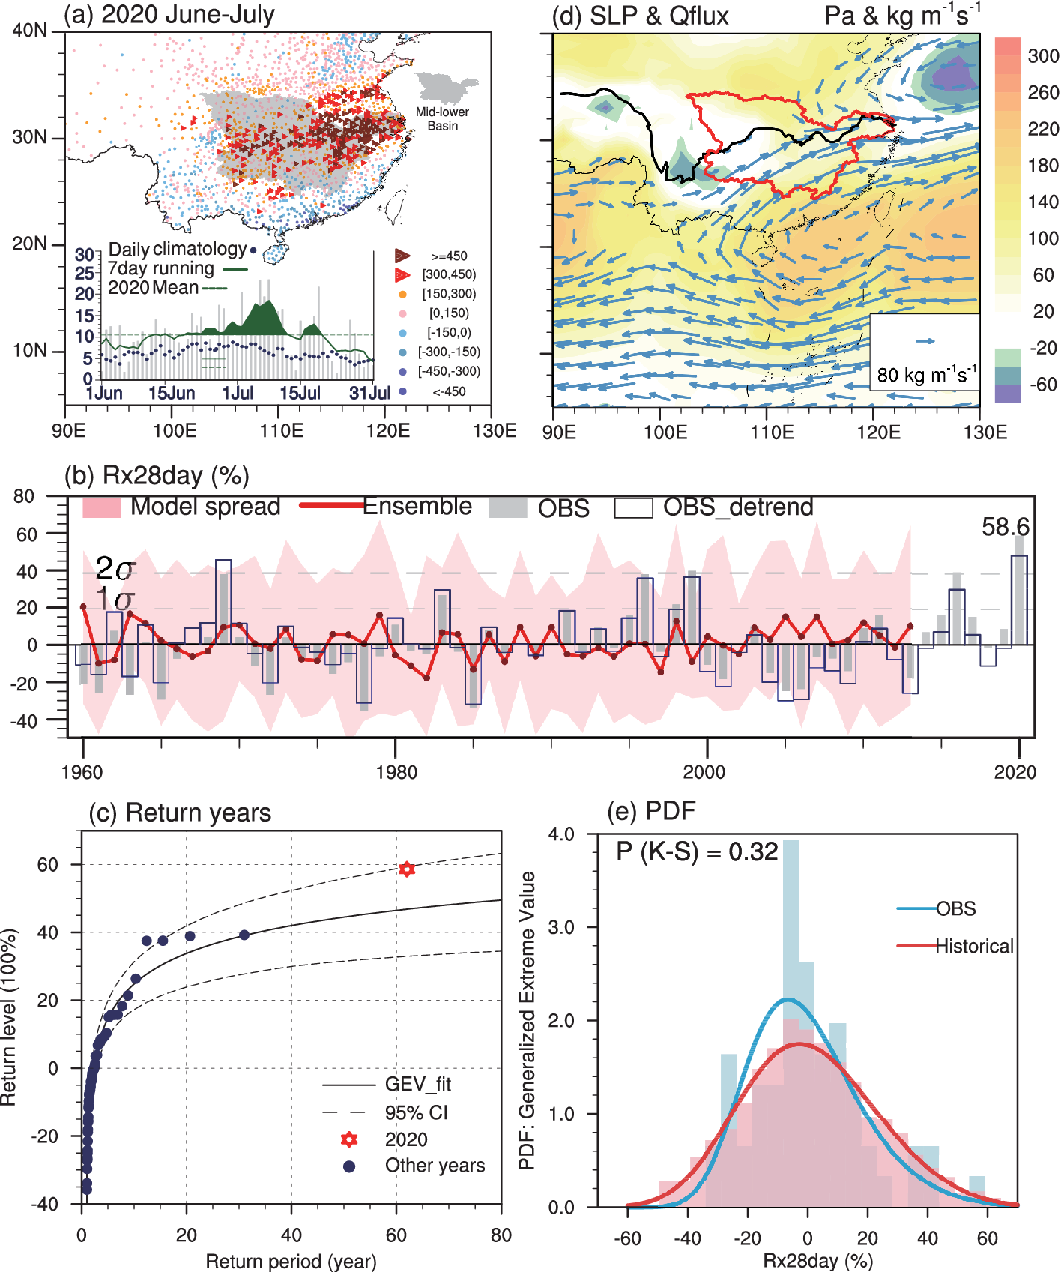
Fig. 1. (a) Observed Accumulated Precipitation (AP) anomalies (mm) during JJ 2020, with inset showing the daily rainfall evolution of which dashed green line for the mean value, green curve for 7-day running average, and blue dots for the daily climatology. (b) Time series of regional mean Rx28day% for observations (bar) and Historical simulations (red line and pink shading). (c) Return periods of observed Rx28day% in GEV fit with 90% uncertainty range, with red star for the 2020 event and blue circles for other years. (d) Anomalies of SLP (shading; Pa) and column-integrated water vapor flux (vectors; kg∙m⁻¹∙s⁻¹) during JJ 2020. The MLYRB is highlighted in red. (e) PDFs of Rx28day% for observations (blue) and Historical simulations (red) with p value for K–S test.
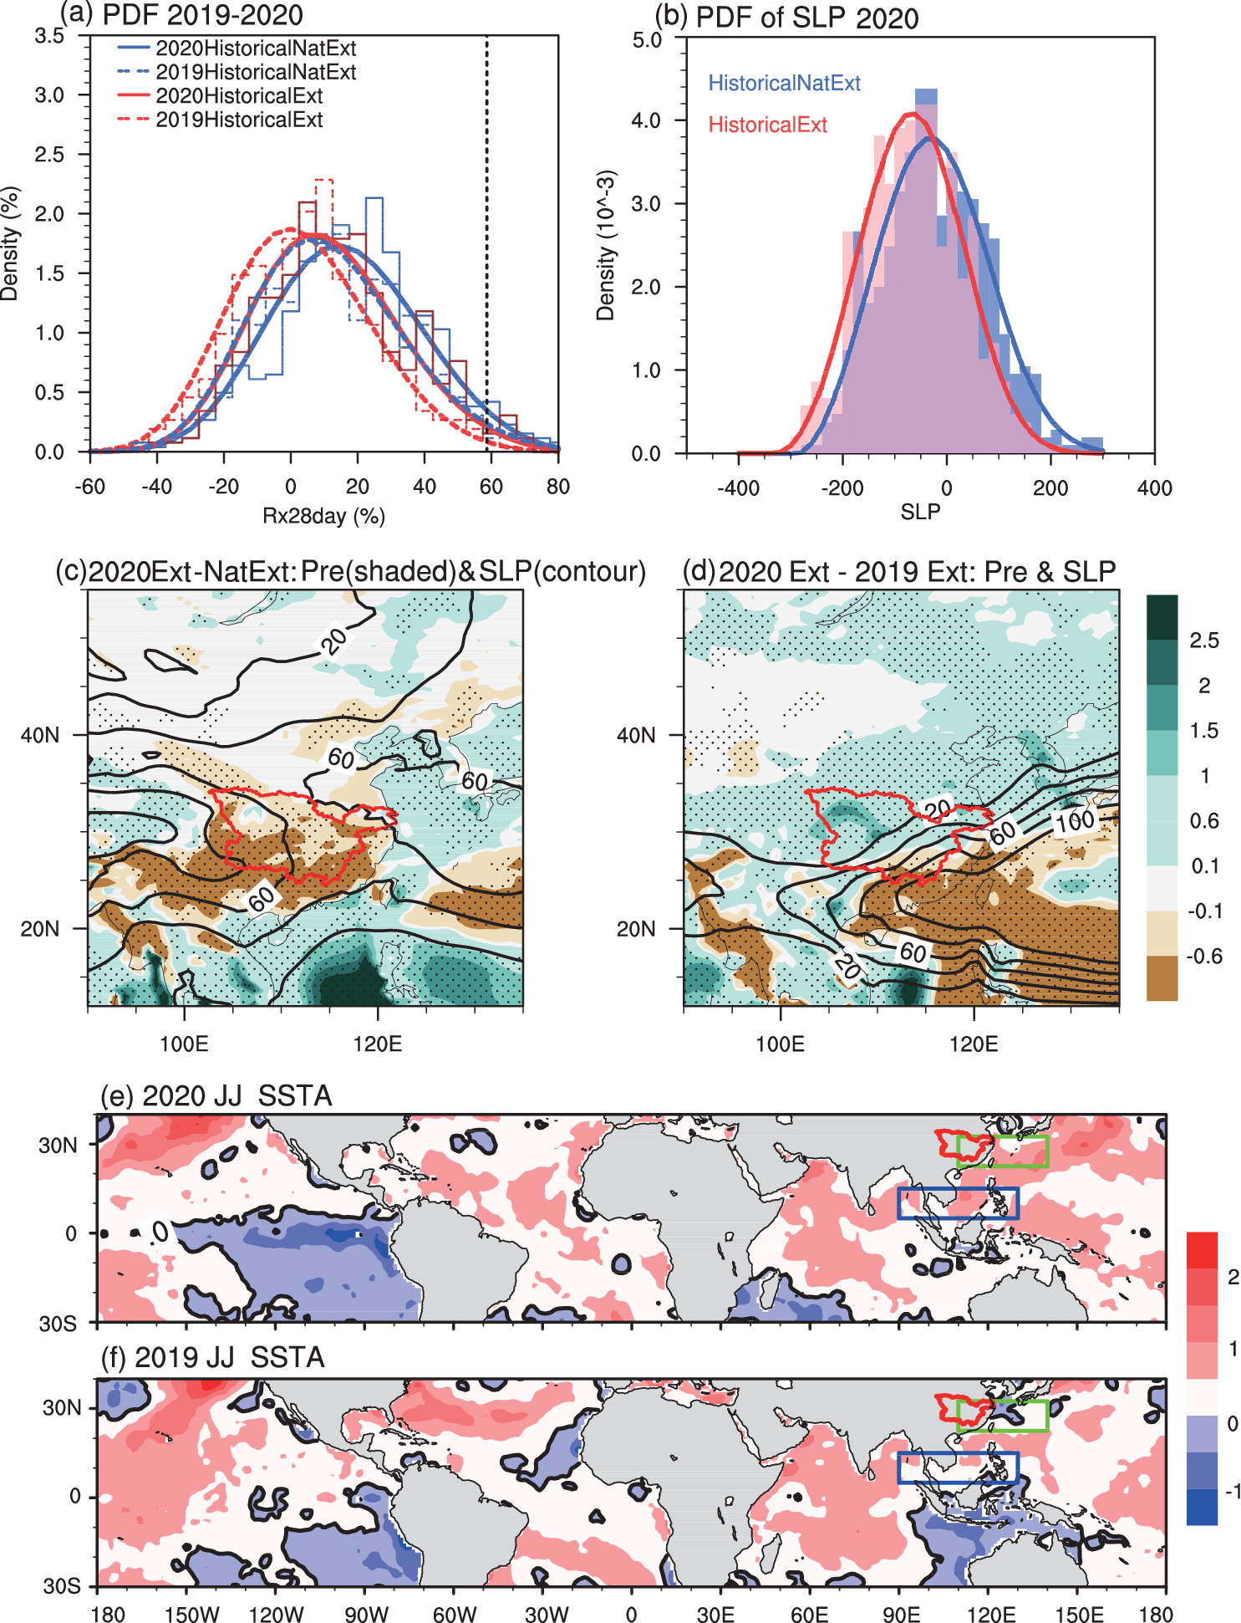
Fig. 2. (a) The PDFs of Rx28day% for HistoricalExt (red) and HistoricalNatExt (blue) simulations in 2019 (dashed) and 2020 (solid). The dotted black line denotes the observed 2020 event. (b) The PDF of 2020 EASM index, calculated by JJ mean anomalous SLP difference (Pa) between blue and green box (e and f) for 2020 HistoricalExt (red) and HistoricalNatExt (blue) simulations. (c) Ensemble mean differences of JJ mean precipitation (shadings, mm∙day⁻¹) and SLP (contours, Pa) between 2020 HistoricalExt and HistoricalNatExt simulations. Dots denote the region with 5% significance level, and MLYRB is highlighted in red. (d) same as (c) except for differences between 2020 and 2019 HistoricalExt simulations. (e) 2020 and (f) 2019 JJ mean SST anomalies (°C) relative to the climatology of 1981–2010.

