The 2020 record-breaking Meiyu in the Yangtze River Valley of China: The role of anthropogenic forcing and atmospheric circulation

Chunhui Lu¹, Ying Sun^{1, 2*}, Xuebin Zhang³

1. National Climate Center, Laboratory for Climate Studies, China Meteorological Administration, Beijing 100081, China
2. Collaborative Innovation Center on Forecast and Evaluation of Meteorological Disasters, Nanjing University of Information Science and Technology, Nanjing, 210044, China.
3. Climate Research Division, Environment and Climate Change Canada, Toronto, Canada

*Corresponding Author:
Ying Sun
Address: National Climate Center, China Meteorological Administration, Beijing, China
Email address: sunying@cma.gov.cn

Capsule:
Anthropogenic forcing has likely reduced the probability of the 2020 June-July Meiyu in the Yangtze River Valley by approximately 54%; however, the anomalous circulation of 2020 favored the occurrence of heavy precipitation.
Introduction
The Chinese Meiyu is a period of intense precipitation during the East Asian rainy season, and typically provides the majority of June-July precipitation in the Middle-Lower Yangtze River Valley (YRV) (Ding and Chan 2005). In 2020, the YRV experienced a record-breaking Meiyu, characterized by a heavy and persistent precipitation, a wide meridional rain belt and frequent heavy rainstorms (Ding et al. 2021). The June-to-July total precipitation amount in the Meiyu region was about 672 mm, 99% more than the 1961-1990 average and the highest on record since 1960 in the region. The Meiyu lasted for 62 days, with 74 stations experiencing record-breaking total precipitation amount and over 600 rivers across China exceeding their warning water levels (CMA 2021a). The resulting disasters, including flooding and landslides, affected more than 30 million people and 3.58 million hectares crops in the YRV, resulting in a direct economic loss about 132.2 billion Chinese Yuan (CMA 2021b).

A few studies have investigated the circulation pattern of the 2020 Meiyu and the possible drivers of it. The anomalous persistent Western North Pacific Subtropical High (WNPSH) and the southwesterly jet on its western side was found to be the dominant circulation pattern during this event, which was caused by both La Niña-like sea surface temperature (SST) anomaly in the equatorial Pacific and warm SST anomaly in the tropical Indian Ocean (Liu and Ding 2020; Ding et al. 2021; Pan et al. 2021). The Tibetan Plateau vortices (TPVs) may be another possible contributor by transforming the positive vorticity into troughs and moving eastward to modulate the precipitation in the YRV (Li et al. 2021). These studies suggest the important role of natural factors internal to the climate system including SST variation in the 2020 Meiyu. However, the role of anthropogenic external forcing in the summer 2020 Meiyu has not been extensively evaluated. Previous studies (Li et al. 2018; Zhou et al. 2018) have shown that the strong El Niño of 2015-2016 may account for the extreme precipitation event in the YRV during 2016 summer while anthropogenic effects can be only found on smaller spatial scales. A few studies (Burke and Stott 2017; Lu et al. 2020; Li et al. 2020) proposed that human-induced warming and natural variation played important roles in the changes in intensity and frequency of extreme precipitation in the YRV. Here, we investigate how externally forced factors and synoptic circulation conditions may have affected the 2020 Meiyu event based on the Coupled Model Intercomparison Project Phase 6 (CMIP6, Eyring et al. 2016) simulations.

Data and Methods
The Meiyu region (28º-34º N, 110º-122.5º E, black box in Figure 1a) defined by China Meteorological Administration (CMA 2017) was selected as the key study region. Daily precipitation data at 414 stations in the region for 1960-2020 were extracted from a homogenized observational dataset developed by China National Meteorological Information Center (Yang and Li 2014). Two metrics, including percentage precipitation anomaly (PPA) and maximum five-consecutive-day precipitation anomaly (RX5day, relative to the 1961–1990 average) from June to July were used to describe different characteristics of 2020 Meiyu. The observed precipitation and RX5day at each station were first averaged onto the grid boxes of 2° × 2° and then averaged to obtain the area-weighted regional mean precipitation in the Meiyu region. The PPA was then calculated by the anomaly of regional mean precipitation divided by the 1961-1990 average. The NCEP/NCAR reanalysis data (Kalnay et al. 1996) were used for the investigation of atmospheric circulation changes, including 500-hPa geopotential height (Z500) and 850-hPa zonal and meridional winds (UV850).

For the model results, PPA and RX5day were calculated similar to observation based on 53 runs of nine CMIP6 models under historical (natural + anthropogenic) forcings (ALL) and 49 runs under natural-only (NAT) forcing, respectively (Table S1). We extended the historical ALL forcing runs to 2030 with the SSP2-4.5 (Shared Socioeconomic Pathways) scenario (2015-2030). The SSTs, atmospheric and land conditions of CMIP simulations are not synchronous with observations, therefore using CMIP simulations to evaluate a specific year is not possible. Thus, we selected the period of 2001-2020 as present-day climate. We didn’t select period (2011-2030) centered on the year of the event, as the NAT-forcing run end in 2020. This slightly affects our attribution results. Given the small recent trends in precipitation in Meiyu region (Ding et al. 2020), the recent two decades (2001-2020) reasonably represent current climatic conditions, as also assumed in other studies (Christidis and Stott 2015).

To estimate the anthropogenic influence on the 2020 Meiyu, we calculated the probabilities of events exceeding the threshold of 2020-like Meiyu for the ALL and NAT forcing experiments, i.e., with (P_{ALL}) and without (P_{NAT}) the effect of anthropogenic influence. The 2020 thresholds for both PPA (99.6%) and Rx5day (71.2 mm) were firstly adjusted by the method used in Sun et al. (2018) because the limitations of current generation of climate models to reproduce the very heavy precipitation (details in supplemental material). The adjusted thresholds for PPA and Rx5day are 51.2% and 57.1 mm respectively. The Kernel Density Estimation (KDE) was used to estimate the probability density distribution, which has been proved to be suitable to estimate the probability density functions (PDFs) of precipitation event (Ma et al. 2017; Lu et al. 2021). The probability ratio (PR) was then defined as PR_Anthro = P_{ALL} / P_{NAT}. Uncertainties in PR were obtained using 1000 bootstraps, with PR computed for each bootstrap realization (Christidis et al. 2015).

To estimate the effects from atmospheric circulation, the method suggested by Christidis and Stott (2015) was used. We first selected the key circulation region that dominate this Meiyu event in the observation, i.e., the WNPSH region as shown in Figure 1e. The anomalous WNPSH has been confirmed as the key circulation pattern driving the 2020 Meiyu, and reflects the joint influence from the anomalous SSTs in the equatorial Pacific and Indian Ocean (Pan et al. 2021). Then we partitioned simulated June-July Z500 from all models and years (2001-2020) under ALL forcing into two groups (Table S2): one that is highly correlated (correlation coefficients above 0.7) with the observed Z500 in 2020 over the key WNPSH region, and one that is less correlated (correlation coefficients below 0.7) with observed Z500. For these two high-correlation and low-correlation groups, the probabilities of events exceeding the 2020-like threshold value (P_{High} and P_{Low}) were calculated respectively based on KDE. The probability ratio (PR) for the circulation effects was defined as PR_Circ = P_{High} / P_{Low}. Uncertainties in PR was estimated as those used in the analysis for the anthropogenic influence. We also conducted sensitivity test for different coefficients from 0.6 to 0.8, and found negligible influence on the final results (Figure S2a).

Results
Figure 1a shows that the observed June-July positive PPA was centered in the YRV. In the Meiyu region, the PPA in most stations were more than 50% and 74 stations experienced the record-breaking precipitation. The RX5day anomaly at nearly half of the stations were greater than 100 mm, with the maximum value reaching 435.5 mm. Figures 1c and 1d show the temporal evolutions of observed and model simulated PPA and RX5day anomalies over the Meiyu region from June to July. It is apparent that June-July 2020 was the wettest on record since 1960, with PPA and RX5day both reaching the highest values. This extreme precipitation was associated with the low-level southwesterly winds on the western side of the WNPSH, which continuously transport water vapor into the YRV (Figure 1e). Figure 1f displays the model ensemble mean of Z500 and UV850 in June-July from the high-correlation group during the current climate state of 2001-2020 under ALL experiments. The extended WNPSH and the obvious southwesterly flow on its western side, which is similar to the observed circulation pattern, provide favorable conditions for heavy precipitation events.

Figures S1a and S1b show the histogram and KDE estimate of the probability distribution of the observed and simulated June-July PPA and RX5day anomalies during 1960–2014. The models reasonably simulate the probability distribution for PPA and RX5day over the Meiyu region, with quite similar shapes between observation and models. Figures S1c and S1d show the p-values from Kolmogorov-Smirnov tests that compare the observed distribution with multi-model ensemble and individual models. The agreement remains good for both PPA and RX5day when models are tested individually. This suggests that the models can be used to conduct the attribution analyses.

To investigate human influence on the Meiyu event, we compared the CMIP6 model experiments under ALL and NAT forcings. For PPA, the PDF shift towards a drier condition under ALL forcing relative to NAT forcing (Figure 2a), suggesting a decrease of probability of such persistent heavy precipitation events over the YRV due to human influence. The probability of the 2020-like event defined by PPA (51.2%) is around 1.78% (90% confidence interval: 1.28%-2.38%) in the ALL ensemble, while in the NAT ensemble the probability increases to 3.29% (2.56%-4.12%). This gives a probability ratio of 0.54 (0.36-0.81). For the RX5day, the PDF almost does not show any change for both experiments. The probability ratio for the 2020-like RX5day anomaly (57.1 mm) is 0.95 (0.5-1.61), indicating little anthropogenic influence on this metric. Previous studies proposed two competing effects of anthropogenic forcing on the precipitation in East Asia. One is the effect of increased moisture caused by global warming (Trenberth et al. 2003) and the other is the cooling effect induced by the increased anthropogenic aerosols. The latter could weaken the thermal differences between land and ocean, and thus reduce the East Asian summer monsoon (EASM), decreasing the likelihood of persistent heavy precipitation (Song et al. 2014; Li et al. 2015; Rimi et al. 2019). Therefore, for the June-July PPA that mostly represents the persistent precipitation, anthropogenic forcing have likely reduced the probability of the similar events. But for the extreme rainfall (RX5day), the aerosol effects may be counteracted by the increased moisture induced by global warming, resulting in weak anthropogenic signal in quantitative analyses (Zhang et al. 2019).

We then analyzed the effect of circulation pattern on this event. We compared the PDF_{S} of simulated precipitation between high- and low-correlation groups under ALL forcing (Figure 2b, d). Both PPA and RX5day results show that the anomalous circulation increases the chance of heavy precipitation occurring. The PDFs of high correlation group shift towards a wetter regime compared with those for the low correlation group. The Kolmogorov-Smirnov test shows that the distributions from high- and low-correlation groups are significantly separated as the p-values are near-zero. The probability of the 2020-like PPA event is around 2.9% (with 90% confidence interval 1.7%-4.0%) in the high-correlation ensemble, while it decreases to 1.2% (0.6%-1.7%) in the low-correlation ensemble. This gives a probability ratio of 2.3 (1.2-5.2). For RX5day, the PDF shifts towards wetter regime in the high-correlation ensembles, with the occurrence probability increasing about 3.2 (1.3-5.6) times compared with that from the low-correlation group. This indicates the influence of persistent circulation on this Meiyu event. Further analyses indicate that these results are insensitive to the selection of critical area, as long as the southwesterly jet on the western side of the WNPSH is included in the area (Figure S2b).

Conclusions
For the 2020 record-breaking Meiyu, we analyzed both PPA and RX5day based on observations and CMIP6 models. We found that human influence tends to reduce the probability of PPA that represents the persistent precipitation, but have insignificant impacts on the RX5day that represents extreme heavy rainfall. The probability of the 2020-like persistent precipitation has decreased by about 54% under anthropogenic forcing, which is consistent with previous studies based on CMIP5 models and other large-ensemble models (Zhang et al. 2019; Li et al. 2021). However, we should keep in mind that the adjusted threshold for this event may cause the inaccurate estimate of the probability changes. For the effects of circulation pattern, the prevailing flow pattern along the WNPSH has increased the occurrence probability of 2020-like PPA and RX5day by about 2.3-fold and 3.2-fold, respectively. As the key circulation system for the 2020 Meiyu, the anomalous strong WNPSH was jointly affected by the SST in the equatorial Pacific and Indian Ocean, which reflects important role of the SST changes. Though the CMIP6 models generally are able to simulate the long-term warming in the Pacific and Indian Ocean, more detailed analyses about SST influence are needed in the future. Especially, understanding different roles of anthropogenic forcing and internal fluctuation of ocean in the SST changes could help separate the contribution from the different factors to the occurrence of precipitation.

Acknowledgements
This study was supported by the National Natural Science Foundation of China (42025503 and 41775082) and the National Key Research and Development Program of China (2018YFA0605604).

REFERENCES
Burke, C., and P. A. Stott, 2017: Impact of anthropogenic climate change on the East Asian summer monsoon. J. Climate, 30, 5205–5220, https://doi.org/10.1175/JCLI-D-16-0892.1.
Christidis, N., and P. A. Stott, 2015: Extreme rainfall in the United Kingdom during winter 2013/14: the role of atmospheric circulation and climate change. Bull. Am. Meteorol. Soc., 93, https://doi.org/10.1175/BAMS-D-15-00094.1.
Christidis, N., P. A. Stott, F. W. Zwiers, 2015: Fast-track attribution assessments based on pre-computed estimates of changes in the odds of warm extremes. Climate. Dyn., 45, 1547–1564, https://doi.org/10.1007/s00382-014-2408-x.
CMA, 2017: GB/T33671: Meiyu monitoring indices. Beijing: Standards Press of China (in Chinese).
CMA, 2021a: China Climate Bulletin 2020 (in Chinese with English abstract). China Meteorological Administration, 54 pp.
CMA, 2021b: Yearbook of Meteorological Disasters in China 2020 (in Chinese with English abstract). China Meteorological Administration, in press.
Ding, Y., and J. Chan, 2005: The East Asian summer monsoon: An overview. Meteorol. Atmos. Phys., 89, 117−142, https://doi.org/10.1007/s00703-005-0125-z.
Ding, Y., P. Liang, Y. Liu and Y. Zhang, 2020: Multiscale variability of Meiyu and its prediction: a new review. J. Geophys. Res. Atmos., 125, https://doi.org/10.1029/ 2019JD031496.
Ding, Y., Y. Liu and Z. Hu, 2021: The record-breaking Meiyu in 2020 and associated atmospheric circulation and tropical SST anomalies. Adv. Atmos. Sci., https://doi.org/10.1007/s00376-021-0361-2.
Eyring, V., S. Bony, G. A. Meehl, and Coauthors, 2016: Overview of the Coupled Model Intercomparison Project Phase 6 (CMIP6) experimental design and organization. Geosci. Model Dev., 9, 1937–1958, https://doi.org/10.5194/gmd-9-1937-2016.
Kalnay, E., and Coauthors, 1996: The NCEP/NCAR 40-Year Reanalysis Project. Bull. Amer. Meteor. Soc., 77, 437–471, https://doi.org/10.1175/1520-0477 (1996) 077<0437: TNYRP>2.0.CO;2.
Li, X., M. Ting, C. Li, and N. Henderson, 2015: Mechanisms of Asian summer monsoon changes in response to anthropogenic forcing in CMIP5 models. J. Climate, 28, 4107–4125, https://doi.org/10.1175/ JCLI-D-14-00559.1.
Li, C., and Coauthors, 2018: Attribution of extreme precipitation in the lower reaches of the Yangtze River during May 2016. Environ. Res. Lett., 13, 014015, https://doi.org/10.1088/1748-9326/aa9691.
Li, R., and Coauthors, 2021: Anthropogenic influences on heavy precipitation during the 2019 extremely wet rainy season in Southern China. Bull. Amer. Meteor. Soc., https://doi.org/10.1175/BAMS-D-20-0135.1.
Li, X., K. Zhang, P. Gu, et al., 2021: Changes in precipitation extremes in the Yangtze River Basin during 1960-2019 and the association with global warming, ENSO, and local effects. Sci. Total Environ., 760, https://doi.org/10.1016/ j.scitotenv.2020.144244.
Li, L., C. Zhu, R. Zhang, and B. Liu, 2021: Roles of the Tibetan Plateau vortices in the record Meiyu rainfall in 2020. Atmos. Sci. Lett., https://doi.org/10.1002/asl.1017.
Liu, Y., and Y. Ding, 2020: Characteristics and possible causes for the extreme Meiyu in 2020. Meteor. Mon., 46, 1393–1404 (in Chinese).
Lu, C., F. C. Lott, Y. Sun, P. A. Stott, and N. Christidis, 2020: Detectable anthropogenic influence on changes in summer precipitation in China. J. Climate, 33, 5357–5369, https://doi.org/10.1175/JCLI-D-19-0285.1.
Lu, C., J. Jiang, R. Chen, and Coauthors, 2021: Anthropogenic influence on 2019 May-June extremely low precipitation in southwestern China. Bull. Amer. Meteor. Soc., https://doi.org/10.1175/BAMS-D-20-0128.1.
Ma, S., T. Zhou, O. Angélil, and H. Shiogama, 2017: Increased chances of drought in southeastern periphery of the Tibetan Plateau induced by anthropogenic warming. J. Climate, 30, 6543–6560, https://doi.org/10.1175/JCLI-D-16-0636.1.
Pan X., T. Li, Y. Sun and Z. Zhu, 2021: Cause of extreme heavy and persistent rainfall over Yangtze River in summer 2020. Adv. Atmos. Sci., https://doi.org/10.1007/s00376-021-0433-3.
Rimi, R. H., K. Haustein, M. R. Allen, and E. J. Barbour, 2019: Risks of pre-monsoon extreme rainfall events of Bangladesh: Is anthropogenic climate change playing a role? Bull. Amer. Meteor. Soc., 100, S61–S65, https://doi.org/10.1175/ BAMS-D-18-0152.1.
Song, F., T. Zhou, and Y. Qian, 2014: Responses of East Asian summer monsoon to natural and anthropogenic forcings in the 17 latest CMIP5 models. Geophys. Res. Lett., 41, 596–603, https://doi. org/10.1002/2013GL058705.
Sun, Y., S. Dong, T. Hu, and Coauthors, 2018: Anthropogenic influence on the heaviest June precipitation in Southeastern China since 1961. Bull. Amer. Meteor. Soc., https://doi.org/10.1175/BAMS-D-18-0114.1.
Trenberth, K. E., A. Dai, R. M. Rasmussen, and D. B. Parsons, 2003: The changing character of precipitation. Bull. Amer. Meteor. Soc., 84, 1205–1218, https://doi.org/10.1175/BAMS-84-9-1205.
Yang S., and Q. Li, 2014: Improvement in homogeneity analysis method and update of China precipitation data (in Chinese with English abstract). Advances in Climate Change Research, https://doi: 10.3969/j.issn.1673-1719.2014.04.008.
Zhou, C., K. Wang, and D. Qi, 2018: Attribution of the July 2016 extreme precipitation event over China's Wuhan. Bull. Amer. Meteor. Soc., 99, S107-112.
Zhang, W., W. Li, L. Zhu, and Coauthors, 2019: Anthropogenic influence on 2018 summer persistent heavy rainfall in central western China. Bull. Amer. Meteor. Soc., https://doi.org/10.1175/BAMS-D-19-0147.1.

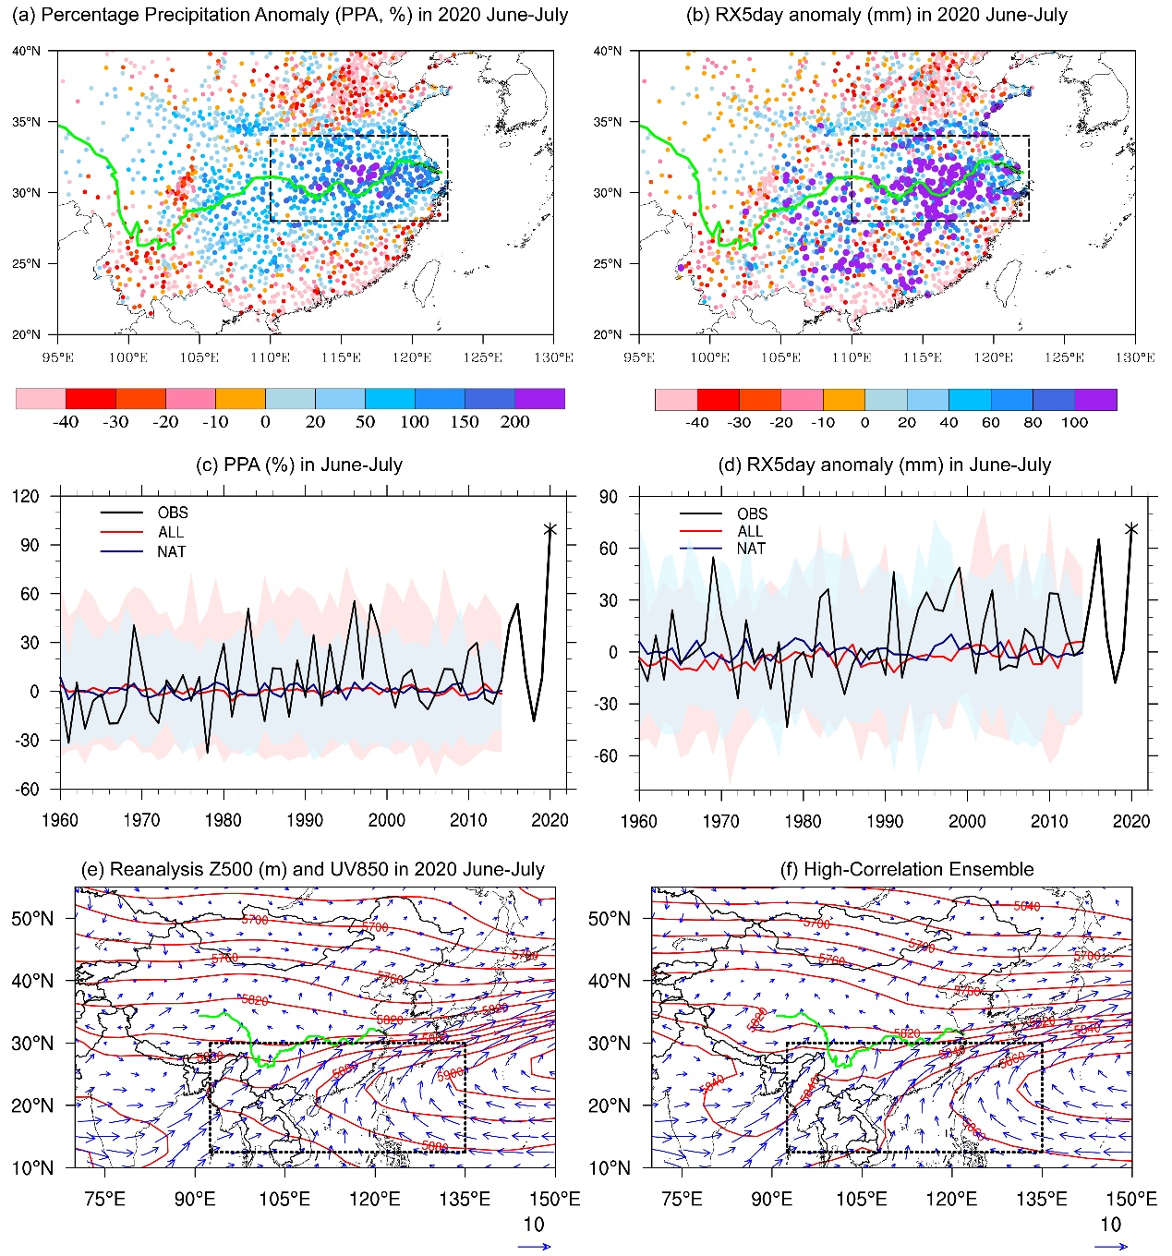
Figure 1 (a) Percentage precipitation anomaly (PPA, %) and (b) RX5day anomaly (mm) in June-July for observations in 2020. (c), (d): Regional PPA (%) and RX5day anomaly (mm) in June-July for observations (black), ALL simulations (red) and NAT simulations (blue) for 1960-2014. Thick lines denote ensemble mean, and shading denotes the 5–95% ranges of the individual model simulations. (e) Geopotential height (red contours, gpm) at 500hPa and winds (blue vectors, m/s) at 850hPa in June-July of 2020 based on reanalysis data. (f) Z500 (gpm) and UV850 (m/s) in June-July of 2001-2020 based on the mean of June-July extracted from the CMIP6 results with the ALL experiment, for which the circulation pattern correlates well (coefficient greater than 0.7) with the 2020 reanalysis pattern over the region marked by the black box. Green line in (e) and (f) indicates the Yangtze River.

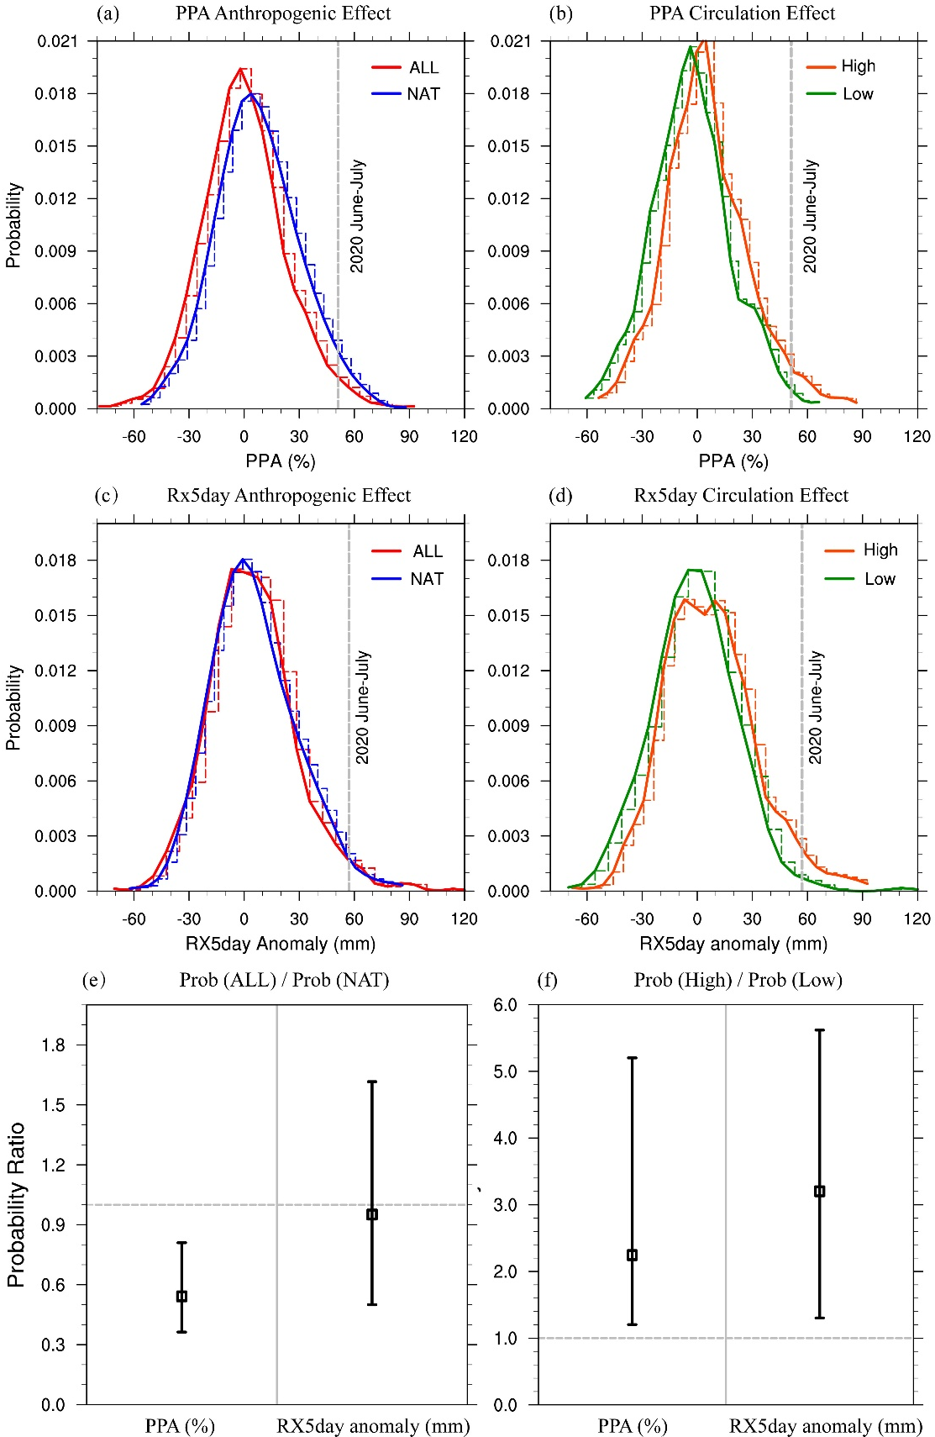
Figure 2 The impact of the anthropogenic forcings and 2020 Meiyu circulation pattern on the 2020-like Meiyu: the June-July PPA (a) and RX5day anomaly (c) distributions from model experiments with (red contours) and without anthropogenic forcings (blue contours); the June-July PPA (b) and RX5day (d) anomaly distributions in the high-correlation ensemble (orange contours) and low-correlation ensemble (green contours) based on CMIP6 ALL results; the changes in the probability due to anthropogenic forcings (e) and the changes in the occurrence probability of 2020-like Meiyu of under the influence of a 2020-like circulation pattern (f). Best estimates of the change in the probability are marked by the square symbols and the 5%–95% uncertainty range by the vertical whiskers.

