Was the Record‐Breaking Meiyu of 2020 Enhanced by Regional Climate Change?

Yuanyuan Ma^{1,2}, Zhiyuan Hu^{2,3*}, Xianhong Meng¹, Fei Liu^{2,3}, Wenjie Dong^{2,3}

¹ Key Laboratory of Land Surface Process and Climate Change in Cold and Arid Regions, Northwest Institute of Eco-Environment and Resources, Chinese Academy of Sciences, Lanzhou, China
² School of Atmospheric Sciences, Key Laboratory for Climate Change and Natural Disaster Studies of Guangdong Province, Sun Yat-sen University, Zhuhai, 519082, China
³ Southern Marine Science and Engineering Guangdong Laboratory, Zhuhai, 519082, China

*Corresponding Author:
Dr. Zhiyuan Hu
Address: School of Atmospheric Sciences, Sun Yat-sen University, Zhuhai, China
Email address: huzhiyuan@mail.sysu.edu.cn

Abstract
The record-breaking Meiyu rainfall amount of 2020 around the Yangtze River was decreased by approximately 9.2–14.1% due to the post-1980 regional climate change in Asia.

Introduction
In 2020, the middle and lower reaches of Yangtze River (MLYR: 28°–33°N, 110°–121°E) in China suffered an unexpected long‐persisting Meiyu season, and both the duration and rainfall amount reached the highest record since 1961 (Wei et al. 2020). Especially, the average cumulative precipitation for the period of 1 June to 31 July exceeded +750 mm with a maximum value of 1720 mm, and the precipitation anomaly reached +350 mm (Fig. 1a), which was about 88% more than 1980–2010 climatology in this region (Fig. 1b). The corresponding extreme precipitation caused severe flooding over the MLYR region, affecting 63.46 million people and resulting in a direct economic loss of over 178.96 billion Yuan (https://www.chinanews.com/sh/2020/08-14/9264482.shtml).
This super-Meiyu was primarily driven by the enhanced upward movement and moisture flux (Fig. 1c). They were caused by the abnormal East Asian westerly jet in the upper level and the southwesterly jet in the lower level, which were associated with abnormal position and intensity of the Western Pacific Subtropical High (Ding et al. 2021). These circulation anomalies coincided with the North Atlantic Oscillation (NAO, Liu et al. 2020), North Atlantic SST anomaly (Zheng and Wang, 2021), the strong preceding Indian Ocean Dipole (IOD, Takaya et al., 2020; Zhou et al. 2021), an early development of La Niña (Qiao et al. 2021), and an exceptionally persistent MJO active phase in the Indian Ocean (Zhang et al. 2021). Besides, the air temperature in Asia has been increasing rapidly (e.g., Huang et al., 2012; Kawase et al., 2020) and it is possible that climate change contributes to the extreme rainfall in 2020.
When attributing a specific extreme event to climate change, the approaches are important to extend the chain of complex physical causality. Generally, an “absolute” approach assesses overall changes in event likelihood, but the contribution of specific aspect of climate change is not considered (Swain et al., 2020). The ‘‘ingredient-based’’ approach with the absolute and conditional frameworks can ascertain the most essential physical conditions and then assess changes in the probability of these conditions (Swain et al., 2020). The “storyline” approach (Shepherd et al., 2018), typically uses a regional model to simulate an observed event under different boundary forcing and can offer better understanding of local scale processes such as thermodynamical and dynamical changes (Meredith et al., 2015). In this study, we will apply the “storyline” approach to evaluate the impact of climate change on the extreme rainfall event on a physically based causal narrative.

Data and Methods
The gauge observations of daily precipitation during 1961–2020, using ~824 stations over China with rigorous quality control (Cao et al., 2016), are obtained from the China Meteorological Administration to examine this Meiyu event from the perspective of climate. The quasi-real‐time hourly precipitation from ~2400 stations collected and performed quality control for the hourly precipitation from the Chinese hourly gauge network (Shen et al. 2010), are used to validate the simulated precipitation.
We investigate the impact of post-1980 regional climate change on the super-Meiyu using the Weather Research and Forecasting (WRF) model. The initial and boundary meteorological fields (IBCs) are obtained from the National Center for Environmental Prediction final analysis (NCEP/FNL) data with 1º horizontal resolution and 6 h temporal intervals. The model domain centers at 30°N, 105°E with grid numbers of 280 × 220 and spacings of 27 km (Fig. 1d). The unevenly spaced terrain-following vertical coordinate levels are used with 38 vertical layers up to 50 hPa. To better capture this Meiyu rainfall, a series of parameterization schemes are tested and the final main physical options are listed in Table1 of Fig. S1b.
Two series of ensemble simulations are carried out to assess the sensitivity of the extreme Meiyu rainfall to regional climate change. One ensemble of simulations is driven with realistic IBCs based on the NCEP/FNL data (CTL runs), and the other has the identical set-up, except that trend of the post-1980 regional climate change estimated by the fifth generation European Centre for Medium-Range Weather Forecasts atmospheric reanalysis data are removed from the IBCs. The subtracting the climate change trend is usually used to evaluate the impact of climate change by the “storyline” approach (Swain et al., 2020). It is useful for extreme rain events in United States (e.g., Wang et al., 2018), Japan (e.g., Kawase et al., 2020), Indian (e.g., Cho et al., 2016) and over the Black Sea and Mediterranean region (e.g., Meredith et al., 2015). Note that the trend in climate change includes both anthropogenic global warming and natural decadal variability, but the atmosphere warming and moistening in Asia can be largely attributed to human activities (Zhang et al., 2019). Based on the adjusted variables, six sensitivity experiments including Dair, Dair_TQH, Dair_TH, Dair_Q and Dair_UV runs are set and more information can be found in Table2 of Fig. S1b. All simulations are conducted from May 25 to August 1, 2020, and the days before June 1 are considered as a spin-up period (Zhong et al., 2007; Jerez et al., 2020).
This study aims to conduct several months of regional climate simulation to evaluate the effects of climate change on the long‐persisting Meiyu season of 2020. To reduce and assess the uncertainties, each experiment adopts a piecewise-integration method (Zhang et al., 2008) and has six ensemble runs with different microphysical parameterizations (Table1 in Fig. S1b). These set -up gives a high signal-to-noise ratio, which allowing fewer members and better understanding of thermodynamical and dynamical responses of climate change (Meredith et al., 2015). Experiments with realistic IBCs show that the piecewise-integration method can effectively reduce simulated precipitation biases compared with the continuous-integration method (Fig. S1c-d).

Results
The climate in Asia becomes warmer and more humid from 1980 to 2020 (Fig. 1d and Fig. S1a). During this time, the temperature increases are most apparent in middle and high latitudes regions, while specific humidity increases are clearest over the ocean. The climate warms most in the lower and upper atmosphere and humidity increases are greatest in the middle atmosphere (Fig. 1e).
The ensemble mean of six CTL runs reasonably captures the intensity and location of the accumulated precipitation amount during the extreme rainfall event (Figs. 2a and 2b). Also, the CTL runs well reproduces the cumulative process of precipitation of the heavy rainfall event (Fig. 2c). Specifically, the simulated regional-mean total precipitation amount is 777.9 mm with a standard deviation of 17.3 mm and a high signal-to-noise ratio of 45.0. Compared with observations, the total precipitation bias is 31.6 mm, which only accounts for approximately 4.2% of observed precipitation.
The difference in the total precipitation between the ensemble mean of CTL runs and Dair runs shows that post-1980 climate change decreases precipitation over the MLYR (Fig. 2e). Comparing the timing evolution of the accumulated precipitation between CTL runs and Dair runs, we can see that the difference in ensemble mean precipitation starts at 1 June, and increase gradually to the end of the heavy precipitation event (Fig. 2c). The difference is ‒107.7 mm at 31 July (Fig. 2d), which is equivalent to ‒11.9% (‒14.1 % to ‒9.2%) relative to the Dair runs (Fig. S2a). Further, the influence of climate change on this extreme event is mainly induced by the temperature and geopotential, while that in the relative humidity and horizontal winds is very small (Fig. 2d).
To understand the pronounced changes in precipitation, we further address the relative roles of thermal and dynamical changes induced by the climate change. Comparatively, the equivalent potential temperature (Fig. S2c) and the water vapor mixing ratio (Fig. S2d) are increasing significantly in the lower and middle atmosphere, but decreasing in the upper atmosphere, indicating the enhanced atmospheric thermal instability and humidity in the CTL runs. However, these local thermal changes do not induce increased precipitation, probably because of the maximum warming and moistening at ~850 hPa, which cause more stable stratification conditions in the low atmosphere. Dynamical changes show that the climate change induces northeast-southwest direction moisture flux and wind field anomaly and a strong downward movement (Fig. 2e and Fig. S2b), which is opposite with the circulation anomalies of East Asian summer monsoon (EASM) circulation (Fig. 1c). The differences in vertical velocity profiles show a clear weakened upward movement in the CTL runs and the change of vertical movement is consistent with the change of precipitation (Fig. 2f). This demonstrates that the climate change decreases the precipitation mainly by the circulation anomalies related to dynamical changes, which indicates the weakened large-scale background EASM circulations. The weakening EASM may be associated with the increased static stability in the vertical atmosphere (Held and Soden, 2006; Liu et al., 2013), land–sea thermal contrast (Kamae et al., 2014) and spatial inconsistency of global warming (Zuo et al., 2012).

Conclusions
This study evaluates the contribution of regional climate change on the super-2020 Meiyu rainfall event over the MLYR region by a “storyline” approach. The model reasonably captures the spatial distribution and cumulative process of total precipitation amount. Sensitivity experiments indicate that the post-1980 regional climate change in IBCs reduces the total precipitation by approximately 9.2–14.1%. The weakened precipitation is mainly attributed to the EASM circulation anomalies associated with dynamical changes. This is consistent with Zhou et al (2020), who showed that anthropogenic forcing reduced the probability of the 2020 extreme rainfall through weakening the EASM circulation caused by anthropogenic aerosols. Therefore, precipitation changes in China are not only related to changes in atmospheric temperature and moisture, but also changes in the background atmosphere circulations. This study demonstrates the regional climate change in Asia are unfavorable for this rainfall event, thus the extreme external forcings, such as the IOD, NAO and El Niño-Southern Oscillation (ENSO) on such events may play the dominant roles (e.g., Ding et al. 2021; Zhou et al. 2021; Qiao et al. 2021; Liu et al. 2020). Future work is required to evaluate the influence of global warming or climate change in specific external forcings (e.g., ENSO and IOD) on the 2020 rainfall event.

Acknowledgments
This work was supported by National Natural Science Foundation of China (41905013, 41930759, 42075105, 41805116) and the CAS “Light of West China” Program. Meteorological data were obtained from the China Meteorological Administration (http://data.cma.cn/en/). We would like to gratefully thank the above organization providing data.

References
Cao, L., Y. Zhu, G. Tang, F. Yuan, and Z. Yan, 2016: Climatic warming in China according to a homogenized data set from 2419 stations. Int. J. Climatol., 36, 4384–4392, https://doi.org/10.1002/joc.4639.
Cho, C., R. Li, S-Y, Wang, J-H, Yoon, and R. R. Gillies, 2016: Anthropogenic footprint of climate change in the june 2013 northern India flood. Clim. Dyn., 46, 797–805.
Ding, Y. H., Y.-Y. Liu, and Z.-Z. Hu, 2021: The record-breaking Meiyu in 2020 and associated atmospheric circulation and tropical SST anomalies. Adv. Atmos. Sci., https://doi.org/10.1007/s00376-021-0361-2.
Held, I. M., and B. J. Soden, 2006: Robust responses of the hydrological cycle to global warming. J. Climate, 19, 5686–5699.
Huang, J., X. Guan, and F. Ji, 2012: Enhanced cold-season warming in semi-arid regions, Atmos. Chem. Phys., 12, 5391–5398, doi:10.5194/acp-12-5391-2012.
Jerez, S., López‐Romero, J. M., Turco, M., Lorente‐Plazas, R., Gómez‐Navarro, J. J., Jiménez‐Guerrero, P., & Montávez, J. P. (2020). On the spin‐up period in WRF simulations over Europe: Trade‐offs between length and seasonality. Journal of Advances in Modeling Earth Systems, 12, e2019MS001945. https://doi.org/ 10.1029/2019MS001945.
Kamae, Y., M. Watanabe, M. Kimoto, and H. Shiogama, 2014: Summertime land-sea thermal contrast and atmospheric circulation over east asia in a warming climate—part I: past changes and future projections. Climate Dyn., 43(9–10), 2553–2568.
Kawase, H., Y. Imada, H. Tsuguti, T. Nakaegawa, and I. Takayabu, 2020: The heavy rain event of July 2018 in japan enhanced by historical warming. Bull. Amer. Meteor. Soc., 101(1), S109-S114.
Liu, B., Y. Yan, C. Zhu, S. Ma, and J. Li, 2020: Record-breaking Meiyu rainfall around the Yangtze River in 2020 regulated by the sub-seasonal phase transition of the North Atlantic Oscillation. Geophys. Res. Lett., 47(22), e2020GL090342. https://doi.org/10.1029/2020GL090342.
Liu, J., B. Wang, M. A. Cane, S. Y. Yim, and J. Y. Lee, 2013: Divergent global precipitation changes induced by natural versus anthropogenic forcing. Nature, 493(7434), 656–659.
Meredith, E. P., D. Maraun, V. A. Semenov, and W. Park, 2015: Evidence for added value of convection-permitting models for studying changes in extreme precipitation. J. Geophys. Res., 120:12500–12513.
Meredith, E. P., V. A. Semenov, D. Maraun, W. Park, and A. V. Chernokulsky, 2015: Crucial role of Black Sea warming in amplifying the 2012 Krymsk precipitation extreme. Nat. Geosci., 8, 615–619. doi:10.1038/ngeo2483.
Qiao, S., D. Chen, B. Wang, H.-N. Cheung, F. Liu, J. Cheng, S. Tang, Z. Zhang, G. Feng, and W. Dong, 2021: The longest 2020 Meiyu season over the past 60 years: Subseasonal perspective and its predictions. Geophys. Res. Lett., 48, e2021GL093596. https://doi.org/10.1029/2021GL093596.
Shen, Y., A. Xiong, Y. Wang, and P. Xie, 2010: Performance of high-resolution satellite precipitation products over China. J. Geophys. Res., 115, D02114, https://doi.org/10.1029/2009JD012097.
Shepherd, T. G., and Coauthors, 2018: Storylines: An alternative approach to representing uncertainty in physical aspects of climate change. Climatic Change, 151, 555–571, https://doi.org/10.1007/s10584-018-2317-9.
Swain, D.L., D. Singh, D. Touma, and N. S. Diffenbaugh, 2020: Attributing extreme events to climate change: A new frontier in a warming world. One Earth, 2(6), 522-527.
Takaya, Y., I. Ishikawa, C. Kobayashi, H. Endo, and T. Ose, 2020: Enhanced Meiyu-Baiu rainfall in early summer 2020: Aftermath of the 2019 super IOD event. Geophys. Res. Lett., e2020GL090671. https://doi.org/10.1029/ 2020GL090671.
Wang, S. S., L. Zhao, J-H, Yoon, P. Klotzbach, and R. R. Gillies, 2018: Quantitative attribution of climate effects on Hurricane Harvey’s extreme rainfall in Texas. Environ. Res. Lett., 13, 054014.
Wei, K., C. Ouyang, H. Duan, Y. Li, and S. Zhou., 2020: Reflections on the catastrophic 2020 Yangtze River Basin flooding in southern China. The Innovation, 1(2), 100038, https://doi.org/10.1016/j.xinn.2020.100038.
Zhang, J, Zhao, T, and Dai, A, et al., 2019: Detection and attribution of atmospheric precipitable water changes since the 1970s over China. Sci. Rep. 2019; 9: 17609.
Zhang, W., Z. Huang, F. Jiang, M. F. Stuecker, G. Chen, and F.-F. Jin, 2021: Exceptionally persistent Madden-Julian Oscillation activity contributes to the extreme 2020 East Asian summer monsoon rainfall. Geophys. Res. Lett., 48, e2020GL091588. https://doi.org/10.1029/2020GL091588.
Zhang, Z., C. Qiu, and C. Wang, 2008: A piecewise-integration method for simulating the influence of external forcing on climate. Progress in Natural Science: Materials International, 18, 1239–1247.
Zheng J, and C. Wang, 2021: Influences of three oceans on record-breaking rainfall over the Yangtze River Valley in June 2020. Science China Earth Sciences, 64, https://doi.org/10.1007/s11430-020-9758-9.
Zhou, Z.-Q., S.-P. Xie, and R.-H. Zhang, 2021: Historic Yangtze flooding of 2020 tied to extreme Indian Ocean conditions. Proc. Natl. Acad. Sci., 118 (12) e2022255118. https://doi.org/10.1073/pnas.2022255118.
Zhou, T., Ren, L., and Zhang, W., 2021: Anthropogenic influence on extreme Meiyu rainfall in 2020 and its future risk, SCIENCE CHINA Earth Sciences (under review).
Zhong, Z., Yijia, H. U., Jinzhong, M. I. N., & Honglei, X. U. (2007). Numerical experiments on the spin‐up time for seasonal‐scale regional climate modeling. Journal of Meteorological Research, 21(4), 409–419.
Zuo, Z., S. Yang, A. Kumar, R. Zhang, Y. Xue, and B. Jha, 2012: Role of thermal condition over Asia in the weakening Asian summer monsoon under global warming background. J. Climate, 25(9), 3431–3436.
Figures
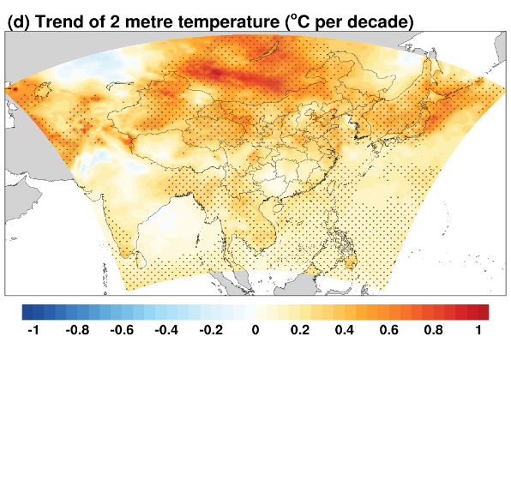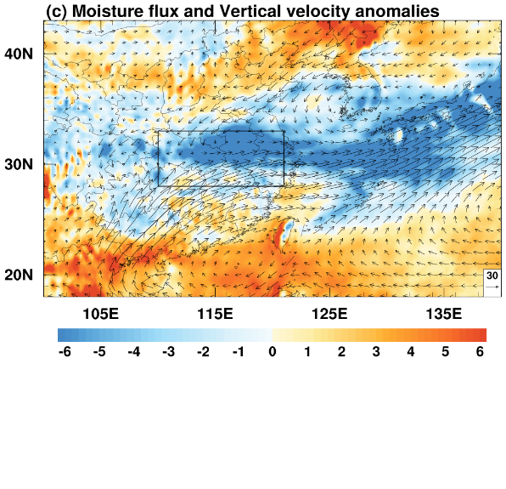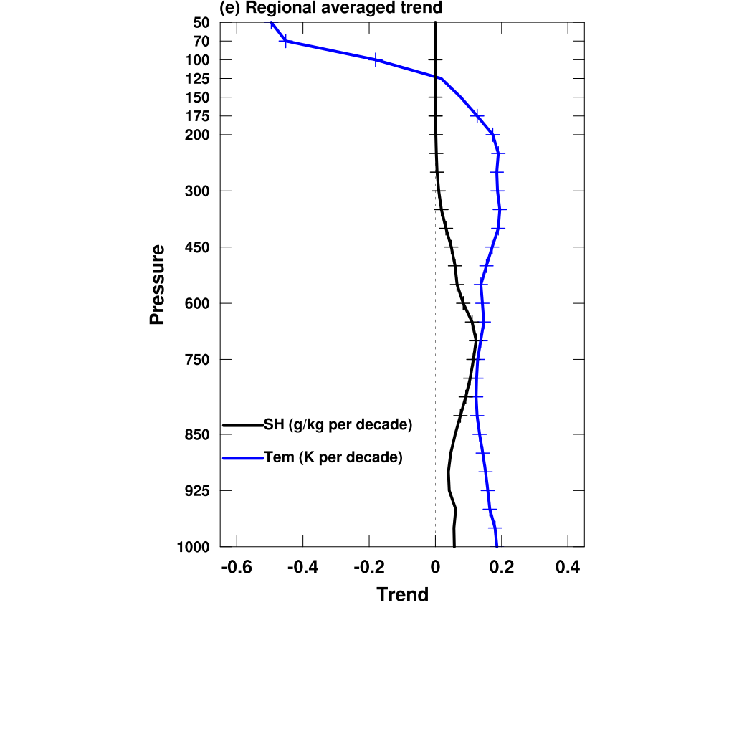
Fig. 1. (a) The observed rainfall anomalies relative to 1981–2010 climatology. The black box denotes the MLYR region (28°–33°N, 110°–121°E). (b) Time series of accumulated rainfall percentage anomalies for the black box in (a) during 1 June to 31 July relative to 1981–2010. (c) 500-hPa vertical velocity anomalies (shading, 10^{–2} Pa s^{–1}, negative values denote upward motion) and 850-hPa moisture flux anomalies (vectors, g m⁻¹ s⁻¹ Pa⁻¹) during 1 June to 31 July relative to 1981–2010. (d) Model domains and trend of 2 m temperature during 1980-2020, where the dotted area is the region exceeding the 95% confidence level. (e) Vertical profiles of regional-mean air temperature (Tem) and specific humidity (SH) trend over the model domain, where the 95% confident level of aera-average field are marked with “+”.
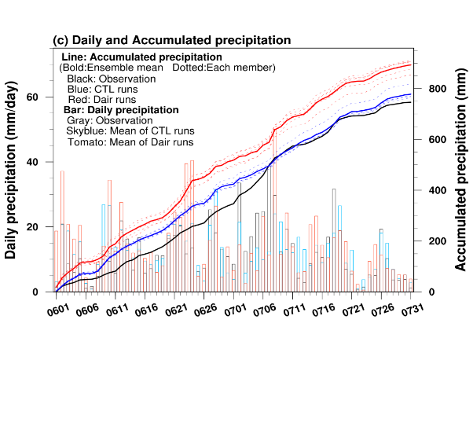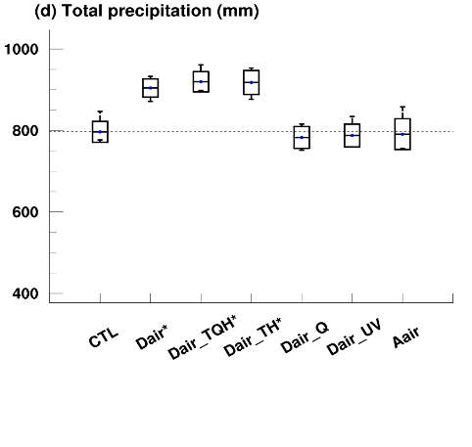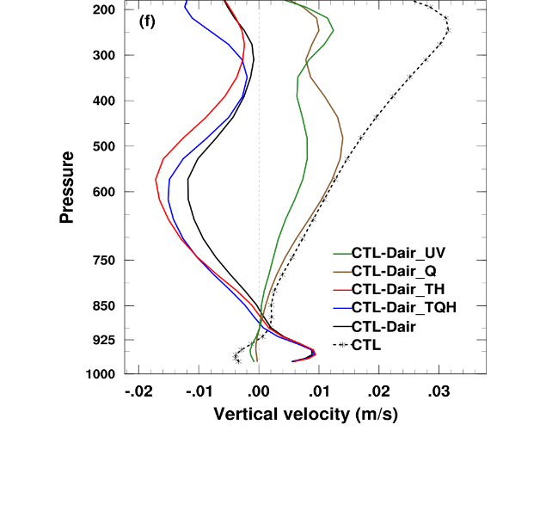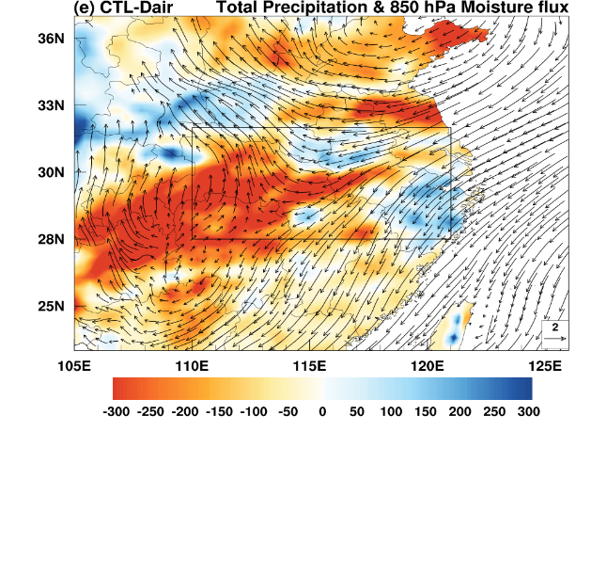
Fig. 2. (a) Gauge-analyzed total precipitation from 1 June to 31 July 2020. (b) As in (a), but for the ensemble means of precipitation from CTL runs. (c) Time series of regional-averaged daily (bar) and accumulated precipitation (line) over the MLYR region. (d) The minimum, maximum and mean total precipitation and the standard deviations simulated by each experiment. The x-axis labels marked with “∗” indicate a significant difference from CTL runs at 95% confidence interval of t-test. (e) Difference of total precipitation (shading, mm) and 850-hPa moisture flux (vectors, g m⁻¹ s⁻¹ Pa⁻¹) between CTL runs and Dair runs. (f) Vertical profiles of regional-mean vertical velocity of CTL runs (m/s) and the difference in the vertical velocity (10^{–1} m/s) compared with CTL runs.

