Were meteorological conditions related to the 2020 Siberia wildfires made more likely by anthropogenic climate change?

Zhongwei Liu¹, Jonathan M. Eden¹, Bastien Dieppois^{1,2}, Igor Drobyshev^{3,4,5}, Carolina Gallo Granizo¹ and Matthew Blackett^{1,6}

¹ Centre for Agroecology, Water and Resilience (CAWR), Coventry University, UK
² Marine Research Institute, University of Cape Town, Republic of South Africa.
³ Southern Swedish Forest Research Centre, Swedish University of Agricultural Sciences, Alnarp, Sweden.
⁴ Institut de recherche sur les forêts, Chaire de recherche du Canada en en aménagement forestier durable, Université du Québec en Abitibi-Témiscamingue (UQAT), Canada.
⁵ Forest Research Institute of the Karelian Research Centre of the Russian Academy of Petrozavodsk, Russia.
⁶ School of Energy, Construction and Environment, Coventry University, UK.
Corresponding Author: Jonathan Eden, jonathan.eden@coventry.ac.uk

30-word capsule summary
The meteorological conditions that coincided with extreme wildfires in Siberia during 2020 were up to 80% more likely than a century ago as a result of global warming.

Introduction
The summer of 2020 saw Siberia hit by widespread wildfires for a second consecutive year. By September alone, 14 million hectares had been burnt by more than 18,000 individual fires (Witze, 2020). The 2020 fires were responsible for the emission of approximately 350 megatonnes of carbon, more than four times the annual average observed across Siberia during the preceding two decades (Ponomarev et al., 2021). While fire activity is common in Siberia, accounting for between 8.5% and 25% of annual burned area worldwide (Kharuk et al., 2021), it was the dominance of fires at northerly latitudes that made the 2020 event truly exceptional. Fires beyond 65°N typically account for <10% of Siberia’s annual total burned area – their contribution during 2020 exceeded 25%, the largest observed since 2001 (Conard and Ponomarev, 2021), promptly raising concerns about the growing influence of wildfires on permafrost thaw (Kim et al., 2020) and greenhouse gas emissions (Ponomarev et al., 2021).

During 2020, spring and summer temperatures were abnormally high across Siberia. At Verkhoyansk in Yakutia (67°33′N 133°23′E), a new record of 38°C was set for the highest daily maximum temperature ever recorded north of the Arctic Circle (WMO, 2020). A comprehensive study conducted by the World Weather Attribution consortium concluded that such intense temperature, spanning such a large area, would have been almost impossible during the first half of 2020 without the influence of human-induced climate change (Ciavarella et al., 2021).

While this period of extreme heat was undoubtedly an important factor driving wildfire activity, a specific assessment of the contribution of human-induced climate change should account for other meteorological factors that collectively present fire-conducive conditions. Such an assessment is made challenging by Siberia’s vast geographical extent and varied climatology. Here, we isolate Siberia’s most intense fire episodes during 2020 and quantify the influence of global warming on the meteorological conditions associated with each. The collective analysis of a series of individual events that formed part of a larger phenomenon constitutes a unique aspect of this study. In our analysis of individual fire hotspots, we maintain a consistent spatiotemporal event definition, allowing for comparisons of results at different hotspots.

Data and Methods
Throughout the study, fire-conducive meteorological conditions are defined by the Canadian Fire Weather Index (FWI; van Wagner, 1987), a widely-used metric based on relative humidity, surface wind speed, precipitation and temperature to quantify forest fire danger. It forms the basis of global fire weather datasets (Field et al., 2015; Vitolo et al., 2020) and the Global Wildfire Information System. Our study region is defined by the West, East and Northeast Siberian taiga ecoregions (Olson et al., 2001), which collectively constitute an area of 6,700,000 km² and represent some of the most extensive areas of natural forests in the world. The location and intensity (defined by fire radiative power) of fire events during the April-September 2020 fire season were determined using satellite-derived data from the Visible Infrared Imaging Radiometer Suite (Schroeder et al., 2014), made available via the Fire Information for Resource Management System (FIRMS). Historical FWI data for the period 1979-2020 are taken from the global fire danger reanalysis (0.25° resolution; Vitolo et al., 2020) produced by the Copernicus Emergency Management Service for the European Forest Fire Information System. Simulations of historical FWI data for the period 1880-2014 (~0.7° resolution) are taken from the CNRM-CM6-1 general circulation model (Voldoire et al., 2019) developed for the sixth phase of the Coupled Model Intercomparison Project (CMIP6; Eyring et al., 2016). This model is chosen due to (a) the availability of a relatively large (30-member) ensemble, and (b) its capacity to realistically represent extreme FWI statistics across Siberia (Gallo Granizo et al., 2021).

We conduct independent attribution analysis at a series of 13 ‘hotspots’ associated with the most intense 2020 fires (see supplementary material for details). The ‘2020-type event’ is defined at each hotspot as the April-September maximum value of 7-day mean FWI (hereafter FWIx7day) occurring within the hotspot’s spatial domain. A statistical method based on a time-dependent Generalised Extreme Value (GEV) distribution, frequently applied to both observational and climate model data in previous work (e.g. Schaller et al., 2014; Eden et al., 2016; van der Wiel et al., 2017; Eden et al., 2018; Otto et al., 2018; Krikken et al., 2021), is used to estimate the change in probability of a 2020-type event as a result of global warming. For each hotspot, a pool of spatial maxima in FWIx7day from all 135 years and all 30 ensemble members are fitted to a GEV distribution in which the location 𝜇 and scale 𝜎 parameters are assumed to scale linearly with 4-year smoothed global mean surface temperature (GMST; GISTEMP Team, 2021; Lenssen et al., 2019). Both the shape 𝜉 parameter and the 𝜎/𝜇 ratio remain constant (Philip et al., 2020).

At each hotspot, we evaluate the return time, and hence the probability, of a 2020-type event occurring in a ‘past’ climate of 1880 (p₀) and a ‘present’ climate of 2020 (p₁). Changes in likelihood of 2020-type events are quantified using the probability ratio (PR) p₀/p₁. We also calculate the percentage change in FWI magnitude (%MAG) between a 2020-type event and an event of comparable likelihood occurring in 1880. Following evaluation of the model’s representation of extreme FWI statistics, a simple bias correction is used to account for systematic discrepancies between the reanalysis and CNRM-CM6-1 (see supplementary material for details). Confidence intervals (CIs) for each GEV fit, and subsequently for both PR and %MAG, are estimated with a 1,000-sample non-parametric bootstrap.

Results
Fires were widespread throughout the study region during April-September 2020 (Figure 1a). The most intense fires occurred in several clusters and generally north of 60°N. The highest-intensity fires were detected throughout the fire season, with a large proportion occurring between mid-June and August (Figure 1b). The individual fire detections at the centre of each hotspot all reside in the upper tail of the fires’ empirical cumulative distribution function (Figure 1c). The 2020 anomalies in FWIx7day were largest in central and northern Siberia, especially to the west of the Verkhoyansk mountains and across the Kolyma lowland (Figure 1d) where a large portion of 2020 FWIx7day values are among the highest 5% of annual maxima observed since 1979 (Figure 1e). At eight of the 13 hotspots, both the probability (PR > 1; Figure 2a-b) and magnitude (%MAG > 0; Figure 2c) of a 2020-type event increased between 1880 and 2020. The likelihood has increased by a factor of 1.1-1.8 corresponding to a change in magnitude of 2-6%; this is significant at the 95% confidence level at five hotspots (Figure 2e-i). Small decreases in both probability and magnitude are found at the remaining five hotspots (Figure 2b-c), of which only hotspot A at the western fringes of the fire-affected area is statistically significant (PR = 0.81; CI range 0.71-0.93; Figure 2d).

Positive changes in likelihood are found at the four hotspots (C, H, K and M) residing north of 65°N, where the exceptionality of 2020 fire weather is evidenced by large anomalies (>10 FWI units) amounting to some of the highest of FWIx7day values observed since 1979 (Figure 1d-e). At hotspot C, the likelihood of a 2020-type event is found to have increased by more than 30% (PR = 1.33; CI range of 1.10-1.55; Figure 2e). A change of almost 20% is found at hotspot H, but is not significant at the 95% level. Further east, significant increases in likelihood are found at hotspots K, M and, further south, L (Figure 2g-i). At hotspot K, which represents an area of the Kolyma lowland that witnessed several extreme fires (FWP > 700MW; Figure 1a), a 2020-type event has become almost 80% more likely since 1880 (PR = 1.78; CI range of 1.22-2.58; Figure 2g). Significant, though smaller, increases are found at hotspots L (PR = 1.57; CI range of 1.29-1.1; Figure 2h) and M (PR = 1.15; CI range of 1.02-1.28; Figure 2i). FWI extremes across the eastern region are likely to be linked to episodes of extreme heat across northern Siberia, but further analysis would be required to connect the attribution of FWI maxima at these hotspots to that of the distribution of extreme heat during the first half of 2020 (Ciavarella et al., 2021).

Hotspots west of the Verkhoyansk range are not associated with significant increases in likelihood despite being representative of the most intense fire clusters across the central Siberian plateau. At hotspots B and E, which correspond to areas of particularly intense fires and large FWI anomalies during 2020, the likelihood of 2020-type conditions were found to have decreased by approximately 10-20% (not significant at the 95% level). The increase in likelihood of more than 20% (PR = 1.21; CI range 1.03-1.46) at the most southerly hotspot, D, is striking given that it is unlikely to be linked explicitly to the extreme heat in the north (Figure 2f).

Conclusions
Our analysis has sought to quantify the role of human-induced climate change on fire meteorological conditions associated with the most intense fire episodes, occurring in Siberia over the 2020 fire season. Previous work has identified the fingerprint of human influence on the extreme heat during the beginning of the year (Ciavarella et al., 2021). To complement such work, we considered the link between long-term global temperature and the meteorological parameters that collectively constitute extreme fire weather. We applied an established statistical method to output from CNRM‐CM6‐1 to quantify the long-term influence of global temperature trends on annual fire weather maxima separately at a series of regions experiencing the most intense fire activity. By averaging the results at different hotspots, we found that fire weather extremes are (a) around 10% more likely across the study region on average, and (b) up to 80% more likely in north-east Siberia, as a result of global warming.

The inter-hotspot differences are intriguing and merit further analysis to quantify the factors that contribute toward trends in extreme fire weather in this vast region. More generally, the results highlight the sensitivity of the findings of wildfire attribution analysis to the spatio-temporal characteristics used to define the event, either in terms of the impact (i.e. the fire intensity) or the prevailing meteorology (i.e. FWI). Results are also expected to be sensitive to the choice of general circulation model, which is an important additional source of uncertainty. While our analysis is based on a model that has been shown to realistically represent fire weather across Siberia (Gallo Granizo et al., 2021), further study would benefit from the inclusion of multiple models.

Acknowledgements
We acknowledge the use of data and/or imagery from NASA's Fire Information for Resource Management System (FIRMS) (https://earthdata.nasa.gov/firms), part of NASA's Earth Observing System Data and Information System (EOSDIS).

References
Conard, S.G. and Ponomarev, E. I. (2020) Fire in the North: The 2020 Siberian Fire Season, Wildfire, 29, 26-32.
Ciavarella, A., Cotterill, D., Stott, P. Kew, S., Philip, S., van Oldenborgh, G.J., Skålevåg, A., Lorenz, P., Robin, Y., Otto, F., Hauser, M., Seneviratne, S.I., Lehner, F. and Zolina, O. (2021) Prolonged Siberian heat of 2020 almost impossible without human influence. Climatic Change 166, 9. https://doi.org/10.1007/s10584-021-03052-w
de Groot, W.J., Cantin, A.S., Flannigan, M.D., Soja, A.J., Gowman, L.M., Newbery, A., 2013. A comparison of Canadian and Russian boreal forest fire regimes. For. Ecol. Manage. 294, 23–34. https://doi.org/10.1016/j.foreco.2012.07.033
Eden, J. M., Wolter, K., Otto, F. E. L., and van Oldenborgh, G. J. (2016) Multi-method attribution analysis of extreme precipitation in Boulder, Colorado, Environ. Res. Lett., 11, 124009, https://doi.org/10.1088/1748-9326/11/12/124009
Eden, J. M., Kew, S. F., Bellprat, O., Lenderink, G., Manola, I., Omrani, H., and van Oldenborgh, G. J. (2018) Extreme precipitation in the Netherlands: An event attribution case study, Weather and Climate Extremes, 21, 90–101, https://doi.org/10.1016/j.wace.2018.07.003
Eyring, V., Bony, S., Meehl, G. A., Senior, C. A., Stevens, B., Stouffer, R. J., and Taylor, K. E. (2016) Overview of the Coupled Model Intercomparison Project Phase 6 (CMIP6) experimental design and organization, Geosci. Model Dev., 9, 1937–1958, https://doi.org/10.5194/gmd-9-1937-2016
Field, R. D., Spessa, A. C., Aziz, N. A., Camia, A., Cantin, A., Carr, R., de Groot, W. J., Dowdy, A. J., Flannigan, M. D., Manomaiphiboon, K., Pappenberger, F., Tanpipat, V., and Wang, X. (2015) Development of a Global Fire Weather Database, Nat. Hazards Earth Syst. Sci., 15, 1407–1423, https://doi.org/10.5194/nhess-15-1407-2015.
Gallo Granizo, C., Eden, J.M., Dieppois, B., and Blackett, M. (2021) Assessing the capacity of Earth System Models to simulate spatiotemporal variability in fire weather indicators, EGU General Assembly 2021, online, 19–30 Apr 2021, EGU21-12208, https://doi.org/10.5194/egusphere-egu21-12208.
GISTEMP Team (2021) GISS Surface Temperature Analysis (GISTEMP), version 4. NASA Goddard Institute for Space Studies. Dataset accessed 2021-05-27 at https://data.giss.nasa.gov/gistemp/.
Hersbach, H., Bell, B., Berrisford, P., Hirahara, S., Horányi, A., Muñoz‐Sabater, J., Nicolas, J., Peubey, C., Radu, R., Schepers, D. and Simmons, A. (2020). The ERA5 global reanalysis. Quarterly Journal of the Royal Meteorological Society, 146 (730), 1999-2049.
Hugelius, G., Loisel, J., Chadburn, S., Jackson, R.B., Jones, M., MacDonald, G., Marushchak, M., Olefeldt, D., Packalen, M., Siewert, M.B. and Treat, C. (2020). Large stocks of peatland carbon and nitrogen are vulnerable to permafrost thaw, Proceedings of the National Academy of Sciences, 117 (34), 20438-20446.
Kharuk, V.I., Ponomarev, E.I., Ivanova, G.A., Dvinskaya, M.L., Coogan, S.C.P., Flannigan, M.D., 2021. Wildfires in the Siberian taiga. Ambio. https://doi.org/10.1007/s13280-020-01490-x
Kim, J. S., Kug, J. S., Jeong, S. J., Park, H. and Schaepman-Strub, G. (2020). Extensive fires in southeastern Siberian permafrost linked to preceding Arctic Oscillation, Science Advances, 6(2), eaax3308. https://doi.org/10.1126/sciadv.aax3308
Krikken, F., Lehner, F., Haustein, K., Drobyshev, I., and van Oldenborgh, G. J. (2021) Attribution of the role of climate change in the forest fires in Sweden 2018, Nat. Hazards Earth Syst. Sci., 21, 2169–2179. https://doi.org/10.5194/nhess-21-2169-2021
Lenssen, N., Schmidt, G., Hansen, J., Menne, M., Persin, A., Ruedy, R. and Zyss, D. (2019) Improvements in the GISTEMP uncertainty model, J. Geophys. Res. Atmos., 124 (12), 6307-6326. https://doi:10.1029/2018JD029522
Olson, D. M., Dinerstein, E., Wikramanayake, E. D., Burgess, N. D., Powell, G. V. N., Underwood, E. C., D'Amico, J. A., Itoua, I., Strand, H. E., Morrison, J. C., Loucks, C. J., Allnutt, T. F., Ricketts, T. H., Kura, 454 Y., Lamoreux, J. F., Wettengel, W. W., Hedao, P., and Kassem, K. R. (2001). Terrestrial ecoregions of the world: a new map of life on Earth, Bioscience, 51 (11), 933-938.
Otto, F.E.L., van der Wiel, K., van Oldenborgh, G.J., Philip, S.Y., Kew, S.F., Uhe, P., Cullen, H. (2018) Climate change increases the probability of heavy rains in northern England/southern Scotland like those of storm Desmond—a real-time event attribution revisited. Environ Res Lett 13(2):024006. https://doi.org/10.1088/1748-9326/aa9663
Ponomarev, E., Yakimov, N., Ponomareva, T., Yakubailik, O., and Conard, S. G. (2021). Current Trend of Carbon Emissions from Wildfires in Siberia. Atmosphere, 12(5), 559. https://doi.org/10.3390/atmos12050559
Philip, S., Kew, S., van Oldenborgh, G.J., Otto, F., Vautard, R., van der Wiel, K., King, A., Lott, F., Arrighi, J., Singh, R., and van Aalst, M. (2020) A protocol for probabilistic extreme event attribution analyses, Adv. Stat. Clim. Meteorol. Oceanogr., 6, 177–203. https://doi.org/10.5194/ascmo-6-177-2020
Samsonov, Y.N., Ivanova, G.A., 2014. Causes and effects of fires in the Siberian boreal forests. Reg. Ecol. Sociol. 1, 257–271.
Schaller, N., Otto, F.E.L. , van Oldenborgh, G.J., Massey, N.R., Sparrow, S. and Allen, M.R. (2014) The heavy precipitation event of May-June 2013 in the upper Danube and Elbe basins, Bull. Am. Meteorol. Soc., 95 (9), p. S69
Schroeder, W., Oliva, P., Giglio, L., & Csiszar, I. A. (2014). The New VIIRS 375m active fire detection data product: algorithm description and initial assessment. Remote Sensing of Environment, 143, 85-96. doi:10.1016/j.rse.2013.12.008
van der Wiel, K., Kapnick, S. B., Oldenborgh, G. J. van, Whan, K., Philip, S., Vecchi, G. A., Singh, R. K., Arrighi, J. and Cullen, H. (2017) Rapid attribution of the August 2016 flood-inducing extreme precipitation in south Louisiana to climate change, Hydrol. Earth Syst. Sci., 21(2), 897–921, https://doi.org/10.5194/hess-21-897-2017
van Oldenborgh, G.J., van der Wiel, K., Kew, S. et al. (2021) Pathways and pitfalls in extreme event attribution, Climatic Change, 166, 13 (2021). https://doi.org/10.1007/s10584-021-03071-7
van Oldenborgh, G. J., Krikken, F., Lewis, S., Leach, N. J., Lehner, F., Saunders, K. R., van Weele, M., Haustein, K., Li, S., Wallom, D., Sparrow, S., Arrighi, J., Singh, R. K., van Aalst, M. K., Philip, S. Y., Vautard, R., and Otto, F. E. L. (2021) Attribution of the Australian bushfire risk to anthropogenic climate change, Nat. Hazards Earth Syst. Sci., 21, 941–960, https://doi.org/10.5194/nhess-21-941-2021
Van Wagner, C. E. (1987) Development and structure of the Canadian forest fire index system, Can. For. Serv., 35.
Vitolo, C., Di Giuseppe, F., Barnard, C. et al. ERA5-based global meteorological wildfire danger maps. Sci Data 7, 216 (2020). https://doi.org/10.1038/s41597-020-0554-z
Voldoire, A., Saint‐Martin, D., Sénési, S., Decharme, B., Alias, A., Chevallier, M., Colin, J., Guérémy ,J.F., Michou, M., Moine, M.P., Nabat, P., Roehrig, R., Salas y Mélia, D., Séférian, R., Valcke, S., Beau, I., Belamari, S., Berthet, S., Cassou, C., Cattiaux, J., Deshayes, J., Douville, H., Ethé, C., Franchistéguy, L., Geoffroy, O., Lévy, C., Madec, G., Meurdesoif, Y., Msadek, R., Ribes, A., Sanchez-Gomez, E., Terray, L., and Waldman, R. (2019) Evaluation of CMIP6 deck experiments with CNRM‐CM6‐1, Journal of Advances in Modeling Earth Systems, 1 (7), 2177-2213. https://doi.org/10.1029/2019MS001683
Witze, A. (2020) The Arctic is burning like never before-and that’s bad news for climate change, Nature, 585 (7825), 336-337. https://doi.org/10.1038/d41586-020-02568-y
WMO (2020) https://public.wmo.int/en/media/news/reported-new-record-temperature-of-38%C2%B0c-north-of-arctic-circle

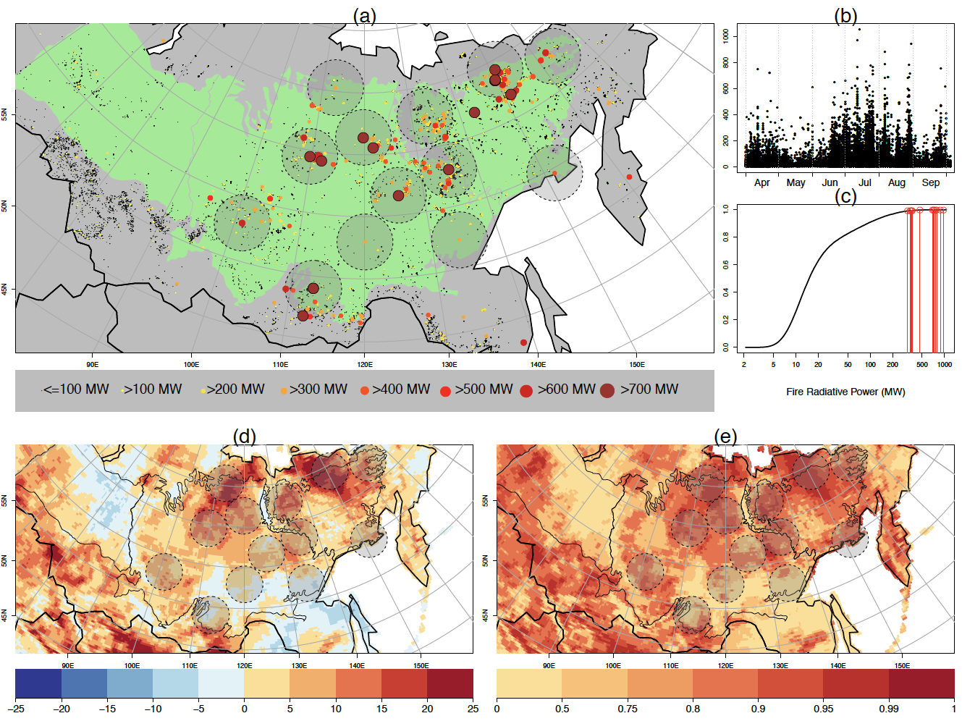

Figure 1: (a) Locations and intensity of April-September 2020 fires detected by FIRMS. Only detections that meet the FIRMS ‘high-confidence’ criteria are shown. Point size and colour show fire radiative power in megawatts (MW) as an indicator of fire intensity. Siberian ecoregions shown in green. (b) Occurrence (date) and intensity (MW) of April-September 2020 fires. (c) Cumulative distribution function of fire intensity (MW); red pins indicate the individual fires at the centre of each hotspot. (d-e) Maximum 7-day mean FWI during April-September 2020 expressed (d) as an anomaly of the 1979-2019 mean annual maxima, and (e) in terms of its probability of occurrence on the basis of the 1979-2019 distribution. In both (d) and (e), the shaded areas within the dashed circles show the location of the 13 hotspots.

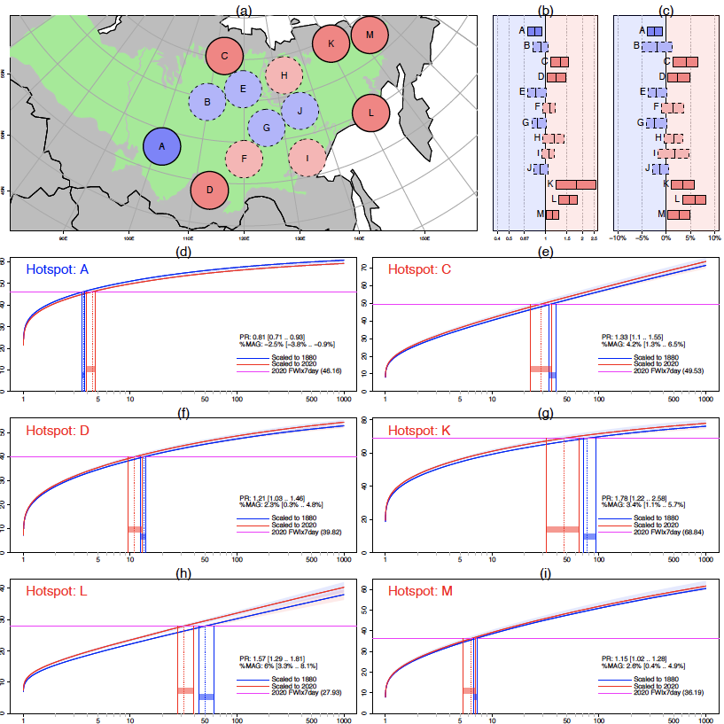

Figure 2: (a) Location of 13 fire hotspots and the overall sign change in likelihood of a 2020-type event between 1880 and 2020 (red: increase; blue: decrease; solid lines: significant; dashed lines: not significant). (b) PR calculated at each hotspot; bars show 95% CIs following non-parametric bootstrapping; central value shown in bold. (c) As (b) but for %MAG. (d)-(i) Gumbel plots for significant hotspots, showing the GEV model fit scaled to the smoothed GMST of 1880 (blue) and 2020 (red). Shading represents the 95% CIs. The magenta lines represent the 2020 FWIx7day events, scaled to the model distribution using bias correction. The blue (red) bars represent the 95% CIs for the return period of a 2020-type event in the climate of 1880 (2020).

