The contribution of human-induced atmospheric circulation changes to the record-breaking winter precipitation event over Beijing in February 2020

Lin Pei¹, Zhongwei Yan², Deliang Chen³*, Shiguang Miao¹

¹ Institute of Urban Meteorology, China Meteorological Administration, Beijing 100089, China
² RCE-TEA, Institute of Atmospheric Physics; University of Chinese Academy of Sciences, Beijing 100029, China
³ Regional Climate Group, Department of Earth Sciences, University of Gothenburg, Gothenburg 405 30, Sweden

CORRESPONDING AUTHOR: Deliang Chen, deliang@gvc.gu.se

Capsule summary
Precipitation in Beijing during February 2020 was the highest since 1951. Anthropogenic influences contributed to a 52.9% increase in the likelihood of circulation anomalies associated with similar extreme precipitations.

During February 2020, North China observed unusually high precipitation, with many stations receiving monthly precipitation total exceeding 300% more than 1981-2010 climatology for February (Fig. 1a). In particular, Beijing received a historical record of 27.8 mm of precipitation (Fig. S1a), which is 592% more than the long-term mean. The combined influences of snow, low temperatures, and frost hazards in this period posed serious challenges to this megacity of over twenty million people, with various socioeconomic impacts and serious effects on transportation and electricity power.
Few attribution analyses have considered regional extreme precipitation events during winter in China (Zhao 2020). The extreme precipitation in February 2020 over Beijing raises questions about whether anthropogenic influences have affected the frequency of such events. However, there are some common deficiencies in reproducing extreme precipitation indices over China in global climate models (GCMs). For example, in the CMIP5 simulations, the areal-mean biases for total precipitation, heavy precipitation and precipitation intensity over China are 127%, 87%, and 22%, respectively (Zhu et al. 2020). It is difficult to directly attribute such local extreme precipitation events using model outputs at coarse resolutions (Trenberth et al. 2015; Zhai et al. 2018; Sun et al., 2021). However, recent studies have conducted attribution analyses of regional extreme events from the perspective of the dominant circulation patterns, also finding human influences to be mainly responsible for changes in these extremes (Horton et al. 2015; Pei and Yan 2018; Zhou et al. 2020). Harrington et al. (2016) demonstrate the utility of an approach in characterizing the meteorological conditions conducive for an extreme drought event in 2013 over New Zealand and identify a robust increase in the likelihood of the observed circulation patterns like those of the 2013 drought in the recent-climate simulations. In a large ensemble of climate model simulations, Schaller et al. (2016) find that anthropogenic warming causes a small but significant increase in the number of January days with the westerly flow, which increases extreme precipitation over southern England. Therefore, this study examines the change in frequency of circulation patterns related to extreme precipitation during February in Beijing.
DATA AND METHOD
The observed and reanalysis datasets used in this study are as follows. 1) Monthly homogenized precipitation observations at 2414 stations in China for 1951 – 2020 provided by the China Meteorological Administration (http://data.cma.cn/). There are 20 stations in the Beijing area. 2) Monthly circulation data comprising wind speed, geopotential height, and relative humidity covering 1951 – 2020, obtained from NCEP-NCAR at 2.5° resolution (Kaynay et al. 1997). 3) Monthly circulation data for 1900 – 2010 from 20th Century Reanalysis version 2 (20CR) at 2° resolution (Compo et al. 2011) and from the ECMWF Atmospheric Reanalysis for the 20th Century (ERA20C) at 1° resolution (Poli et al. 2016).
Monthly circulation simulated by 20 runs of 7 CMIP5 models contributing to the All-Hist, Nat-Hist, and RCP8.5 experiments (Table. S1) obtained from CMIP5 (Taylor et al. 2012) are also used. The All-Hist simulations are forced by natural (solar radiation and volcanic aerosols) and anthropogenic agents (greenhouse gases, aerosols, ozone, and land use), while the Nat-Hist simulations are forced only by natural agents. The RCP8.5 simulations are run with the projected increases in the atmospheric concentration of greenhouse gases, representing the uncontrolled high-emissions scenario.
We applied an approach used in similar studies (Ren et al. 2020; Zhou et al. 2020). We identify the circulation anomaly related to extreme winter precipitation in Beijing using the atmospheric reanalyses and examine how anthropogenic influences alter the probability of such circulation patterns using the ensembles of CMIP5 models.

RESULTS
Atmospheric circulation conditions related to extreme winter precipitation over Beijing and its changes in the 20th century
We calculated the correlation between precipitation over Beijing and anomalies in atmospheric circulation for February in the period from 1951 to 2020. Strong correlation is found in geopotential height at 500 hPa, meridional wind at 850 hPa, and relative humidity near the surface (Fig. 1d-f). When precipitation over Beijing is anomalously high, there is an anomalous anticyclonic system over the western Pacific, resulting in a shallow East Asian trough, which represents a weakened East Asia Winter Monsoon (EAWM) (Jhun and Lee, 2003; Pei et al. 2018). This anomalous anticyclonic system can be seen in the regional mean of the geopotential height within 29°N – 46°N, 123°E – 171°E (green box in Fig. 1d), hereafter referred to as H500. Under these conditions, the Western Pacific region along the east coast of China experiences widespread anomalous southerlies in the lower troposphere (Fig. 1d), favorable for the transportation of warm and humid air from the northwestern Pacific into adjacent regions, including North China, Korea and southern Japan. A practical index for measuring the strength of the EAWM is the meridional wind speed anomaly at 850 hPa over the northwestern Pacific (17°N – 41°N, 114°E – 144°E: green box in Fig. 1e), referred to as V850. As a result, abundant moist air is transported into North China, resulting in abnormally high levels of relative humidity over this region, thereby inducing conditions favorable to extreme winter precipitation (Fig. 1f). The humidity conditions are captured as the regional mean relative humidity within 26°N – 42°N, 110°E – 161°E (green box in Fig. 1f), hereafter referred to as RH1000.
The correlation coefficients between February precipitation in Beijing and the H500, V850 and RH1000 indices for 1951–2020 are all significant under the t-test (α = 0.01) (Fig. 1b). Favorable circulation conditions occur concurrently and promote extreme precipitation events in Beijing. We normalize each time series by its respective standard deviation for 1971-2000 and apply a multiple linear regression (MLR) model to construct a compound index. The MLR equation is y = 0.019 + 0.308 × RH1000* + 0.103 × V850* + 0.315 × H500*, * representing normalized series. This new index is normalized to its climatology and is referred to as the circulation index (CI, red line in Fig. 1b), with a significant correlation coefficient (Corr = 0.58) to winter precipitation in Beijing for 1951–2020. We also examine a suite of other relevant variables but find that adding more circulation variables does not markedly change the correlation because the effect of the other variables is implicitly included in the CI through their correlation with the three dominant variables. The CI reached 2.21σ in February 2020, second to only one stronger event in 1990 (Fig. 1b). Total precipitation over the North China during 1990 was 26.8 mm, highest since 1951 (Fig. S1a). And the precipitation center was located in the south part of North China, rather than the Beijing area (Fig. S1b). Therefore, winter circulation anomalies for February 2020 can be treated as an extreme climate event (corresponding to a CI equal to or greater than 2.21σ).
Based on long-term reanalysis, the probability of extreme atmospheric circulation anomalies, i.e., those with a CI value greater than 2.21σ, increased twofold in the 20th century (Fig. 1c), from a once-in-50-year event during 1901–1950 to a once-in-25-year event during 1951–2000 (Table. 1). There is also a consistent shift in the frequency of the three components that make up CI (i.e., H500, V850 and RH1000) (Fig. S2). The probabilities of extreme values of these components (H500, V850 and RH1000), such as those occurring in 2020, increased from the first half to the second half of the last century by between 20% and 166% (Table. 1). The increase in frequency is statistically significant, but the role of anthropogenic influence remains to be clarified.

Anthropogenic influence on the occurrence of extreme winter circulation conditions
To construct the CI series in the historical and future simulations, the normalized anomalies of H500, V850 and RH1000 are calculated based on the All-Hist 30-year (1971–2000) climatology for each model. There is a remarkable shift toward higher CI values in the All-Hist and RCP8.5 simulations compared with the CI distribution in the Nat-Hist simulations, with a 32% and 68% increase in the mean relative to the standard deviation, respectively (Fig. 2a). There are consistent changes in the component indices in the All-Hist and RCP8.5 scenario toward a more frequent occurrence of the anomalous anticyclonic system over the northwestern Pacific in the mid-troposphere, weakened EAWM (with anomalous southeasterly flows), and abnormally high relative humidity in the Beijing area (Fig. 2b-d). The probability of atmospheric circulation anomalies conducive to extreme winter precipitation in Beijing (CI larger than 2.21σ) changes from 3.4% under the Nat-Hist scenario to 5.2% under the All-Hist scenario and further increases to 9.6% in the future scenario (Table 1). This finding suggests that anthropogenic influence has contributed to an approximately 52.9% increase in the likelihood of such circulation anomalies causing extreme winter precipitation, and the models project a further 84.7% increase under the RCP8.5 scenario. These results are supported by strong intermodel agreement, as 19 out of 20 runs reproduced an increased frequency of atmospheric circulation anomalies with positive CI values (Table. S1).

CONCLUSIONS
Beijing experienced its wettest February in 2020 since at least 1951, but it is challenging to directly attribute such precipitation local extremes using only climate models. Here, employing both observations and climate model simulations, we analyzed the anthropogenic influence on the changes in the likelihoods of atmospheric circulation conditions related to very wet Februarys. Similar extreme precipitation events are associated with an anomalous anticyclone over the northwestern Pacific and a weakened EAWM, resulting in above-average relative humidity in the Beijing area. According to reanalysis data, such circulation anomalies have increased in frequency by approximately 100% in the 20th century. Finally, in an ensemble of 20 runs of CMIP5, we find that anthropogenic influence has caused a 52.9% increase in the likelihood of such extreme circulations, and we project a further 84.7% increase under the RCP8.5 scenario.

ACKNOWLEDGEMENTS.
We wish to thank Andrew Hoell for his valuable inputs which greatly improved the manuscript. This study was supported by the National Key R&D Program of China (2019YFA0607202 and 2017YFE0133600), and the National Natural Science Foundation of China (41805082).

REFERENCES
Chen, D. L., and Coauthors, 2020: Summary of a workshop on extreme weather events in a warming world organized by the Royal Swedish Academy of Sciences. Tellus B: Chemical and Physical Meteorology, 72, 1, 1–13, https://doi.org/10.1080/16000889.1794236
Compo, G. P., and Coauthors, 2011: The twentieth century reanalysis project. Q. J. R. Meteor. Soc., 137, 1–28, https://doi.org/10.1002/qj.776
Harrington, L. J., and Coauthors, 2016: Investigating event-specific drought attribution using self-organizing maps. J. Geophys. Res. Atmos., 121, 12, 766–12,780, doi: 10.1002/2016JD025602
Horton, D. E., and Coauthors, 2015: Contribution of changes in atmospheric circulation patterns to extreme temperature trends. Nature, 522, 465–469, https://doi.org/10.1038/nature14550
Jhun, J. G., and Lee, E. J., 2004: A New East Asian Winter Monsoon Index and Associated Characteristics of the Winter Monsoon. J. Clim., 17 (4), 711–726, https://doi.org/10.1175/15200442(2004)017<0711:ANEAWM>2.0.CO;2
Kalnay, E., and Coauthors, 1996: The NCEP/NCAR 40-year reanalysis project. Bull. Am. Meteorol. Soc., 77, 437–70, https://doi.org/10.1175/1520-0477(1996)077<0437:TNYRP>2.0.CO;2
Pei, L., and Yan, Z. W., 2018: Diminishing clear winter skies in Beijing towards a possible future. Environ. Res. Lett., 13, 124029, https://doi.org/10.1088/1748-9326/aaf032
Pei, L., and Coauthors, 2018: Increasing persistent haze in Beijing: potential impacts of weakening East Asian winter monsoons associated with northwestern Pacific sea surface temperature trends. Atmos. Chem. Phys., 18, 3173–83, https://doi.org/10.5194/acp-18-3173-2018
Poli, P., and Coauthors, 2016: ERA-20C: an atmospheric reanalysis of the 20th century. J. Clim., 29, 4083–97, https://doi.org/10.1175/JCLI-D-15-0556.1
Ren, L., Zhou, T. J., and Zhang, W. X., 2020: Attribution of the record-breaking heat event over Northeast Asia in summer 2018: the role of circulation. Environ. Res. Lett., 15(5), https://doi.org/10.10088/1748-9326/ab8032
Schaller, N., and Coauthors, 2016: Human influence on climate in the 2014 southern England winter floods and their impacts. Nat. Clim. Change, 6, 627–364, doi: 10.1038/nclimate2927.
Sun. Y., and Coauthors, 2021: Understanding human influence on climate change in China. Natl. Sci. Rev., nwab113, https://doi.org/10.1093/nsr/nwab113
Trenberth, K. E., Fasulli, J. T., and Shepherd, T. G., 2015: Attribution of extreme climate event. Nat. Climate Change, 5, 725–730, https://doi.org/10.1038/NCLIMATE2657
Taylor, K. E., and Coauthors, 2012: An overview of CMIP5 and the experiment design. Bull. Am. Meteorol. Soc., 93, 485–98, https://doi.org/10.1175/BAMS-D-11-00094.1
Zhao, W. J., 2020: Extreme weather and climate events in China under changing climate. Natl. Sci. Rev., 7, 938–943, https://doi.org/10.1093/nsr/nwaa069
Zhai, P. M., Zhou, B. T., and Chen, Y., 2018: A Review of Climate Change Attribution Studies. J. Meteor. Res., 32 (5), 671–692, https://doi.org/10.1007/s13351-018-8041-6.
Zhou, C., and Coauthors, 2020: Conditional attribution of the 2018 summer extreme heat over Northeast China: roles of urbanization, global warming and warming-induced circulation changes. Bull. Amer. Meteorol. Soc., 101, S1–S128, https://doi.org/10.1175/BAMS-D-19-0197.1
Zhu, H.,and Coauthors, 2020: Does CMIP6 Inspire More Confidence in Simulating Climate Extremes over China? Adv Atmos Sci, 37: 1119–1132

Table 1. The frequency of extreme winter atmospheric circulation anomalies (CI, RH1000, V850 and H500) was stronger than that of the 2020 event in the reanalysis data (20CR and ERA20C) and simulations (CMIP5).
Frequency |  | RH1000 | V850 | H500 | CI
Cir (2020) |  | 3.21σ | 0.77σ | 1.03σ | 2.21σ
20CR | 1901–1950 | 0 | 26.0% | 6.0% | 2.0%
 | 1951–2000 | 0 | 32.0% | 16.0% | 4.0%
 | Change | / | 23.0% | 166.0% | 100.0%
ERA-20c | 1901–1950 | 0 | 16.0% | 10.0% | 0
 | 1951–2000 | 0 | 24.0% | 12.0% | 4.0%
 | Change | / | 50.0% | 20.0% | /
Simulations from 20 CMIP5 model runs | Nat-Hist: 1951–2000 | 1.3% | 21.1% | 9.0% | 3.4%
 | All-Hist: 1951–2000 | 1.8% | 25.2% | 14.3% | 5.2%
 | RCP8.5: 2050–2099 | 2.6% | 29.8% | 26.7% | 9.6%
 | Change(AllHist-NatHist) | 38.5% | 19.4% | 58.9% | 52.9%
 | Change(RCP8.5-AllHist) | 44.4% | 18.3% | 86.7% | 84.7%
σ: standard deviation of the time series for 1971 – 2000.

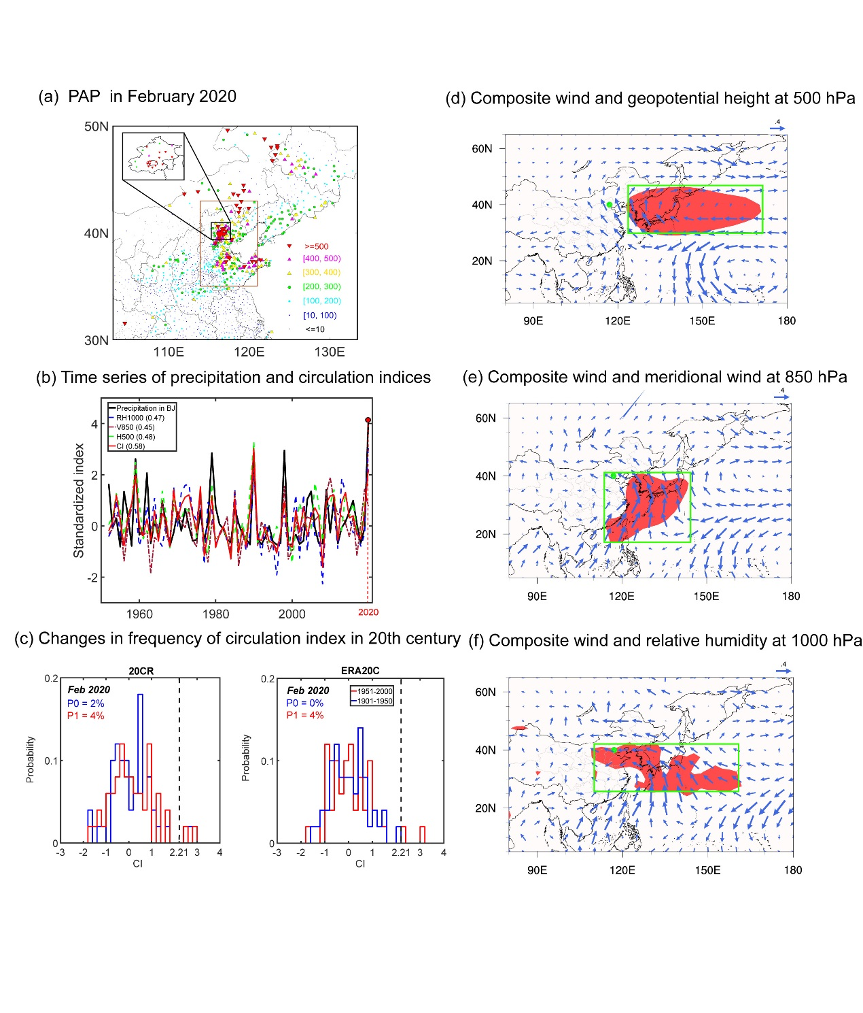
FIG. 1. (a) Percentage anomaly of precipitation (PAP, unit: %) during February 2020 related to 1951 – 2020 climatology. North China is outlined by the brown rectangle, 35.5°N – 43°N, 114°E – 121°E. (b) Normalized time series of precipitation (black), CI (red), and components of CI (blue for RH1000*; brown for V850*; green for H500*) for 1951-2020. (c) Histograms for CI during the first (blue) and second (red) halves of the 20th century, based on 20CR (left) and ERA20C (right). Dotted line denotes the 2020 event. (d – f) Correlation coefficients between observed precipitation and circulations: (d) geopotential height (shading) with composite wind (vector) at 500 hPa; (e) meridional wind speed (shading) with composite wind (vector) at 850 hPa; (f) relative humidity (shading) with composite wind (vector) at 1000 hPa. Linear trends are removed before calculating the correlations. Shading area shows where changes are significant under the t-test (α= 0.05). Beijing (40°N, 117°E) is marked with a green dot.

Fig. 2. GEV distributions of CI (a), H500 (b), V850 (c) and RH1000 (d) in the historical (1951–2000, green for NatHist and blue for AllHist) and future (2050 – 2099, red) periods. Dotted line denotes the 2020 event.

