Development of a Rapid Response Capability to Evaluate Causes of Extreme Temperature and Drought Events in the United States

Joseph J. Barsugli^{a.b} David R. Easterling^{c}, Derek S. Arndt^{c}, David A. Coates^{d}, Thomas L. Delworth^{e}, Martin P. Hoerling^{b}, Nathaniel Johnson^{c}, Sarah B. Kapnick^{e}, Arun Kumar^{f} , Kenneth E. Kunkel^{d}, Carl J. Schreck^{d} , Russell S. Voseª, Tao Zhang^{f,g}

ªCIRES, Univ. of Colorado Boulder, Boulder, CO
^{b}NOAA/Physical Sciences Laboratory, Boulder, CO
^{c}NOAA/National Centers for Environmental Information, Asheville, NC
^{d}CISESS, North Carolina State University, Asheville, NC
^{e}NOAA/Geophysical Fluid Dynamics Laboratory, Princeton, NJ
^{f}NOAA/National Centers for Environmental Prediction, College Park, MD
^{g}ESSIC, University of Maryland, College Park, MD

Corresponding author: Joseph J. Barsugli, joseph.barsugli@colorado.edu

- Introduction
In January 2021 work began on a NOAA Climate Program Office funded project “that develops and tests a potential rapid event analysis and assessment capability.” (NOAA CPO, 2020). This 3-1/2 year effort brings together scientists from four NOAA Laboratories/Centers and university scientists at two of NOAA’s Cooperative Institutes. This funded project has two high-level goals: (1) to address outstanding dataset, model, and methodological gaps in explaining extreme events within a changing climate, and (2) to build a prototype rapid event attribution system for temperature-related and drought extremes that could eventually serve routine climate information needs at local, state, and regional levels. The focus on temperature-related extremes derives from the conclusions of the US National Academy of Sciences report that confidence in attribution findings is greatest for this class of extremes (NAS, 2016). The project will leverage additional research projects that were funded under the same call that focus on the underlying mechanisms for these types of extreme events.
Several climate trends in the United States present challenges for the attribution of temperature-related extremes (Fig. 1). The first is the lack of appreciable daytime warming during the hottest time of year over the central US — a so-called “warming hole” (Fig. 1a and 1b). This poses a conundrum in the attribution of heat waves in this region both scientifically and in perceived relevance and will require that the long-term trend itself be adequately explained. A second phenomenon is the increase in summertime soil moisture in the Central US concomitant with the upward observed trend in precipitation (Figure 1c), contrary to trends predicted by many climate models (e. g. Dai, 2013), posing an analogous challenge for drought attribution over the Central US. In contrast, there has been prevalent drought in the western US since the turn of the millennium whose causes (Lehner et al., 2019, Seager et al, 2014, and see Hoell et al, this issue), and implications for extreme event attribution, are yet to be definitively unraveled. While understanding these trends constitutes an important prelude to attribution of single events, the rest of this perspective concerns the development of an extreme event attribution capability within NOAA.

- Why a rapid assessment capability?

The scientific value of extreme event attribution has been well described in the literature (e.g. Stott et al, 2013; 2016). While the science community often produces research explaining previous events (e. g. as part of an annual Special Issue of the Bulletin of the American Meteorological Society beginning with Peterson et al. 2012 and most recently Herring et al. 2021), the methodology, data sets, and scientific focus of such studies are not uniform nor are they produced routinely and predictably. While this diversity of analytical approaches is a strength of the larger research enterprise, it poses some shortcomings as a potential climate service. This project seeks to address some of these shortcomings by providing a transparent and reproducible quantification of the changing weather and climate hazard along with the reasons for these changes, using a set of standard and well-documented methods and datasets. The aim is to create attribution information usable in the public and private sectors for planning analogous to the manner in which weather forecasts are produced, representing a new service for building climate resilience (Rogers and Tsirkunov 2013; Pulwarty and Sivakumar 2014). Additionally, the release of such data aims to improve climate information equity by making resource-intensive risk analysis (often the product of analyzing terabytes of data) publicly available after major events.
How does this project define “rapid?” During and immediately following a high-impact extreme event there is considerable public interest in its likely causes, motivating the development of a capacity for quasi-real time analysis. There is also a longer time frame of interest. After an event there is a period of recovery, planning and re-investment as the affected communities move towards rebuilding and seek to incorporate practices to increase resilience. The perceived risk of another such an extreme event often increases during this period (whether justified or not), and new perceptions affect subsequent planning for future disasters (Birkmann et al. 2008; Kousky 2010). During this planning stage in an events aftermath, a re-evaluation of the hazard posed by such events is important for determining resilience (Amaratunga and Haigh 2011, Pascale et al., 2020). The National Academy of Sciences report on event attribution noted that the science of the causes of these events can inform “emergency managers, regional planners, and policy makers at all levels of government.” (NAS, 2016), though we recognize that the value of event attribution for informing adaptation is a matter of ongoing debate (e. g. Hulme et al. 2016). For this project, “rapid” thus entails two time frames with different audiences: the first, as the event is ongoing and immediately following when public interest is high, and the second in the weeks to months following the event when accurate present-day and forward-looking risk assessments are desired by risk managers, policymakers and affected communities. To reach the audiences for this information, this project will work with existing climate service providers and boundary organizations within and outside NOAA, including the NOAA Regional Climate Centers and Regional Integrated Sciences as Assessments (RISA) that have established communication channels and stakeholder networks.

- Key aspects of a rapid attribution prototype
The project objectives are organized around five principal steps in conducting a timely extreme event attribution (Fig. 2), spanning the pre-event preparation of data and tools to the post-analysis communication of scientific findings. We see this as an iterative process, with lessons learned from event analysis feeding back into research and development. Key aspects are the following:
- Pre-event Research and Development. An early project objective is the selection, development (as needed), and evaluation of a standard “core” collection of observational and model datasets for rapid attribution. The core observational datasets for analysis of heat and cold extremes comprise both station and gridded data; a dew point temperature dataset is under development in order to more meaningfully investigate heat stress extremes, particularly where temperature trends are weak. The core model simulations will consist primarily of large ensembles of free-running coupled model simulations (Coupled Model Intercomparison Project or “CMIP-style”, e. g. Eyring et al. 2016) and boundary-forced atmosphere model simulations (Atmosphere Model Intercomparison Project “AMIP-style”, e. g. Gates et al, 1999), along with seasonal forecasts from initialized versions of these modeling systems. The use of large ensembles allows for better statistical sampling of rare extreme events, and such ensembles have become a well-established in the study of climate variability and change, as well as in attribution (e.g. Stone and Allen 2005; Kay et al. 2015; Sippel et al. 2015). To enlarge the compass of existing model simulations, team members are producing large ensembles using the GFDL-SPEAR (Delworth et al., 2020), NCEP FV3/GFS (Zhou et al. 2019, though at coarse resolution), and NCAR CESM/CAM5/6 modeling systems (Neale, R, et al., 2010, Danabasoglu et al., 2020).
Model-based attribution frameworks will also be evaluated, including comparison of attribution from coupled models, long historical AMIP simulations, and time-slice simulations with modified boundary conditions (so-called “counterfactual” simulations in which known climate change drivers are withheld, e.g. Christidis et al., 2013 and 2015, Seager and Hoerling 2014; Sun et al. 2018; Hoerling et al 2019). Model and observational data sets, including capabilities to intercompare and diagnose these datasets, will be made available through this project, including through the Facility for Weather and Climate Assessments (FACTS, Murray et al. 2020).
- Event monitoring and triggering protocols. The project will explore physically-based, objective definitions of extreme events, aware of regional differences in what constitutes an event extreme. The distributions of historical extremes occupy a broad spectrum of intensity, duration, and extent, posing a challenge for monitoring. However, temperature extremes and droughts tend to be regional in scale, and/or have large-scale meteorological drivers associated with them, and these scales will guide our initial monitoring and analysis. Using objective criteria we will develop a library of past events for use in methodological development and evaluation, including the evaluation of potential new methods and tools (section 1a, above). These criteria also open the door to using forecast guidance for anticipatory monitoring to enable more timely assessments as events unfold. Existing monitoring efforts and widely used indices will be evaluated for developing triggers for event assessment.

- Initial Observational Analyses. An event, perhaps ongoing, will be promptly characterized relying primarily on core datasets. This quasi-real-time analysis of conditions on the ground serves several purposes: to hone in on a definition of the event that reflects its “extreme” physical characteristics, to place such events in the historical context of known variability and trends in frequency of occurrence, and to identify proximate drivers for further analysis. Issues of data homogeneity, completeness, and quality (Easterling et al, 2016), as well as data latency, and potential missing or delayed observations during extremes are among the challenges in conducting a timely assessment. These difficulties notwithstanding, the objective is to provide timely and accurate characterization of the event, including placing the extreme event within an appropriate historical context, while withholding statements on causality until careful diagnosis is completed.

- Detailed causal analysis. Following the characterization of the event by observational analysis a detailed causal analysis will be performed. The analysis will focus both on the change in probability of the event and on the likely contribution of various causal factors to the magnitude of the event, including both thermodynamic and dynamic drivers. The primary objectives of this analysis include determining the unconditional change in probability and magnitude due to anthropogenic forcing as well as the conditional change given various proximate drivers such as coincident SST and sea ice conditions (for example, see the discussion of unconditional and conditional attribution in NAS, 2016). Other conditioning factors may also be considered, including atmospheric circulation anomalies and antecedent land surface conditions, as motivated by the observational analysis of the event.
The primary approach will be probabilistic analysis of the global, large ensembles described above. Large ensembles allow for a reduction in errors in attribution due to sampling bias and allow for a better characterization of the role of internal variability. AMIP ensembles are included among the attribution methodologies for several reasons. First, AMIP simulations have a smaller climatological bias than the less constrained coupled simulations. Second, AMIP simulations can be viewed as an “empirically constrained” model that bridges the gap between purely observational analysis and coupled models. Third, they include the specific boundary forcing operating during an event. For these reasons AMIP simulations will be particularly useful in elucidating the causes of events where the observed regional trends are not well-aligned with those expected from coupled models but are better simulated by the AMIP ensembles.

- Communication of event attribution. At each stage above we will develop and evaluate possible communications messages, platforms and partners. We will establish a protocol for clear-language statements of causality and changing risks, and the staging of publicly released information on extreme event assessments. Considerable synthesis will be needed to bring the different lines of evidence into a coherent set of attribution statements. To help inform planning and policy it will be essential to place the attribution findings in the context of climate projections. Conditional attribution – that is, attribution that takes into account particular conditioning factors such as the phase of El Niño, anomalous atmospheric circulation patterns or other factors that are specific to environment in which the extreme event takes place -- allows for “storyline” narratives to bolster credibility where unconditional attribution of global warming impacts is not sufficient (Shepherd, 2014, Lloyd and Oreskes, 2018)
As a research project within NOAA we will primarily leverage or adapt established capabilities of NOAA NCEI to disseminate results to the public, as NCEI routinely issues climate assessments and summaries in plain-language format (see NOAA NCEI, 2021, https://www.ncei.noaa.gov/news/national-climate-202106 for an example of a plain language climate assessment). We will also issue our reports as research (experimental) products for others in our intended audience. As our intended audience spans the technical perspective of disciplinary reviewers and scientists and the broader perspective of decision-makers and the interested public, we recognize the need to communicate at multiple technical and conceptual levels.

- Concluding remarks
The Texas cold wave of February 2021 - occurring only a month after project inception - allowed us to start exercising some of the proposed observational datasets and learn some preliminary lessons. The first lesson is the extent to which data latency may constrain the quality and timeliness of an initial observational analysis. A reasonably complete roster of preliminary gridded products and station observations with long period of record was available within 4 days from the peak of the event. However, it was apparent that several stations in the hardest-hit areas had missing or delayed reports, likely due to power outages. As in the analogy of a flood that wipes out stream gauges, the most extreme reports might be missing. The second lesson is the difficulty in characterizing the event as it was unfolding. While the severe impacts were focused in the southern Great Plains, the temperature extremes themselves spanned a much larger geographical region and emerged earlier (Figure S1a). The best way to define this “extreme event” from a physical perspective, taking into account intensity, duration and extent, is not immediately clear. However, it was clear that regional indices (Fig S1b) captured the severity of the event better than a nationwide index. Also, a notable negative skewness of the temperature distribution was recognized over the impact region – there have been 3-sigma cold events, but no 3-sigma warm events – alerting us that unconditional probabilities for an extreme cold wave are greater than had a Gaussian distribution been assumed (Fig. S1c, see also Tamarin-Brodsky et al., 2020, Loikith and Neelin, 2019, and Sardeshmukh et al, 2015). Because the project is only starting and the core datasets are still under development, these preliminary analyses were used only to guide the research component of the project and were not disseminated.
Recognizing that event attribution science is an emerging field, rapid attribution will of necessity be provisional. Different methodological choices can yield different results for the same event (e.g. van Oldenborgh et al., 2017). Therefore, we view the ability to re-attribute past events in order to systematically evaluate methods and datasets as essential to our research project.
The vision for this research project is to establish capabilities central to the development of a NOAA operational event attribution function that would regularly and reliably report on the likely causes of extreme events in the context of climate variability and change. The focus of this prototype development is on extremes in the “United States and outlying territories” (NOAA CPO, 2020). International or interagency collaboration on the attribution of events worldwide can be facilitated through the use of this project’s global public datasets and proposed analysis tools. While we are just getting started, our goal is to build a transparent and open extreme event attribution system that serves NOAA’s mission to understand and predict changes in climate and weather and share that knowledge and information with others.

Acknowledgments.
The project is funded by the NOAA Climate Program Office, and in part through the NOAA cooperative agreements with CIRES (NA17OAR4320101) and CISESS. We thank Judith Perlwitz for an insightful review.

REFERENCES
Amaratunga, D., and R. Haigh, 2011: Post-disaster reconstruction of the built environment: Rebuilding for resilience. John Wiley and Sons. 315 pp.
Birkmann, J., P. Buckle., J. Jaeger, M. Pelling, N. Setiadi, M. Garschagen, N. Fernando, and J. Kropp, 2010: Extreme events and disasters: a window of opportunity for change? Analysis of organizational, institutional and political changes, formal and informal responses after mega-disasters. Nat. Hazards, 55, 637-655.
Christidis, N., P. A. Stott, A. A. Scaife, A. Arribas, G. S. Jones, D. Copset, J. R. Knight, and W. Tennant, 2013: A new HadGEM3-A-based system for attribution of weather- and climate-related extreme events. J. Climate, 26, 2756–2783, https://doi.org/10.1175/JCLI-D-12-00169.1.
Christidis N, P. A. Stott, and F. W. Zwiers, 2014: Fast track attribution assessments based on pre‐computed estimates of changes in the odds of warm extremes. Clim. Dyn., 45: 1547– 1564. doi:10.1007/s00382-014-2408-x.
Dai, A., 2013: Increasing drought under global warming in observations and models, Nat. Clim. Chang., 3, 52-58. doi:10.1038/nclimate1633
Danabasoglu, G., and Coauthors, 2020: The Community Earth System Model version 2 (CESM2). J. Adv. Model. Earth Syst., 12, e2019MS001916, doi: 10.1029/2019MS001916.
Delworth, T. L., et al., 2020: SPEAR: The Next Generation GFDL Modeling System for Seasonal to Multidecadal Prediction and Projection. J. Adv. Model. Earth Syst., 12, e2019MS001895.
Easterling, D. R., K. E. Kunkel, M. F. Wehner, and L. Sun, 2016: Detection and attribution of climate extremes in the observed record, Wea. Clim. Extremes,11, 17-27
Eyring, V., S. Bony, G. A. Meehl, C. A. Senior, B. Stevens, R. J. Stouffer, and K. E. Taylor, 2016: Overview of the Coupled Model Intercomparison Project Phase 6 (CMIP6) experimental design and organization, Geosci. Model Dev., 9, 1937–1958, doi:10.5194/gmd-9-1937-2016, 2016.
Gates, W. L., and Coauthors,1999: An Overview of the Results of the Atmospheric Model Intercomparison Project (AMIP I), Bull Amer. Meteor. Soc, 80, 29-56.
Gregory, J. M., J. F. B. Michell, and A. J. Brady, 1997: Summer drought in northern midlatitudes in a time-dependent CO2 climate experiment. J. Climate, 10, 662-686.
Herring SC, N. Christidis, A. Hoell, M. Hoerling, and P. Stott, 2021: Explaining extreme events of 2019 from a climate perspective. Bull Amer. Meteor. Soc, 102, S1– S116.
Hoerling, M., J. Barsugli, B. Livneh, J. Eischeid, X. Quan, and A. Badger, 2019: Causes for the century-long decline in Colorado River flow. J. Climate, 32, 8181-8203.
Hulme M., S. O'Neill, S. Dessai, 2011: Is weather event attribution necessary for adaptation funding?, Science, 334, 764– 765.
Kay, J. E., and Coauthors, 2015: The Community Earth System Model (CESM) Large Ensemble Project: A Community Resource for Studying Climate Change in the Presence of Internal Climate Variability. Bulletin of the American Meteorological Society, 96, 1333–1349, https://doi.org/10.1175/BAMS-D-13-00255.1.
Kousky, C., 2010: Learning from extreme events: Risk perceptions after the flood. Land Econ., 86, 395-422.
Lehner, F., C. Deser, I. Simpson, and L. Terray, 2018: Attributing the U.S. Southwest’s recent shift into drier conditions. Geophys. Res. Lett., 45, 6251–6261, https://doi.org/10.1029/2018GL078312.
Lloyd E. A., and N. Oreskes, 2018: Climate change attribution: when is it appropriate to accept new methods?, Earths Future, 6, 311–325
Loikith, P. C., and J. D. Neelin, 2019: Non-Gaussian Cold-Side Temperature Distribution Tails and Associated Synoptic Meteorology. Journal of Climate, 32, 8399–8414, https://doi.org/10.1175/JCLI-D-19-0344.1.
Murray, D., and Co-Authors, 2020: Facility for Weather and Climate Assessments (FACTS): A Community Resource for Assessing Weather and Climate Variability. Bull. Amer. Meteor. Soc., 101, E1214–E1224, doi: 10.1175/BAMS-D-19-0224.1
National Academies of Sciences, Engineering, and Medicine (NAS), 2016: Attribution of Extreme Weather Events in the Context of Climate Change. Washington, DC: The National Academies Press. doi:10.17226/21852
Neale, R. B., and Coauthors, 2010: Description of the NCAR Community Atmosphere Model (CAM5.0). NCAR Tech. Note NCAR/TN-486+STR, 268 pp., www.cesm.ucar.edu/models/cesm1.1/cam/docs/description/cam5_desc.pdf.
NOAA, Climate Program Office, 2020: Understanding-the-Causes-and-Mechanisms-of-Extreme-Climate-Events, Accessed May 8, 202, https://cpo.noaa.gov/Funding-Opportunities/FY2020-Recipients/Understanding-the-Causes-and-Mechanisms-of-Extreme-Climate-Events
NOAA, National Center for Environmental Information (NCEI), 2021: Assessing the U.S. Climate in June 2021. Accessed 5 November 2021, https://www.ncei.noaa.gov/news/national-climate-202106.
Pascale, S., S. B. Kapnick, T. L. Delworth, and W. F. Cooke, 2020: Increasing risk of another Cape Town “Day Zero” drought in the 21st century. Proc. Natl. Acad. Sci., 117, 29495-29503.
Peterson T. C., P. A. Stott, S. Herring, 2012: Explaining extreme events of 2011 from a climate perspective. Bul.l Am. Meteorol. Soc., 93, 1041– 1067.
Pulwarty, R. S., and M. V. Sivakumar, M. V., 2014: Information systems in a changing climate: Early warnings and drought risk management. Wea. Clim. Extremes, 3, 14-21.
Rogers, D. P., and V. V. Tsirkunov, V. V., 2013: Weather and climate resilience: Effective preparedness through national meteorological and hydrological services. Directions in Development, Washington, DC: World Bank, 141 pp., doi:10.1596/978-1-4648-0026-9.

Sardeshmukh, P. D., Compo, G. P., & Penland, C. (2015). Need for Caution in Interpreting Extreme Weather Statistics, Journal of Climate, 28(23), 9166-9187.
Seager, R., and M. Hoerling, 2014: Atmosphere and ocean origins of North American droughts. J. Climate, 27, 4581-4606.
Shepherd, T. G., 2014: Atmospheric circulation as a source of uncertainty in climate change projections. Nature Geoscience, 7, 703– 708. https://doi.org/10.1038/ngeo2253
Sippel, S., D. Mitchell, M. T. Black, A. J. Dittus, L. Harrington, N. Schaller, and F. E. L. Otto, 2015: Combining large model ensembles with extreme value statistics to improve attribution statements of rare events. Weather and Climate Extremes, 9, 25–35, https://doi.org/10.1016/j.wace.2015.06.004.
Stone, D. A., and M. R. Allen, 2005: The End-to-End Attribution Problem: From Emissions to Impacts. Climatic Change, 71, 303–318, https://doi.org/10.1007/s10584-005-6778-2.
Stott, P. A., and Coauthors, 2016: Attribution of extreme weather and climate-related events. WIRES Clim. Change, 7, 23-41.
Stott P. A., and Coauthors, 2013: Attribution of weather and climate‐related extreme events. Climate Science for Serving Society: Research, Modelling and Prediction Priorities, G. R. Asrar and J. W. Hurrell eds., Springer, 307– 337.
Sun, L., D. Allured, M. Hoerling, L. Smith, J. Perlwitz, and D. Murray, 2018: Drivers of 2016 record Arctic warmth assessed using climate simulations subjected to factual and counterfactual forcing. Wea. Clim. Extremes, 19, 1–9, https://doi.org/10.1016/J.WACE.2017.11.001.
Tamarin-Brodsky, T., K. Hodges, B. J. Hoskins, and T. G. Shepherd, 2020: Changes in Northern Hemisphere temperature variability shaped by regional warming patterns. Nat. Geosci., 13, 414–421, https://doi.org/10.1038/s41561-020-0576-3.
van Oldenborgh, G. J., and Coauthors, 2017: Attribution of extreme rainfall from Hurricane Harvey, August 2017. Environ. Res. Lett., 12, 124009, https://doi .org/10.1088/1748-9326/aa9ef2.
Zhou, L., S. Lin, J. Chen, L. M. Harris, X. Chen, and S. L. Rees, 2019: Toward Convective-Scale Prediction within the Next Generation Global Prediction System, Bull. Amer. Meteor. Soc., 100, 1225-1243

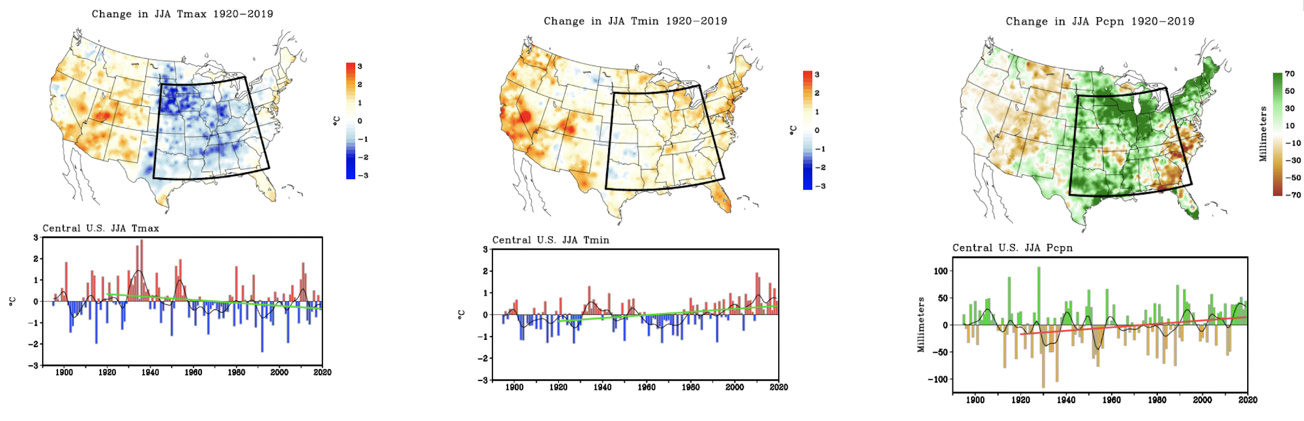
Figure 1. Climatic trends lead to challenges in attribution of temperature and drought. Summer (JJA) daily maximum surface air temperature (°C, left) shows no positive trend over the central U. S. (black box) whereas daily minimum surface air temperature (°C, middle) has warmed. Precipitation (mm, right) has increased over this area consistent with increasing soil moisture. Change maps (upper row) are for the period 1920-2019, determined from endpoints of a linear regression fit. The time series for the central U. S. region (lower panels) are for the 1895-2019 departures relative to a 1895-2019 mean. The 1920-2019 linear trend is shown by the superposed line.

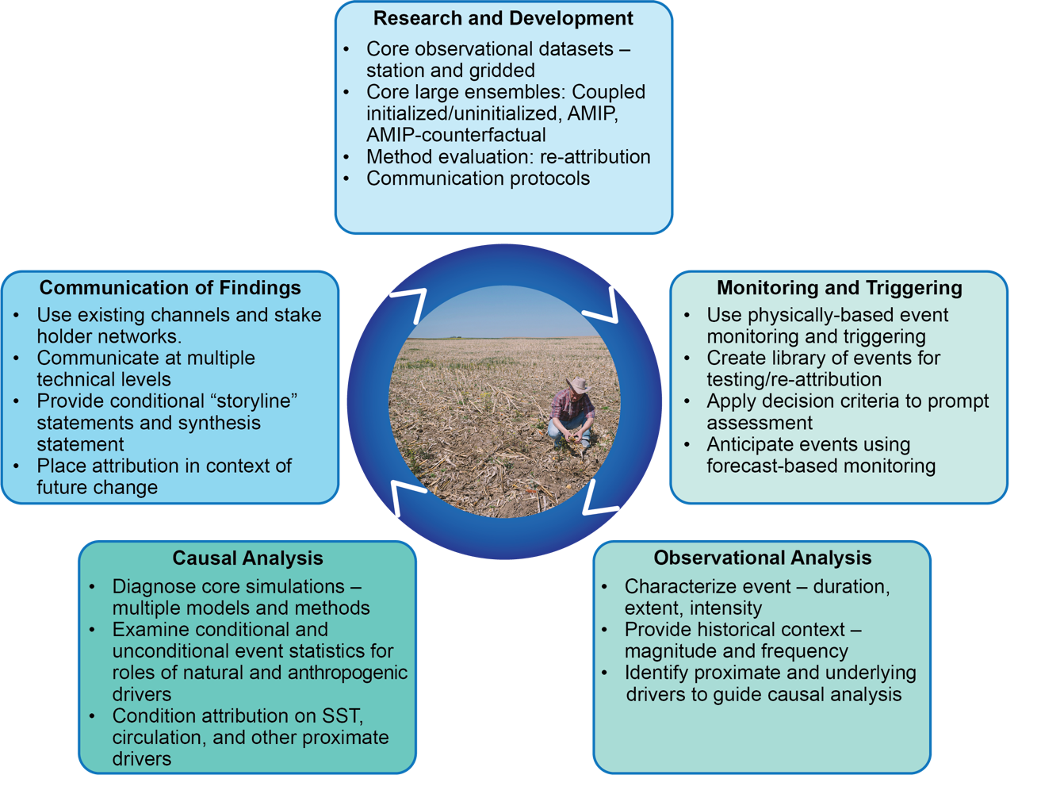
Figure 2: Key objectives of the rapid attribution prototype viewed as an iterative development process.

